Supporting wellness in the autism community during Covid-19
Routine, Relaxation, Preparation and Resources

Compiled by the Autism@UL Special Interest Group at the University of Limerick. This group includes autistic staff and students, parents of children with autism, clinicians, researchers and members of the local community.

Please note: Some people prefer to be called an ‘autistic person’, while others prefer ‘person with autism’. In order to respect both views, we use the terms interchangeably throughout this document.

This is a challenging time. For autistic people it may be particularly difficult.
People with autism experience the same emotions as everyone else. At times, we can experience these feelings more intensely.
Do what you know works for you and your family to stay safe and well.
If you are finding it difficult, we have some ideas that may be helpful for people with autism, families, friends and carers.
Routine

Routine is important for everyone. Our daily routine has changed now. Try to set up a new routine. It can help to use visuals (written words, pictures, or real items) to explain this new routine. Begin the day by going through this visual plan. Return to it as many times as is necessary during the day.
Be aware of time
Without our usual daily routine, it can be easy to spend a long time on one task. Try to stick to the time boundaries in your daily plan. You could set a timer or an alarm on your phone to remind you to take a break or move on to something else.
Stay active
Exercise can be a positive way to start the day. It gives us energy. It is nice to go outside for a walk or a run but you can exercise indoors too. You can dance or take part in an online workout or yoga class.
Do things you enjoy
Plan time in your day to engage with your interests. Some people like drawing, others like listening to music. Some people like comics, others like animals. When we do things that interest us, we feel happy, and it can be calming.
Eat Well
There is no specific food guaranteed to protect you from the coronavirus so general healthy eating guidelines are the best advice for now. Where possible stick to your usual meal routine.
Quiet space
Find a space that is just for you. If you are working from home, set up a workstation. Alternatively, set up a space in your home that is quiet and calming. Tell other people that it is your place. You can go there if you feel overwhelmed.
Sleep well
Set a bedtime in your daily plan and stick to it.
Relaxation

For everyone this is a stressful and anxious time and we need to find ways to cope.

Managing Day to Day
Some activities help us to manage our anxiety (for example, talking to someone about how we are feeling, exercising, meditating, drawing, or playing music). Build time for these activities into your daily routine.
If you are having anxious thoughts, talk to someone about it. It helps to share these feelings with someone else.
Try one of these activities to bring a moment of calm:
- Take a breath through your nose, breathe deeply in to your stomach and slowly release the breath
- Slowly press your fingertips together for 10 seconds
- Slowly straighten up your back and spine
- Push your feet hard into the floor.
If someone is asking the same questions repeatedly (even though you keep providing them with the answer), it can indicate that they are feeling overwhelmed and anxious about the situation. It can help to provide them with the answer in a visual format, by writing it down, or by creating a social story.
Social stories help us to understand what is happening. AsIAm have produced helpful social stories to explain the current situation, including Lockdown restrictions explained and Coping with COVID-19 whilst in residential care.
Here is a link to a social story explaining the current situation for children produced by theautismeducator.ie. Nosy Crow have published a free information book explaining the coronavirus for children, illustrated by Gruffalo illustrator Axel Sheffler. It is available here.
Set realistic expectations
We need to spend more time on self-care and managing anxiety. This means that we may have less time for work or study. Our productivity may be lower than usual. That is OK. Get in touch with your employer or educator and talk about what you can realistically do. Your Human Resources department will be able to provide advice and there may be an Employee Assistance programme in place. Autistica have produced information for employers about the impact of Covid-19 on autistic employees.
Maintain social connections
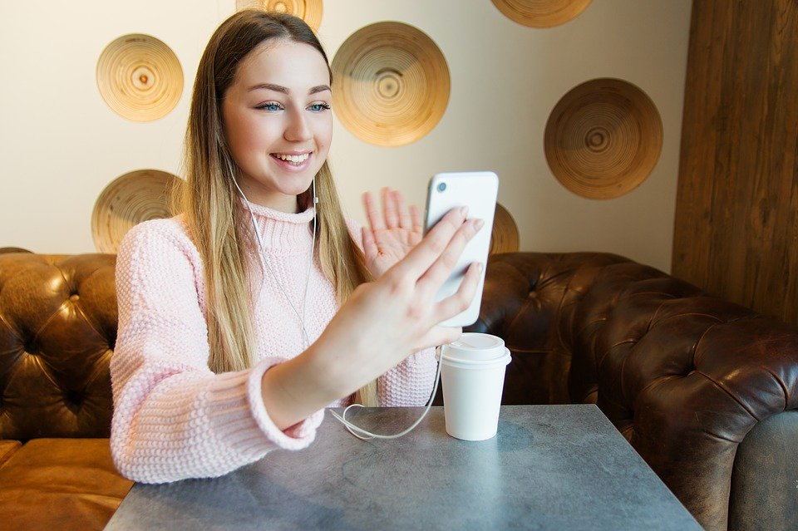
Even though we cannot visit friends and family there are other ways that we can stay in touch. You can phone someone, or you may be able to organise a video call. This helps us to feel close even though we are physically distant. Stay connected to people with whom you have a positive relationship. Reach out for help, advice and support.
Take breaks from the news
There is so much information available it can be overwhelming. News repeats during the day so limit yourself to watching one trustworthy news item a day, for example, the news on RTÉ One.
Limit the time you spend on social media. The information on there can be misleading. Make sure that the sources of information are trustworthy, such as the HSE social media pages: @HSELive on Twitter, and irishhealthservice on Instagram.
Be compassionate
You may disagree with some of the restrictions, for example, certain open spaces are closed. You need to obey these new rules, even if they do not make sense to you and you are frustrated by it. Try to remember that everyone is doing their best.

Preparation

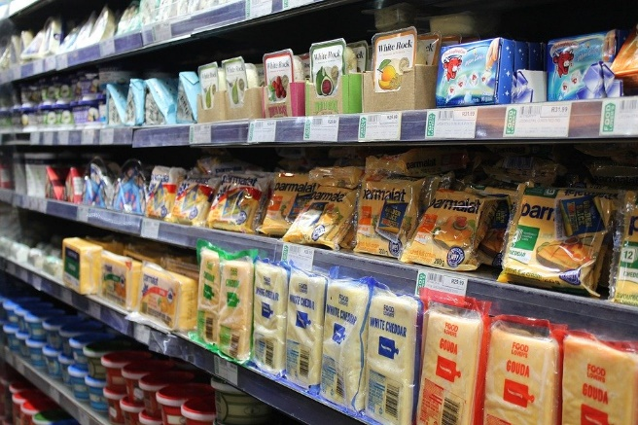
Grocery shopping
Contact your local supermarket or look on their website to find a quiet or protected time to visit the store. Explain that autistic people may need more time to process the new information and instructions to shop safely following social distancing measures.
Some people with autism follow strict food routines or diets that require specific food products. Currently, there is no reported shortage of food supply.
Strategies for dealing with Selective Eating during isolation:
- Some people do best when meal times are at the same time, place and situation every day
- Use visual timetables and visual schedules. Written timetables or picture symbol schedules detailing when and where eating will happen, what will be eaten and the type of behaviour expected at meal times makes mealtimes more predictable and a less anxious occasion
- Establish as calm and comfortable an environment as possible
- Some people eat more when they have a video or music on, whilst for others this may be distracting.

The hospital
It is possible that you will need to go to hospital. Have your health passport ready. The HSE have developed a Health Passport template. There is also a guidance document with advice on how to fill in the health passport.
The doctors and nurses are extra busy at this time so it is a good idea to have a short version of your health passport ready with key information:
- What helps to reduce your anxiety
- What makes your anxiety worse
- How best to communicate with you
- Ongoing Medication
- Allergies or food requirements
- Underlying conditions
- Next of kin
- Any specific supports that you have
Also, include something about your interests, or something that is important in your life. It may help to reduce your anxiety if the nurse or doctor talks to you about that.
Prepare a social story about going to the hospital. The following picture-based stories have been produced by the HSE Speech and Language Therapy Team at Dublin North Central:
- Getting ready to go to the Test Centre
- Getting ready to go to the Test Drive-in Centre

Garda checkpoints
The Gardaí are making sure that people follow the current restrictions that are in place to keep us safe.
A Garda might stop you at a checkpoint. This can be stressful.
Have a document ready that has key information that you can share with the Garda (see example below). Include your name, address and diagnosis.
Include a description of what your behaviour might look like if you feel stressed, and something the Garda can do to help you feel less stressed.
Include information about how you communicate, for example, if you do not use verbal language to communicate.
My Name is | THIS IS WHAT MY BEHAVIOUR LOOKS LIKE WHEN I AM STRESSED
I LIVE at
Emergency contact person (name and contact details)

my Diagnosis is | THIS CAN HELP TO CALM ME DOWN
how i communicate

Resources

Covid-19 related resource links:
The HSE have produced a Public Information booklet about Covid-19. There is also an Easy-Read version, and a version in the Irish language. There is information in a variety of languages available here.
The HSE have a website dedicated to supporting our mental health.
See the HSE guide to Coping with Distress during Covid-19.
The HSE have a guide to cocooning available here.
See this guide to Managing Sleep from the HSE.
Inclusion Ireland have created a document that explains the current restrictions.
AsIAm have a page dedicated to COVID-19 related resources.
The Illinois Autism Partnership have produced visuals to support daily planning for children with autism here.
Behaviour
If you or your child are engaged in behaviour that is challenging, then contact your service provider for support. Yvonne Newbold outlines lessons from her experience as a parent here that may be helpful.
Resource links for activities to keep children busy
The National Council for Special Education (NCSE) have shared links and resources – click here.
RTÉ2 are providing a ‘home schooling hub’ daily from 11am to 12 noon.
Try having a theme for a day, e.g. pirate day, baking day, cinema day etc.
Go on a virtual visit to the National Museum of Ireland – Natural History, or further afield, like the Anne Frank House or the San Diego Zoo.
Family friendly HQ have some ideas for sensory activities at home here.
Ted-Ed have interesting educational video content available for adolescents and adults. View the collection here.

