Module Satisfaction Survey, Autumn 2014
Summary of institutional-level findings
Introduction
In accordance with published policy and procedures (accessible here), the University of Limerick regularly undertakes a module satisfaction survey (MSS) of UL students. In October 2014, MSS requests were distributed to UL students who were undertaking one or more modules that semester. This represented some 54,500 individual requests to over 13,000 students taking one or more of approximately 1,200 modules on offer. Some 19,000 responses were received, which represents an overall response rate of 35%.

Reporting structure
- Individual module reports were made available to the lecturer listed as being responsible for the module.
- Heads of department received reports detailing all departmental modules (copied to the faculty dean).
- Executive Committee received a report that summarised departmental and faculty-level aggregate data.
- This publically available report provides a summary of institutional-level survey findings.
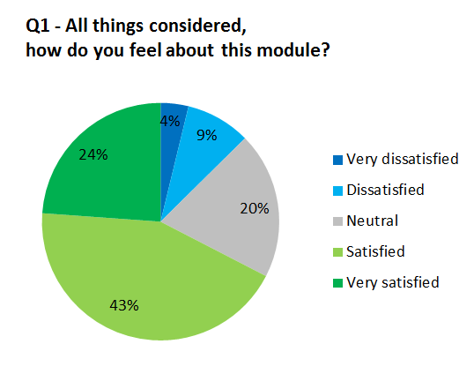
Institutional-level summary findings
In the case of MSS question 1 (“All things considered, how do
you feel about this module?”), 67% of respondents indicated satisfaction, 20% recorded a neutral response and 13% registered dissatisfaction.

The table below summarises the institutional average values recorded, on a scale of 1 to 5, for each question and, in the case of question 2, question component (1 = very dissatisfied, 5 = very satisfied).
Question no. | Question | Institutional average score
1 | All things considered, how do you feel about this module? | 3.8
2 | All things considered, how do you feel about each of the following aspects of this module?
2 (a) | - Content | 3.8
2 (b) | - Difficulty | 3.6
2 (c) | - Resources | 3.8
2 (d) | - Delivery | 3.8
2 (e) | - Assessment model | 3.8
2 (f) | - Schedule | 3.9
2 (g) | - Rooms and facilities | 4.1
2 (overall average) |  | 3.8

The University of Limerick wishes to acknowledge with thanks the cooperation of staff and students in operationalising this survey.

