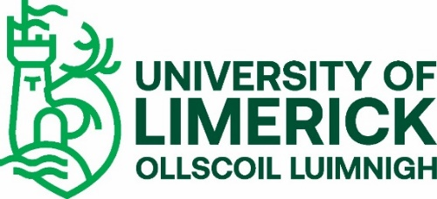

UNDERGRADUATE STUDENT VETTING REQUIREMENT 2021

The University of Limerick (UL) offers a number of undergraduate and taught postgraduate educational and training programmes that require students to undertake placements with external agencies. Such placements may bring the students into contact with children and vulnerable adults and require them to assume positions of trust. To ensure the protection of the public and justify public trust and confidence, the University is committed to ensuring that only suitable candidates are allowed to undertake these programmes.

In accordance with the National Vetting Bureau Acts 2012-2016 and UL’s Student Vetting Policy, there is a statutory requirement for all students on programmes that include a placement involving work with children or vulnerable adults to be vetted.
If your programme is on the list of UL Programmes with a Vetting Requirement you should now:
Go to the UL Student Vetting website https://www.ul.ie/provost/functions-processes/student-vetting and print off the Vetting Pack for Undergraduate Students.
- Complete the Vetting Invitation Form NVB (1) in accordance with the Guidelines for Completing Vetting Invitation Form NVB (1).
- Complete Photographic Identity Certification Form 2 to include a scan/photocopy of the relevant document image (passport, driving license (credit card size) or national ID card) and take the form and original ID to be certified by one of the approved certifiers listed on form.
- If you are under 18 years of age, your parent/guardian needs to complete and sign the National Vetting Bureau Parent/Guardian Consent Form NVB (3).
- After you have submitted your vetting forms and they have been processed by UL, you will receive an email from the National Vetting Bureau (evetting.donotreply@garda.ie) with a link to a full online vetting application form, which you must complete within 30 days or it will expire.
Additional Required Documents
If you have lived outside of Ireland or your home country for a period of more than six months since reaching 16 years of age, you are also required to provide an International Police Clearance Certificate (Criminal History Check) from each country in which you have lived. (For the United States, a National FBI Check is required). International Police Clearance certification should check for criminality and, where possible, clear you to work with children and vulnerable adults.
If you are an International non-EU student, you are also required to sign a Sworn Affidavit once in Ireland. More information regarding Police Clearance Certificates, Sworn Affidavits and International students can be found at the Student Vetting for International Students webpage: https://www.ul.ie/provost/functions-processes/student-vetting
Vetting Document Submission
Please keep a copy for your records and submit all original vetting documents either by post to the CDV Unit, Plassey House, University of Limerick, Limerick, V94T9PX, or, if on campus, submit to the Student Vetting Dropbox located in the Foyer, Main UL Reception. You may wish to use tracked post where important documents are being submitted. If you are awaiting a Police Clearance Certificate, this can be submitted separately after your initial documents are submitted. Police Clearance Checks can be returned on request once verified.
Please Note
Full details of any convictions or criminal prosecutions (past or pending) must be included in the online application form. It is imperative that no false information be furnished. Failure to provide full details may result in you not being able to undertake your practice placement. Where issues arise around clearance, you will be contacted by either the National Vetting Bureau or the UL Liaison Person.
Confirmation of Vetting process
You will receive a number of automated emails during your vetting process. The first when your Vetting Application Form is received and processed, another if you are outstanding submission of any documents, one when your E-Vetting application has been processed by the National Vetting Bureau and finally an email from UL advising that the vetting process is complete.
Confirmation of Vetting for Programme Placement is provided by the programme Course Director.
Please note that your registration remains provisional until you have complied with UL’s student vetting requirements.
Further details on UL’s student vetting process can be found on the UL Student Vetting website: https://www.ul.ie/provost/functions-processes/student-vetting
If you cannot find the answer to your query on the website, the UL CDV Unit can be contacted at: ULStudentvetting@ul.ie
----------------------------------------------------------------------------------------------------
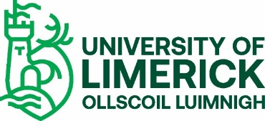
UNDERGRADUATE STUDENT VETTING CHECK LIST (not to be returned)
Please ensure that you submit the relevant documents as prescribed on the form
ESSENTIAL
- Vetting Invitation Form NVB(1)
- UL Photographic Identify Certification Form 2 (signed by a prescribed
Certifier as listed on the form)
ADDITIONAL
- Parent/Guardian Consent Form (NVB 3) – ONLY if you are under 18
years of age

- Police Clearance Certificate – ONLY if you have lived outside of your home country for more than six months since reaching 16 years of age

- A Sworn Affidavit – ONLY if you are an international Non-EU student

Please post all original vetting documents to CDV Unit, Plassey House, University of Limerick, Castletroy, Limerick V94 T9PX or submit to the Student Vetting Dropbox in the foyer of UL Main Reception

