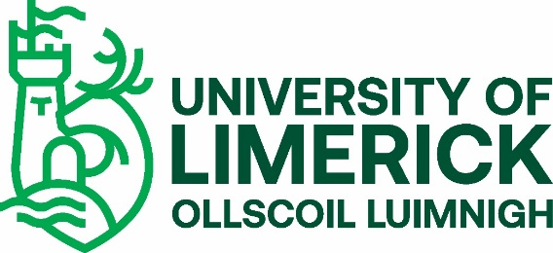

CO-OP STUDENT VETTING REQUIREMENT 2021

The University of Limerick (UL) offers a number of undergraduate and taught postgraduate educational and training programmes that require students to undertake placements with external agencies. Such placements may bring the students into contact with children and vulnerable adults and require them to assume positions of trust. To ensure the protection of the public and justify public trust and confidence, the University is committed to ensuring that only suitable candidates are allowed to undertake these programmes.
In accordance with the National Vetting Bureau Acts 2012-2016 and UL’s Student Vetting Policy, there is a statutory requirement for all students on programmes that include a placement involving work with children or vulnerable adults to be vetted.
As a student who has been offered a Co-op placement involving children or vulnerable adults, you should now go to the Co-op section on the UL Student Vetting website https://www.ul.ie/provost/functions-processes/student-vetting and:
- Complete Vetting Invitation Form (NVB 1) in accordance with the Guidelines for Completing Vetting Invitation Form (NVB 1).
- Complete UL Photographic Identity Certification Form 2 to include a scan/photocopy of the relevant document image (passport, driving license (credit card size) or national ID card and UL Student ID card and take the form and original ID to be certified by one of the approved certifiers listed on the form.
- AFTER You have submitted your vetting forms and they have been processed by UL, you will receive an email from the National Vetting Bureau (evetting.donotreply@garda.ie) with a link to a full online Vetting Application Form which must be completed within 30 days or it will expire.
Additional Requirements
If you have lived outside of Ireland or your home country for a period of more than six months since reaching 16 years of age, you are also required to provide an International Police Clearance Certificate (Criminal History Check) from each country in which you have lived. For the United States, a National FBI Check is required. International Police Clearance certification should check for criminality and, where possible, clear you to work with children and vulnerable adults. Please apply for this certification as soon as possible as it can be a lengthy process. Original documents can be returned on request following verification.
If you are a non-EU student, you will also be required to sign a Sworn Affidavit. More details on Student Vetting for International Students webpage.
Vetting Document Submission
Please keep a copy for yourself, and either post the original completed vetting documents to: Complaints, Discipline & Vetting Unit, Plassey House, University of Limerick, Limerick V94 T9PX, or, if on campus, submit to the UL Student Vetting Dropbox in the Foyer of Main UL Reception. If you are awaiting a Police Clearance Certificate, this can be submitted separately after your initial documents are submitted.
Please Note
Full details of any convictions or criminal prosecutions (past or pending) must be included in the online application form. It is imperative that no false information be furnished. Failure to provide full details may result in you not being able to undertake your practice placement. Where issues arise around clearance, you will be contacted by either the National Vetting Bureau or the UL Liaison Person.

Confirmation of Vetting Process
You will receive a number of emails during your vetting process. The first, when your Vetting application documents have been received, another if you are outstanding submission of any documents, one when your E-Vetting application has been processed by the National Vetting Bureau, and a final one when your UL Vetting process is complete.
Confirmation of your vetting for your placement is provided by your Course Director who should be asked to supply you with a UL Vetting Confirmation Placement Agreement Form (available on Student Vetting website).
Confirmation of Vetting where students were vetted by Placement Provider
Where you have been vetted by your Placement Provider, you will have received an automated email from UL advising you to submit a Placement Provider Vetting Confirmation Agreement form to the CDV Unit.
Once you have provided this form and it has been received and processed, your vetting status will be updated and you will receive an automated email to this effect from UL.
Please note that your registration remains provisional until you have complied with UL’s student vetting requirements.
More information on UL Student Vetting process can be found at:
https://www.ul.ie/provost/functions-processes/student-vetting

------------------------------------------------------------------------------------------------------------------------------------------
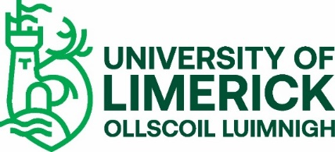
CO-OP STUDENT VETTING CHECK LIST (not to be returned)
Please ensure that you submit the following relevant documents as prescribed on the form.
Essential
- Vetting Invitation Form (NVB 1)

- A UL Photographic Identity Certification Form 2, which should include
a copy of either your passport, driving licence (credit card size only) or
National ID card and a copy of your UL Student ID card, both of which
must be certified as prescribed on the form

Additional if relevant
- Parent/Guardian Consent Form (NVB 3) – ONLY if you are under 18
years of age

- Police Clearance Certificate – ONLY if you have lived in another country
for more than six months since reaching 16 years of age

- Signed Sworn Affidavit – ONLY if you are a non-EU student

- Placement Provider Vetting Confirmation Placement Agreement Form (if
You have been vetted by your Placement Provider)

