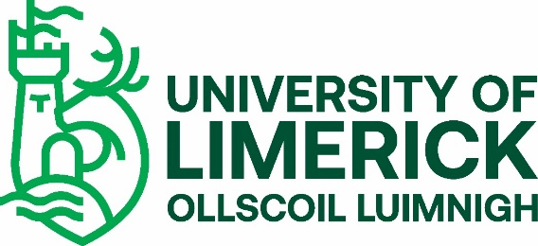
UL Programmes with a Garda Vetting Requirement
The programmes listed in the tables below have been designated as having a Garda vetting requirement (as an entry requirement).
Undergraduate Programmes
 | Particular modules on the National Certificate in Exercise and Fitness programmes, run by the National Council for Exercise & Fitness (NCEF)
LM026 | BA in Performing Arts
LM089 | BSc in Sport & Exercise Sciences
LM090 | BSc in Physical Education
LM091 | B Ed Languages
LM092 | BSc (Education) in Biological Science
LM094 | BTech (Education) in Materials & Architectural Technology
LM095 | BTech (Education) in Graphics, Engineering & Technology
LM096 | BSc (Education) in Physics & Chemistry
LM097 | BSc (Education) in Mathematics & Computer Science
LM100 | BSc in Physiotherapy
LM101 | Bachelor of Medicine Bachelor of Surgery
LM103 | BSc in Paramedic Studies
LM150 | BSc in Nursing (General)
LM152 | BSc in Nursing (Mental Health)
LM154 | BSc in Nursing (Intellectual Disability)
LM156 | BSc in Midwifery

This list is updated as required.
The most recent update to the UG list was made on 5th October 2021.

UL Programmes with a Garda Vetting Requirement

Postgraduate Programmes

MA in Guidance Counselling & Lifespan Development
MA in Community Music
MA in Music Therapy
MSc in Human Nutrition & Dietetics
MSc in Occupational Therapy (Professional Qualification)
MSc in Physiotherapy (Professional Qualification)
MSc in Speech & Language Therapy (Professional Qualification)
MSc in Sports Performance P/T and F/T
MSc Allied Sports Coaching
MSc Nursing (Dementia Care)
MSc Nursing (Peri-Operative Care)
MSc Nursing (Palliative Care)
MSc Nursing (Psychosocial Interventions In Mental Health Care)
MSc Nursing (Respiratory Care)
MSc Nursing (Older Person)
+MSc in Public Health
Professional Master of Education (6 streams)
Doctorate Clinical Psychology

+ Vetting on entry for this programme to commence AY 2020/2021

This list is updated as required. The most recent update to the PG list was made on 12th October 2020.

