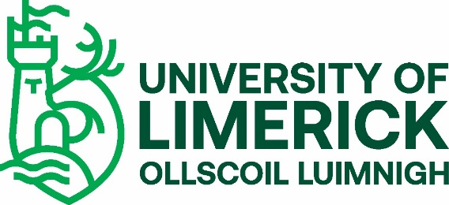

Guidelines for Completing Vetting Invitation Form (NVB 1)
Please read the following guidelines before completing this form.
The form must be completed in full in BLOCK CAPITALS using a black ball point pen. Writing must be clear and legible.
Photocopies or scans will be accepted initially during Covid-19 crisis, however original forms must be submitted once campus is re-open to students.
All applicants are required to provide documents to validate their identity (Photo ID Form).
If you are under 18 years of age, a completed Parent\Guardian Consent Form (NVB 3) will be required. Please note that where the applicant is under 18 years of age, the electronic correspondence will issue to the Parent/Guardian. This being the case, you must provide your Parent/Guardian email address on the NVB 1 form.
Notes on filling in the NVB 1 form:
Student Ref
Please fill in your UL Programme Code (e.g. LM030) or Programme Name (e.g. BA Performing Arts) and your Student ID Number (Applicant number) in the boxes in the top-right corner of this form.
Personal Information
Insert details for each field, allowing one character/digit per box.
The email address you enter will be the one to which the link to the full online vetting application form will be sent by the National Vetting Bureau after this Vetting Invitation has been processed initially by UL. You must fill out the full online application form which is sent to you by the National Vetting Bureau immediately as it will expire after a month.
Current address means the full address of where you are now living, including the Eircode/Postcode. Northern Ireland addresses must include the full 6-digit postcode or the application will not be processed.
If you have lived outside of Ireland for more than 6 consecutive months since reaching the age of 16 years, tick Yes and list the countries in the Countries box and the duration of time in the Duration box; otherwise, tick No. If yes, please note that you will be required to supply a Police Clearance Certificate from that/those countries. More details regarding Police Clearance Certificates can be found on the UL Student Vetting website.
Declaration of Application
You must confirm your understanding and acceptance of the two statements by signing and dating the application form at Section 2 and ticking the box provided.
Submission of Form
Details on how to submit this form can be found in the respective student’s Student Vetting Cover Letter.
More information on the UL student vetting process can be found at:
https://www.ul.ie/provost/functions-processes/student-vetting
RETURN THIS FORM AS DIRECTED ON RESPECTIVE STUDENT VETTING COVER LETTER |  | Student Ref:  Student to fill in:
 |  | Programme Code/Name:
 |  | Student ID Number:
 | Vetting Invitation (NVB 1)
Section 1 – Personal Information

Under Sec 26(b) of the National Vetting Bureau (Children and Vulnerable Persons) Acts 2012 to 2016, it is an offence to make a false statement for the purpose of obtaining a vetting disclosure.
Forename(s):
Middle name:
Surname:
Date of birth: | D | D | / | M | M | / | Y | Y | Y | Y
Email address:
Contact tel. no.:
Role being vetted for: | S | T | U | D | E | N | T |  | P | L | A | C | E | M | E | N | T
Current address:
Line 1:
Line 2:
Line 3:
Line 4:
Line 5:
Eircode/Postcode:
Lived abroad for more  than 6 months over the age of 16? | Yes |  | No |  | Countries: |  |  |  |  |  |  | Duration:
If Yes, Police Clearance Certificate(s) will need to be provided. Please check UL Student Vetting website for more details.
Section 2 – Additional Information
Name of organisation | University of Limerick

I have provided documentation to validate my identify as required and I consent to the making of this application and to the disclosure of information by the National Vetting Bureau to the Liaison Person pursuant to Section 13(4)(e) National Vetting Bureau (Children and Vulnerable Persons) Acts 2012 to 2016. Please tick box 
Applicant’s

signature: |  | Date: | D | D | / | M | M | / | Y | Y | Y | Y
Please note that after you return this form, the National Vetting Bureau will send you an email with a link to the e-vetting website to fill out the full ONLINE Vetting Application form. The email will be from: evetting.donotreply@garda.ie. Please fill out the online form as soon as possible as it has an expiry date.

