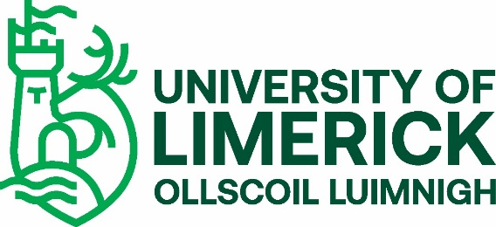

INTERNATIONAL STUDENT VETTING/POLICE CLEARANCE REQUIREMENT 2021
The University of Limerick (UL) offers a number of undergraduate and taught postgraduate educational and training programmes that require students to undertake placements with external agencies. Such placements may bring the students into contact with children and vulnerable adults and require them to assume positions of trust. To ensure the protection of the public and justify public trust and confidence, UL is committed to ensuring that only suitable candidates are allowed to undertake these programmes.
In accordance with the National Vetting Bureau Acts 2012-2016 and UL’s Student Vetting Policy, there is a statutory requirement for all students on programmes that include a placement involving work with children or vulnerable adults to be vetted.
If your programme is on the list of UL Programmes with a Vetting requirement you should now:
Go the UL Student Vetting website: https://www.ul.ie/provost/functions-processes/student-vetting and print off the following forms: Vetting Invitation NVB (1); Photographic Identity Certification Form 2 and the Postgraduate Student Vetting Cover Letter.
- Complete a Vetting Invitation Form (NVB 1) in accordance with the Guidelines for Completing Vetting Invitation Form (NVB 1).
- Complete UL Photographic Identity Certification Form 2 to include a scan/photocopy of the relevant document image (driving license (credit card size) or national ID card and take the form and original ID to be certified by one of the approved certifiers listed on the form.
- Submit an original Police Clearance Certificate/Criminal History Check from every country you have lived in for more than six months since over the age of 16 years. (For the United States, an FBI national check must be submitted.) International Police Clearance certification should check for criminality and, where possible, clear you to work with children and vulnerable adults. Please apply for this certification as soon as possible as it can be a lengthy process.
- You will be required to sign a Sworn Affidavit once in Ireland.
- If under 18 years of age, you will need to submit a Parent/Guardian Consent Form (NVB 3), completed by your parent/guardian.
- After you have submitted your vetting forms and they have been processed by UL you will receive an email from the National Vetting Bureau (evetting@donotreply@garda.ie) with a link to a full online vetting application form which you must complete within 30 days or it will expire and you will have to start the vetting process again.
Form Submission – Original documents only to be submitted
Please keep a copy for yourself and either post all original vetting documents to the DV Unit, Plassey House, University of Limerick, Castletroy, Limerick V94 T9PX, or, if campus, please submit to the UL Student Vetting Dropbox in the Foyer of Main UL Reception. You may wish to use tracked post where important documents are being submitted. If you are awaiting a Police Clearance Certificate, this can be submitted separately after your initial documents are submitted.
Please note
Full details of any convictions or criminal prosecutions (past or pending) must be included in the online application form. It is imperative that no false information be furnished. Failure to provide full details may result in you not being able to undertake your practice placement. Where issues arise around clearance, you will be contacted by either the National Vetting Bureau or the UL Liaison Person.
Confirmation of Vetting Process
You will receive a number of automated emails during your vetting process. The first when your Vetting Application Form is received and processed, another if you are outstanding submission of any documents, one when your E-Vetting application form has been processed and a final one when your UL vetting process is complete.
Confirmation of your vetting for your placement provider is provided by your Course Director.
Please note that your registration remains provisional until you have complied with UL’s student vetting requirements.
Further details on UL’s Student Vetting process can be found at: https://www.ul.ie/provost/functions-processes/student-vetting
If you cannot find the answer to your query on the website, the UL CDV Unit can be contacted at: ULStudentvetting@ul.ie

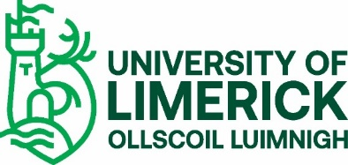
INTERNATIONAL STUDENT VETTING CHECK LIST (not to be returned)
Please ensure that you submit the following relevant documents as prescribed on the form.
Essential
- Vetting Invitation Form (NVB 1)
- UL Photographic Identity Certification Form 2, which should include
a copy of either your passport, full driving licence (credit card size only) or
National ID card, which has been certified by approved certifier as
prescribed on the form

- Copy of your UL programme offer letter (or other proof of address)
Additional, if relevant
- Police clearance certificates from every country you have lived in for
more than six months since over 16 years of age (can be submitted later)

- Signed Sworn Affidavit if International Non-EU student (can be submitted later)

- Parent/Guardian Consent Form (NVB 3) – ONLY if you are under 18
years of age

