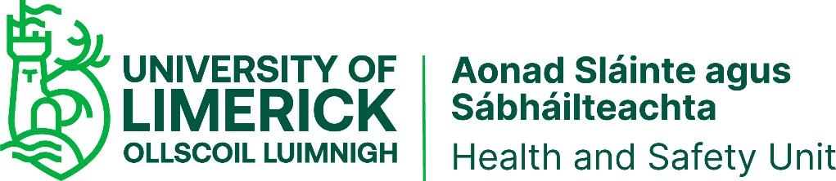

Materials | First Aid Box Contents
 | 1-10 persons | 11-25 Persons | 26-50 Persons *1
Adhesive Plasters | 20 | 20 | 40
Sterile Eye Pads (No. 16) (bandage attached) | 2 | 2 | 4
Individually Wrapped Triangular Bandages | 2 | 6 | 6
Safety Pins | 6 | 6 | 6
Individually Wrapped Sterile Unmedicated Wound Dressings Medium (No. 8) (10 x 8cm's) | 2 | 2 | 4
Individually Wrapped Sterile Unmedicated Wound Dressings Large (No. 9) (13 x 9cm's) | 2 | 6 | 8
Individually Wrapped Sterile Unmedicated Wound Dressings Extra Large (No. 3) (28 x 17.5cm's) | 2 | 3 | 4
Individually Wrapped Disinfectant Wipes | 10 | 20 | 40
Paramedic Shears | 1 | 1 | 1
Examination Gloves Pairs | 5 | 10 | 10
Sterile water where there is no clear running water*2 | 1x500mls | 2x500mls | 2x500mls
Pocket Face Mask | 1 | 1 | 1
Water Based Burns Dressing Small (10x10cm's) *3 | 1 | 1 | 1
Water Based Burns Dressing Large*3 | 1 | 1 | 1
Crepe Bandage (7cm ) | 1 | 2 | 3

Notes:
Local Risk Assessments will dictate the necessity for additional Supplies in certain areas.
*1: Where more than 50 persons are employed, pro-rata provision should be made.
*2: Where mains tap water is not readily available for eye irrigation, sterile water or sterile normal saline (0.9%) in sealed disposable containers should be provided. Each container should hold at least 20ml and should be discarded once the seal is broken. Eye bath/eye cups/refillable containers should not be used for eye irrigation due to risk of cross infection. The container should be CE marked.
*3: Where mains tap water is not readily available for cooling burnt area.
Taken from: https://www.hsa.ie/eng/topics/first_aid/first_aid_frequently_asked_questions/first_aid_faq_responses/

