RESEARCH Researcher Development Programme CPD Log
ER DEVELOPMENT PROGRAMME
E-PORTFOLIO

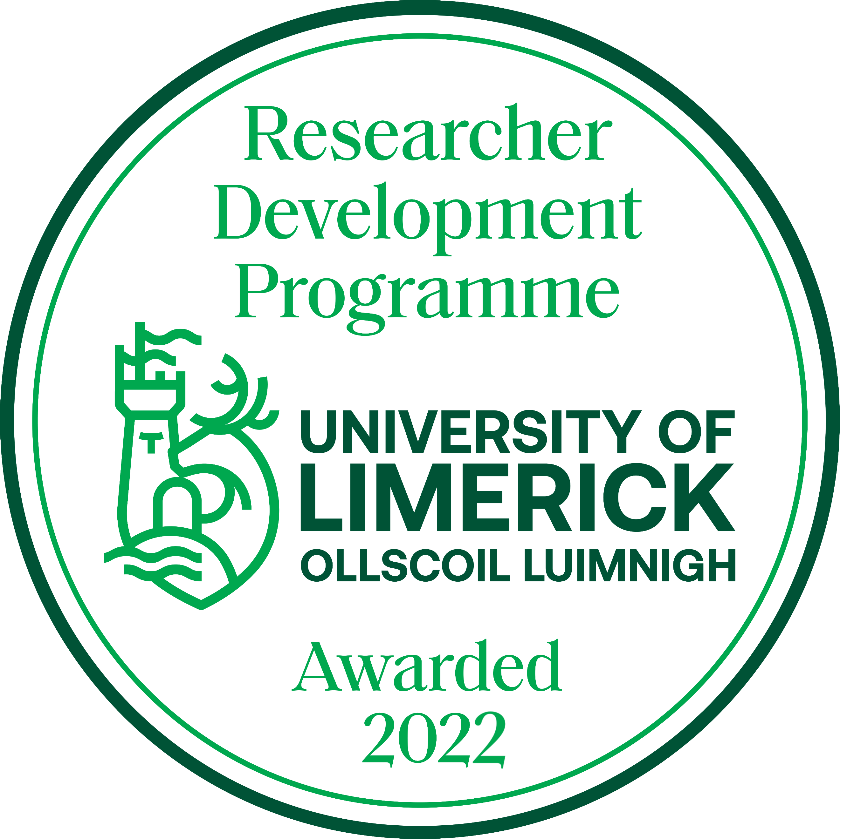

Name:
Department/Research Centre:
Name of PI/Manager:
Last Review Date:
Next Review Date:

This document should be completed on an on-going basis as you complete your Continuing Professional Development. You can record all of your learning here, not only the training modules that you attend as part of the RDP but also any other work or learning that you do that can build your skills as a researcher. This can include but is not exclusive to:

- CPD events
- Mentoring
- Chairing meetings
- Organising or attending conferences
- Presenting papers a symposia
- Award nominations
- Networking events
- Other training

Once you have completed the document, please email it to hrtalentdevelopment@ul.ie

For Ongoing Completion Throughout Programme

Courses Undertaken (including programmes such as Aspiring Research Leaders and Navigate: Research Staff Beyond Academia)
Date | Course/Programme Title | Key Learnings | Action – what action are you committing to as a result of this training? | CPD Hours

Please add extra rows below as required.

Other relevant experiences / feedback / activities
(This could involve meetings with mentors; conference attendance; feedback from PI; etc.)
Date | Activity Undertaken | Key Learning (to be completed after) | CPD Hours

Please add extra rows below as required.

