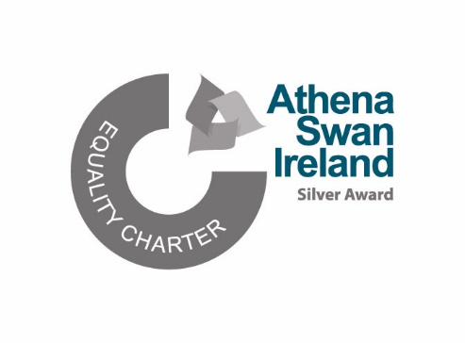

Age Friendly University Committee

Name | Department/School | Area of Interest
Dr Marie Connolly | Human Rights EDI Office
Andrea La Touche | Global and Community Engagement
Ann Marie Kennedy | Accreditation and Quality Office
Donal O’ Leary | Student Affairs Division
Hilary Curley | Office of the Dean, EHS
Joachim Fischer | School of Modern Languages and Applied Linguistics
Maria Rieder | School of Modern Languages & Applied Linguistics
Michaela Schrage-Frueh | School of Modern Languages & Applied Linguistics
Pattie Punch | Library & Information Services Division
Rose Galvin | School of Allied Health
Shirley Ryan | Student Affairs Division
David Conway | Retiree
David Mahedy | Retiree

