BM4003 General Practice/Primary Care
A Guide for Clinical Tutors & Students
AY2023/24
Front cover: students studying at the School of Medicine Building on UL campus (top, centre) and LivingHealth Clinic, Mitchelstown – one of our 140 affiliated general practices (bottom)
Contents

Introduction to GP team and module overview …………………………………………………….. 3
Infection prevention and control on placement ..………………………………………………….. 8
What we want students to learn ………………………………………………………………………….. 10
How this module fits into the curriculum ……………………………………………………………… 19
General structure of the 18-week longitudinal integrated placement (LIC) ……………. 21
The ‘formal’ teaching …………………………………………………………………………………………… 23
Clinical placements and parallel consulting ………………………………………………………….. 27
Monitoring students on clinical placement …………………………………………………………… 36
How students are assessed ………………………………………………………………………………… 38
Injuries sustained while on placement …………………………………………………………………. 42
Research opportunities in general practice ………………………………………………………….. 45
Recommended resources for students ………………………………………………………………… 47
Appendices …………………………………………………………………………………………………………. 52
Important dates to note ………………………………………………………………………………………..66

Introduction to GP Team and Module Overview
Liam Glynn
Professor of General Practice

GP Academic Team
We are an enthusiastic and ambitious group of GP teachers and researchers aiming to develop general practice and primary care in Ireland.
With high quality teaching and research of international standing we maintain active clinical roles and involvement in the development and delivery of primary care services in the Mid-West and beyond.

We deliver an innovative educational programme at the School of Medicine where we teach in three of the four years of the Bachelor of Medicine-Bachelor of Surgery programme.

Our 3rd Year 18-week Longitudinal Integrated Clerkship placement programme in the community is unique in Ireland. This programme is consistently rated highest of all clinical placements by medical students here in the School of Medicine.

To our tutors, we look forward to continuing to engage with you throughout this academic year and to our students, welcome to General Practice!

Prof. Liam Glynn
Professor of
General Practice
e: liam.glynn@ul.ie
t: (061) 202 812
Prof. Pat O’Dwyer
BM4003 Module Lead;
Network Co-ordinator,
Limerick/North Tipperary
e: patrick.odwyer@ul.ie
t: (061) 381 729

Dr. Andrew O’Regan
Associate Professor of General Practice
e: andrew.oregan@ul.ie
t: (061) 234 849

Prof. Aidan Culhane
Network Co-ordinator,
Limerick/North Tipperary
e: aidan.culhane@ul.ie
t: (061) 377 656
Dr. Sarah Hyde
Associate Professor of Clinical Education
e: sarah.hyde@ul.ie
t: (061) 202 860
Dr. Peter Hayes
Associate Professor of General Practice
e: peter.hayes@ul.ie
t: (061) 234 850
Dr. Patrick O’Donnell
Associate Professor of General Practice
e: patrick.e.odonnell@ul.ie
t: (061) 234 850
Dr. John Cuddihy
Network Co-ordinator, South East
e: john.cuddihy@ul.ie
t: (056) 772 1320

Dr. Noreen Lineen-Curtis
Network Co-ordinator, North West
e: noreen.lineen-curtis@ul.ie
t: 086 609 0578
Dr. Declan Herlihy
Network Co-ordinator, Cork/South Tipperary
e: declan.j.herlihy@ul.ie
t: (025) 52000

Dr. Páraic Meaney
Network Co-ordinator, Clare
e: paraic.meaney@ul.ie
t: (065) 683 7604
Dr. Jerry O’Flynn
Network Co-ordinator, Midlands
e: jeremiah.oflynn@ul.ie
t: (057) 933 2444
Dr. Ryan Say
Network Co-ordinator, Kerry
e: ryan.say@ul.ie
t: 083 395 0441

GP Operations Team
Sinead Burke
Executive Administrator
e: Sinead.M.Burke@ul.ie
t: (061) 233 756

Katherine Long
Senior Administrator
e: Katherine.Long@ul.ie
t: (061) 233287

Outline of Teaching and Learning

This module presents students with an opportunity to observe the variety of different ways that patients present to General Practitioners with health issues and concerns. It affords students an unparalleled opportunity to interact with patients on a one-to-one basis while providing supervision from an individual experienced clinical tutor. Every consultation with a patient provides a unique learning opportunity. Students should also come to appreciate the roles of other disciplines involved in primary care and the nature of the processes involved in referral to and discharge process from hospital care.

This guide aims to:
• Assist students in maximising the benefits of their clinical placement in
General Practice and
• Help GP Tutors support students during their time on placement.

Please note, the content of the module may evolve in response to feedback from GP tutors and students; the information provided in this guide therefore is correct as of July 2023 and is subject to change.

Please note that this handbook is issued in addition to other University and School handbooks which students should also refer to prior to the commencement of the academic year (i.e. UL Student Handbook, Handbook of Academic Regulations and Procedures, BMBS Year 3 Course Handbook). The latest versions of these are available on the Year 3 Brightspace site.

School of Medicine Building at University of Limerick

Seeking Help and Support during Placement

It is not unusual to feel overwhelmed and isolated at times during your GP placement. To help overcome this, a “buddy system” has been developed and students will be divided into groups of two or three by the local GP Co-ordinator at the first small group teaching session. Students will be encouraged to maintain contact with their buddies and each group will appoint a representative to liaise with the Co-ordinator and GP Executive Administrator if issues arise.

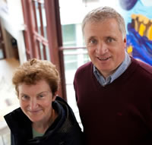
The UL Chaplaincy provides a drop-in or telephone service where students can talk with a chaplain in a non-judgemental, respectful environment.

Fr. John Campion and Sr. Sarah O’Rourke, UL Chaplaincy

UL Éist, the UL counselling and wellbeing service, provides consultations to all registered students, including those away from campus on clinical placements. Consultations can be made in person, over the phone or via Skype.

If you require medical attention while on GP placement, please contact your own GP/GP of your choice. If you are unable to easily access a GP service, any of the below GP practices which operate independently of our placement network have agreed to see students (please note: these services are not subsidised by the University). Students should not attend their assigned GP practice as a patient (unless in an emergency). If you are well enough to return to campus, the UL Student Health Centre offers a subsidised service to registered students. Information on contacting any of the above supports can be found on www.ul.ie/studentaffairs.

Network | Designated GP service recommended by local GP Co-ordinator | Contact number
Limerick/North Tipperary | UL Student Health Centre (CM-061), Student Affairs Division, University of Limerick, Limerick, V94 T9PX | (061) 202 534
Clare | Dr. Emma Kearney, Parnell Medical Centre, Parnell Street, Ennis, Co. Clare, V95 WFD7 | (065) 686 8140
Kerry | Dr. Kerry Houston, Farranfore Medical Centre, Farranfore, Killarney, Co. Kerry, V93 E6HT | (066) 976 4144
Cork/South Tipperary | Dr. Deirdre O’Grady, Family First Medical Practice, 61-63 Mac Curtain Street, Fermoy, Co. Cork, P61 KH74 | (025) 32734
South East | Dr. Julie McMahon, Kilkenny Medical Centre, Garrison House, John’s Green, Kilkenny, R95 WK0E | (056) 776 5966
Midlands | Dr. Cordula Grzonka, Kilbeggan Medical Centre, Mullingar Road, Kilbeggan, Co. Westmeath, N91 EYH2 | (057) 933 2444
North West | Dr. Michael Waldron, Primary Care Centre, 33 Moneen Road, Castlebar, Co. Mayo, F23 ED77 | (094) 904 9250
Infection Prevention and Control on Placement

The University is committed to working with our GP tutors to support clinical placements to the greatest practical degree subject to the priority of protecting the safety of patients, staff and students. In advance of their placement, students have completed online IPC training and signed a declaration committing to the below procedures:
- Students will not present to clinical placement if they have any symptoms of acute infection such as symptoms of viral respiratory tract infection or gastroenteritis
- Students will not be present in clinical areas without a specific purpose relating to their educational requirements
- Students will limit their time in the clinical area to the minimum time necessary for their learning
- Students will be “bare below the elbows/bare above the wrists” when in clinical areas
- Students will comply with local IPC procedures in each individual practice
- If students have chosen not to be vaccinated against key respiratory viruses (SARS-CoV-2 and Influenza) in accordance with current public health guidance they will, to the greatest degree practical, limit contact with high-risk patients
- If students develop an infectious disease (COVID-19 or any other communicable disease), they will immediately notify the University (via the online student absence form) and their placement practice
- Students who are not confirmed as immune to Hepatitis B virus will not engage in exposure prone procedures

What we want students to learn
In this module, our aims are threefold:
- To provide students with an opportunity to encounter and become clinically competent in common clinical problems and conditions in General Practice and Primary Care,
- To provide students with an appreciation of the contextual issues which impact on clinical work in Primary Care,
- To provide a supporting programme of formal teaching and learning activities.

Clinical Care: The clinical problems / conditions in which students are expected to demonstrate basic clinical competence at the end of the module are as outlined in the ‘Anthology of Medical Conditions’ published by the Australian Medical Council. This contains 131 problems / conditions in which students should be competent at the time of graduation and identifies the 47 conditions which are particularly germane to General Practice and which therefore form an important focus of what students learn while on clinical placement (and how we assess them):

Table 1. Anthology of Medical Conditions: General Practice
002 Abdominal Mass  003 Abdominal Pain  006 Abnormal serum lipids  012 Anaemia  018 Burns  019 Cardiac Arrest / Respiratory Arrest  020 Chest discomfort  024 Dementia/memory disturbances  027 Diarrhoea / Constipation  028 Diplopia  029 Dizziness / Vertigo  030 Dying Patient  031 Dysphagia  032 Dyspnoea / Cough / Prevention of Cancers / Chronic Respiratory Diseases  033 Ear Pain  035 Eye Redness  037 Falls  038 Fatigue  040 Fever and Chills  046 Headache  053 Hyperglycaemia / Diabetes Mellitus  054 Hypertension  056 Insomnia / Sleep Disorders / Sleep Apnoea  059 Joint Pain, Mono-articular (Acute, Chronic)  060 Joint Pain, Poly-articular (Acute, Chronic)  065 Mood Disorders | 071 Painful Limb  073 Panic and Anxiety  077 Periodic Health Examination / Growth and Development  081 Pregnancy  082 Contraception / Pregnancy Prevention / Termination  089 Regional Pain  092 Rhinorrhoea / Sore Throat  093 Scrotal Mass  094 Scrotal Pain, Acute  100 Skin and Subcutaneous Lesions  101 Skin Blisters – Boils – Comedones – Ulcers  102 Skin Rash / Dermatitis  103 Speech and Language  Abnormalities / Dysphonia / Hoarseness  107 Substance Abuse / Addiction  114 Urinary Frequency  118 Vaginal Discharge / Urinary Symptoms, Vulvar Lesions, Sexually Transmitted Diseases  119 Violence / Aggression and Mental Illness  124 Weight Gain / Obesity  129 Deformities / Malformations  130 Travel Medicine and Tropical Infections  131 Medical Emergencies

However, in addition to the above, other conditions which are relevant to General Practice/Primary Care may also be assessed.

Care in context: In addition, students are expected to experience and develop an understanding of contextual issues which impact on Clinical Practice.

Learning Objectives:
Your Longitudinal Integrated Clerkship in General Practice is an opportunity to become immersed in the care of individual patients, as part of a primary care team which is an important part of every local community.

The main priorities for this module are to further develop your clinical skills and knowledge of health and illness.

You should learn how to work effectively as part of a team and gain an understanding of the context of general practice in healthcare systems. It is also expected that you further develop your administrative, team-working, and time management skills during the clerkship.

By the end of your rotation you should be able to describe the range of patient presentations commonly seen in General Practice: acute care, emergency care, chronic care, and preventative/primary care.

General practice teams see the full spectrum of people in the community and you should be able to reflect on your own personal attitudes (conscious and unconscious) to different patients/patient groups. You should be able to demonstrate an awareness of the importance of the physical, psychological and social determinants of health, and incorporate these into your diagnostic and management plans. An effective management plan should involve a consideration of all psychological and social elements that resonate with the case, along with typical interventions which are more apparent (pharmacological, referral, review, safety-netting etc). You should be able to recognise your own personal and professional limits and discuss all consultations with your clinical supervisors.

The longitudinal Integrated Clerkship should also give you the opportunity to reflect on the principles that underly all professional practice. You should be able to discuss the principles of confidentiality, autonomy, consent, patient-advocacy, social justice, and the role shared decision making plays in consultations.

Table 2. Learning Outcomes for General Practice/Primary Care
 | OUTCOMES  At the end of your time in GP you should: | DOMAIN  and  Clinical condition number | LEVEL REQUIRED | TEACHING/ LEARNING ACTIVITY  *See below for abbreviation key | ASSESSMENT  #See below for abbreviation key
1 | be able to effectively communicate with a patient in order to discover the reason for attendance, explain the differential diagnosis and discuss a management plan. This should be achieved by  - Responding compassionately to people’s health needs in the context of their social situation, culture and environment | Attitude  skill | Medium -high | LIC  SEM  CBT  VCB | CE  ITA
2 | be competent in performing the following exams  - Cardiovascular,  - Respiratory,  - Gastro-intestinal,  - Neurological-PNS/CNS,  - Thyroid,  - Diabetic foot,  - Lymph node,  - Peripheral vascular,  - Ear, Nose Throat exam,  - Antenatal exam,  - Developmental exam-paediatrics,  - Fundoscopy,  - Pen Torch to assess pupil dilation/ accommodation.  Whilst breast, pelvic, scrotal/rectal exams may not be tested at year 3 GP clinical exams, you may be still asked to verbally describe these. If opportunities arise to observe these exams in your clerkship, with the consent of patients and supervisors-these should be taken.  Although the examination of children is not formally tested in GP clinical exams-If opportunities arise to observe or participate in these exams in your clerkship, with the consent of parents, patients and supervisors-these should be taken. | Skills  077  081  093  094 | Medium-high | LIC  VCB | CE  ITA
3 | demonstrate knowledge on the diagnosis and general practice management of the following chronic medical conditions:  - Asthma,  - COPD,  - Diabetes,  - Thyroid disease,  - Atrial fibrillation,  - Hypertension,  - Cardiac failure,  - Eczema,  - Psoriasis,  - Acne  - Leg ulcers,  - Peripheral vascular dis.,  - UC/Crohns,  - Coeliac disease,  - Chronic Liver Disease,  - Pernicious anaemia  - GERD,  - Rheumatoid arthritis,  - Osteoarthritis,  - Gout,  - Dementia,  - Depression,  - Schizophrenia,  - Anxiety,  - Insomnia,  - Recurring Falls,  - Addiction,  - Chronic Kidney Disease.  - Migraine  - Parkinson’s Disease | Skill & Knowledge  032 124  053 107  054 102  056 101  065 024  073  089  119  037  102  107  119 | Medium-high | LIC  SEM  CBT  VCB | ITA  CE  EMQ/SBA
4 | demonstrate knowledge on the diagnosis and general practice management of the following acute infective conditions (including examination skills where appropriate):  - Respiratory tract infections,  - ENT infections,  - Urinary tract infections,  - Gastroenteritis,  - Influenza,  - COVID-19,  - Chicken pox/shingles,  - Skin infections,  - Sexually acquired infections. | Skill & Knowledge  032 114  033 027  040  092  118  100  101 | Medium-high | LIC  SEM  CBT | ITA  CE  EMQ/SBA
5 | demonstrate knowledge on the diagnosis and GP management of the following musculoskeletal conditions (including examination skills where appropriate):  - Low back and red flag issues,  - Wrist pain,  - Elbow pain,  - Shoulder pain,  - Ankle sprain,  - Plantar fasciitis,  - Achilles tendonitis,  - Acute/chronic knee pain,  - Acute/chronic hip pain. | Skill & Knowledge  037  059  060  071  129  089 | medium | LIC  SEM  CBT | ITA  CE  EMQ/SBA
6 | demonstrate knowledge on the various methods of contraception- prescribed in GP (hormone types, indications and contra-indications, common side effects)  - Pills/rings/patches,  - Coils,  - Depots,  - Sub-dermal implants. | Knowledge  082  118 | medium | LIC  SEM  CBT | ITA  CE  EMQ/SBA
7 | be able to perform the following clinical tasks  - IM injection,  - Plot centiles (paediatric),  - BP/ABI (Ankle -Brachial Index),  - Phlebotomy,  - Inhaler Technique (teach a patient),  - Nebuliser Set up,  - ECG,  - Cervical Smear (assist, with supervision),  - Urinalysis,  - Pregnancy test,  - Glucometer reading,  - Write a referral Letter,  - Prescription review,  - O² provision /Face mask,  - Peak Flow/Spirometry. | Skill and knowledge | Medium-high | LIC  SEM | ITA  CE
8 | understand how to manage the following emergencies in GP (prehospital care):  - Asthma/shortness of breath,  - Chest pain / MI.,  - Sepsis,  - Anaphylaxis,  - Collapse,  - Hypoglycaemia.  - Acute abdominal pain,  - Acute weakness/stroke/transient ischemic attack,  - Acute headache,  - Acute Burns. | Skill and knowledge  032 019  046 018  131  020 | medium | LIC  SEM  CBT | ITA  CE  EMQ/SBA
9 | understand how to recognise and manage the following potential oncological/ acute illness issues in GP  - Anaemia, leukopenia, thrombocytopenia,  - Abnormal LFTs, jaundice,  - Rectal bleeding,  - Acute abdominal mass,  - Haemoptysis/emesis,  - Haematuria,  - Dysphagia,  - Abnormal prostate exam/PSA,  - Generalised lymph nodes,  - Substantial weight loss,  - CNS neoplasm signs and symptoms,  - Scrotal mass/pain,  - Atypical moles, SCC, BCC, or common skin lesions (seb. keratosis, warts, verrucae, skin tags)  - Hoarseness/dysphonia,  - Fatigue,  - Acute Kidney Injury,  - Acute urinary retention.  - Acute deep vein thrombosis (DVT) | Skill and knowledge  032  038  046  093  100  031  027  012  006  003/002  103 | medium | LIC  SEM  CBT | ITA  CE  EMQ/SBA
10 | demonstrate knowledge on the diagnosis and GP management of the following eye conditions (including examination skills where appropriate):  - Red eye,  - Eye discharge and diplopia,  - Cataracts. | Skill and knowledge  035  028 | medium | LIC  CBT | ITA  CE  EMQ/SBA
11 | demonstrate knowledge on the diagnosis and GP management of the following ENT conditions (including examination skills where appropriate):  - Dizziness (acute and chronic),  - Tinnitus,  - Wax/ foreign body ear,  - Otitis media/externa.  - Sore throat. | Skill and knowledge  033  046  029  092 | medium | LIC  SEM | ITA  CE  EMQ/SBA
12 | understand the role of inter-professional care in General Practice (Interplay of GP/Public Health Nurse/OT/PT/SLT/Practice Nurse/Community Nurse Specialist), especially with regard to palliative-care, community-care, primary-care-team and rehab settings. | Knowledge and attitudes  030 | high | LIC  SEM  CBT | ITA  CE
13 | appreciate the difference between appropriate aging, and age associated disease, and reflect on the complexities that ‘atypical presentation’, multi-morbidity, and drug prescription (optimal drug selection and dose) bring to clinical consultations in the elderly and others. | skills | medium | LIC  SEM  CBT  VCB | ITA  CE  EMQ/SBA
14 | be able to demonstrate how health promotion is incorporated into General Practice consultations | Knowledge  Skills | high | LIC  SEM  CBT | ITA  EMQ/SBA
15 | demonstrate an appropriate level of knowledge on the common travel vaccinations, and anti-malarial schedules prescribed in GP. | Knowledge  130 | medium | LIC | EMQ/SBA  ITA

*TEACHING/ LEARNING ACTIVITY
SEM=Seminar/Lecture
CBT=Case Cased Tutorials
LIC=Longitudinal Integrated Clerkship

#ASSESSMENT
ITA=In-training Assessment,
EMQ/SBA=Extended Matching Questions/Single Best Answer
CE=Clinical Exam

Chronic Disease Management in GP
A recent significant change which has occurred in practice is the introduction and integration of the CDM programme, which affords enhanced structured care to patients.

As parallel consulting is and remains the cornerstone of our clinical placement in general practice, CDM presents ideal opportunities for students to learn about management of a variety of chronic diseases. This is an important facet of student learning and when combined appropriately with non-CDM consultations, provides an enhanced educational opportunity for students.

How this module fits into the curriculum
General Practice is a key part of the four-year BMBS curriculum (see Table 3). Our programme which is designed for graduate-entry students (2.1. honours primary degree in any discipline) has a ‘Problem Based Learning’ (PBL) focus in Years 1 and 2, whereby students are presented with ‘cases’ and in small groups ‘brain-storm’ questions and possible solutions to the learning issues which that case may present. This process allows them to learn biomedical (e.g. anatomy, physiology, biochemistry) and clinical sciences (e.g. internal medicine, General Practice) in a more integrated manner. Students will work in collaborative groups facilitated by tutors.

In addition, during Years 1 and 2 students complete a foundation course in ‘Clinical Skills’, which covers the skills required by a doctor for direct patient contact, including consultation and communication skills, practical clinical skills and procedures, and emergency care. Constructive interaction with other health professionals is a key feature of this course in clinical skills.

Therefore, it is reasonable to expect that students in Year 3 will:
- Possess knowledge, skills and attitudes that are consistent with a medical student within 1-2 years of graduation
- Have successfully completed a two-year foundation programme in Clinical/Communication Skills which they now use in clinical settings.

Table 3. Sample structure of Year 3 and 4 modules
 | Semester 1 | Semester 2
Year 3 | General Practice/Primary Care  (18 weeks) | Medicine 1 (9 weeks)
 |  | Surgery 1 (9 weeks)
 | Professional Competencies 3

 | Semester 1 | Semester 2
Year 4 | Professional Competencies 4 (6 weeks Special Study Module)
 | Obstetrics & Gynaecology  (6 weeks) | Medicine 2 (6 weeks)
 | Paediatrics (6 weeks) | Surgery 2 (6 weeks)
 | Psychiatry (6 weeks)

General
structure of the 18-week longitudinal integrated placement (LIC)
Clinical placements in General Practice are of 18-weeks duration commencing in August and January respectively. During their typical week, a student will spend time in GP (5 sessions over 4 days), self-directed learning (3 sessions) and formal teaching on block release (2 sessions). A typical student week is outlined in Table 4.

Table 4. Prototypical week for students during General Practice/Primary Care
 | Monday | Tuesday | Wednesday | Thursday | Friday
AM | GP clinic | GP clinic | Formal teaching in General Practice (block release) | GP clinic | GP clinic
PM | Self-directed study | GP clinic | Formal teaching in Professional Competencies (block release) | Self-directed study | Self-directed study

Note 1: Students’ clinic sessions should involve attendance at the practice five sessions over four days each week. This allows students to review patients 2-3 days after initial presentation. If alternative arrangements become necessary for any reason, they must be discussed with your coordinator in advance.

Note 2: Students may opt to stay in the practice (space permitting) for self-directed learning sessions.

Note 3: Students are expected to attend the local teaching hub for all formal teaching sessions.

Note 4: To ensure each student receives both a standardised attachment and an objective summative ITA assessment we would strongly urge each practice to comply with the recommended 5 clinical sessions and 3 self-directed learning sessions per week as outlined above.

Note 5: Tutors will be required to certify satisfactory attendance. Any student who does not obtain a certificate of satisfactory attendance may not be permitted to undertake year 3 examinations and will be subject to a notification of Professional Misconduct.

The
‘formal’ teaching
Insofar as possible, all small group teaching will be delivered face-to-face on Wednesdays in our regional teaching hubs, however, the School reserves the right to transfer teaching online at short notice as required due to public health advice/inclement weather conditions etc. Students should attend their assigned teaching hub as per the published timetable on Scheduler unless otherwise notified by e-mail. The 10:00-12:00 weekly lectures are delivered online via Big Blue Button and students may access these from their local hub if they have a small group teaching session immediately before or after it. Students can access the lectures remotely if they do not have an in-person small group tutorial scheduled on that day.

The curriculum aims to promote ‘active learning’ and follows two formats: ‘seminars/webinars’ or ‘case-based teaching’. During the 18-week module, one or two of these ‘formal’ seminars will teach clinical skills relevant to the speciality of GP/Primary Care. These practical seminars will be delivered on campus and may run over the course of a full day. Students will be required to return to campus for the day to attend this. Please note that educational sessions may be recorded for academic purposes as part of this module. Any questions/comments you make during these educational sessions may be heard on the recording. The recordings will be retained for a period of 13 months. If you have any questions or concerns about this, please contact generalpractice@ul.ie.

Students should not copy, modify or distribute recordings of a lecture/tutorial/education session to which they have access, without first seeking permission to do so.

Online lectures/webinars: cover specific topics, each featuring an internal/external guest facilitator with a special interest in a particular topic.

Facilitators are asked to give a 50-minute presentation on a specific topic. Students will then be asked to contribute to the discussion (presenting cases etc.).

Examples of topics covered during these seminars may include:
- Introduction to the module
- The doctor patient interaction/mind body illness
- Psychosocial issues and how they impact on care
- Mental health in General Practice
- Child health in Primary Practice
- Acute, unscheduled and emergency care
- Chronic disease management in General Practice
- Skin problems in General Practice
- Common musculoskeletal problems in General Practice
- Women’s health in General Practice
- Addiction in General Practice
- Therapeutics and prescribing in Primary Care
- Care of the elderly in General Practice
- Public Health & General Practice
- Chronic illness in General Practice: Principles and Practice
- Acute (non-emergency) common illness in General Practice

Please note the following points:
- Students are expected to be present for all teaching seminars and attend any campus-based clinical skills workshops.
- Students should arrive/log-in before the commencement time.
- Students will be entitled to claim travel expenses for travelling between their allocated placement practice and regional teaching hub/UL for in-person teaching at Weeks 10 and 18. Submitting a claim for travelling expenses in respect of teaching for which you do not attend in full will be considered a serious breach of regulations and of professional guidelines and will result in a mandatory professional misconduct notification to the BMBS Course Director (see student travel expenses policy on Brightspace).
- You are obliged to attend your small group tutorials for your designated group only.

In addition, a number of plenary seminars relevant to the General Practice/Primary Care module are scheduled as part of the ‘Professional Competencies’ module (e.g. End of Life Care and Ethical Issues).

It is the student’s own responsibility to ensure they have an adequate internet connection to log-in and fully engage with online lectures.

Case based teaching: On up to nine occasions in each 18-week block, students on placement in each network will meet in the local teaching hub for a small group tutorial. The focus of these sessions is clinical problem solving, where students present a sample of cases from their practice and reflect on issues arising from each case. The tutor then facilitates a group discussion on these issues, leading to learning goals or learning outcomes being identified by the group for the following session. The focus on learning outcomes means that, at the end of the session, students should be better able to:
- Present case histories to peers and tutors;
- Objectively appraise case histories and elicit relevant additional information;
- Consider and outline appropriate initial management of individual cases;
- Identify appropriate ‘knowledge gaps’ for further study based on consideration of each case;
- Present the results of individual study to peers and tutors, and
- Consider the implications of this new learning for patient care.

This session is also an opportunity for students to discuss their progress and their overall personal experience of their placement with peers and most importantly the Network Co-ordinator. Students who demonstrate poor attendance in small group teaching sessions will be reviewed at the end-of-year results examination board.

Attendance and participation are key to the formal teaching programme in General Practice/Primary Care module supporting student learning on clinical placement. A record of attendance will be taken at a number of the Wednesday morning seminars/teaching sessions.

The following are mandatory requirements to student progression on module BM4003:
- Attendance at End of Semester Case Presentations
- An attendance record of at least 75% at the selected Wednesday morning online teaching sessions at which attendance is recorded.
- Attendance at five clinical half-day sessions in your designated GP practice over four days each week.
- Completion of mandatory prescribing workbook

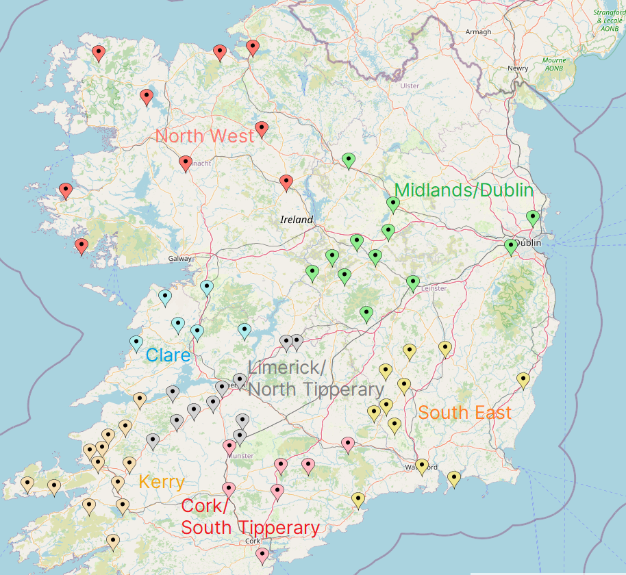
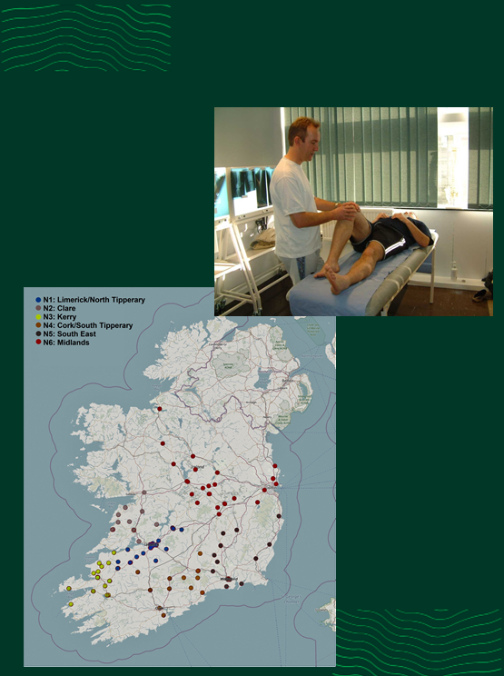
Clinical placements and parallel consulting
Clinical Placement Regulations and Organisation

With few exceptions, each student spends 18 weeks on clinical placement in a University-affiliated teaching practice, located in one of six regions. Activity in each of these regions is locally supported by a GP Network Co-ordinator whose primary role is to support practices and students and to liaise with UL and is thus your local point of contact in the event of issues arising from placements.

Students are reminded that they must not request or accept a clinical placement at any practice:
- At which they or any of their first degree relatives are registered as patients.
- At which any of their first degree relatives are members of practice staff - either
clinical or administrative.
- Which is situated within 10km of an address at which they reside or have ever resided for a period of 12 months or more (5km in Limerick, Cork, Dublin, Kilkenny and Waterford cities and not applicable to international students living here solely as a student on the BMBS programme)

The reasons for this stipulation are manifold and include:
- Avoidance of any embarrassment to patients, if asked to consult with a student to whom they are known.
- Issues of patient confidentiality.
- Facilitation of tutors in allocating patients to students.
- Consulting with patients with whom you are familiar at a personal level is never easy and is an acquired skill - which is acquired over time.
- Optimisation of learning environment - learning from and consulting with patients who are not personally known to you is considered to be more conducive to learning at this point in clinical training.

Please note that it is the sole responsibility of each student to ensure that this stipulation is complied with, if in any doubt or if any clarification is required please contact the Executive Administrator, General Practice (generalpractice@ul.ie). Any contravention of this stipulation will be viewed with the utmost seriousness and will result in a professional misconduct notification being sent to the BMBS Course Director.

The current network structure is:
- N1: Limerick/North Tipperary (GP Co-ordinators: Prof. Pat O’ Dwyer; Prof. Aidan Culhane)
- N2: Clare (GP Co-ordinator: Dr. Páraic Meaney)
- N3: Cork/South Tipperary (GP. Co-ordinator: Dr. Declan Herlihy)
- N4: Kerry (GP Co-ordinator: Dr. Ryan Say)
- N5: South East (GP Co-ordinator: Dr. John Cuddihy)
- N6: Midlands/Dublin (GP Co-ordinator: Dr. Jerry O’Flynn)
- N7: North West (GP Co-ordinator: Dr. Noreen Lineen-Curtis

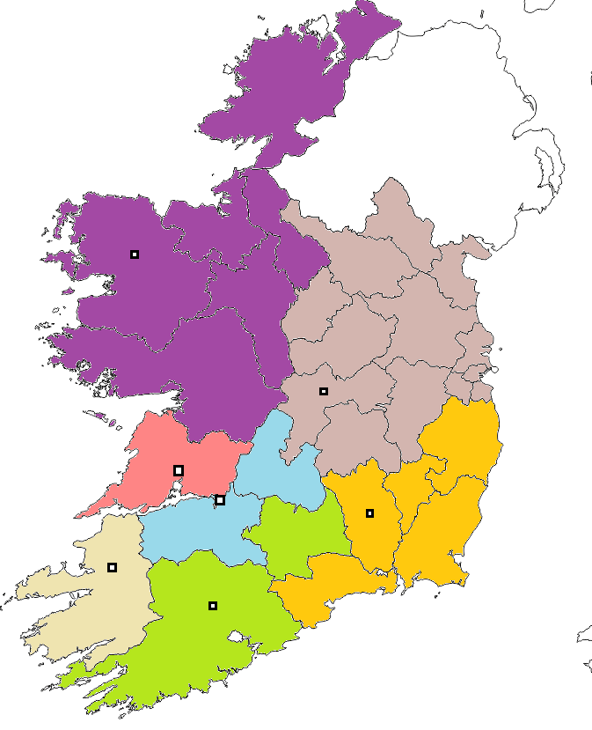
Munster Technological University Kerry, Tralee
Atlantic Technological University Mayo, Castlebar
St. Luke’s General Hospital Kilkenny
Ennis General Hospital
UL School of Medicine
Midland Regional Hospital at Tullamore
LivingHealth Clinic, Mitchelstown

GP network regions and teaching hubs as of August 2023

In advance of clinical placements, students are advised to:
- Contact the GP to whose practice they have been assigned, at least 3-4 weeks in advance of the placement commencement date.
- Send a brief letter of introduction/resume to the GP Tutor. This allows GP Tutors to see the background expertise of student and identify his/her learning needs. Appropriate information for students to forward their GP Tutor includes:
- Personal details (name, next of kin, DOB, nationality, mobile phone
number and email)
- Primary degree details
- Brief synopsis of first two years’ experience on the BMBS programme, grades obtained in Years 1 and 2 and especially whether they are repeating Year 2 exams.
- Areas where you would be keen to develop during the 18-weeks on placement
- Interests outside medicine (e.g. surfing, music, Gaelic football, hurling, literature may be important aspects of cultural life in regions where students will be on placement)
- Particular areas of interest within medicine and plans to pursue same.
- Explore accommodation either on their own or in conjunction with students who have previously been on placement in that practice.
- Visit the practice.
- Become familiar with the recommended resources and obtain at least one text and handbook.
- Introduce themselves to all members of the practice team (e.g. practice nurse, manager, admin team, GP Assistant or GP Registrar).
- Ensure that your immunisations are compliant with the School Immunisation Policy (see website) prior to entering their clinical placements. While the School does not routinely provide seasonal vaccinations, in the case of influenza vaccination students may wish to consider this option on an individual basis and seek advice from their own GP/healthcare provider. Alternatively, students should remove themselves from the clinical setting when suffering from such an illness, and provide appropriate certification in a timely manner.

In the unlikely event that the practice advises that it cannot host the placement, you must inform Kevin O’Connor (GP Placement Officer) as soon as possible.
Students are not permitted to organise their own GP placement.

Please note the following important points:

- The School reserves an absolute right to transfer any student to an alternative practice or to an alternative network hub at any time prior to or after commencement of placement.

- Students are not permitted to contact any GP tutor requesting to transfer practice. Any student who does so will be subject to disciplinary proceedings by the University.

- Please note that each student is responsible for providing their own transport to and from clinical placement sites and UL.

To help students progress through the placement, regular communication/two-way feedback between student and tutor is key. Appendix 7 contains a form to facilitate two-way feedback during General Practice placements. The Student and Tutor should complete and discuss this form at regular intervals (week 4, 8, 12).

Students on clinical placement in General Practice are not required to attend Medicine sessions on Mondays but are required to view the recordings and keep up to date with the Medicine programme.

Tutors on Annual Leave during Student Placement

Tutors occasionally take annual leave while a student is on placement.
This requires that some arrangements are put in place for students during such absences.

Students should continue with their clinical placement insofar as possible.
Some suggested arrangements include:
- Working with locum doctor – if locum is willing to facilitate the student.
- Working with another doctor in the practice – partner, sessional doctor, registrar.
- Working with practice nurse.
- Attachment to other health care professionals – PHN, Pharmacist, OT,
Physiotherapist.
- Project work –case review, literature review, audit etc.
- Extra clinical sessions in week before/after holiday.

Parallel Consulting

During the early weeks on placement the student will ‘sit in’ with the GP Tutor simply as observer. However, the foundation of this clinical placement is based on parallel consulting, where the student consults with a patient before presenting the case to the clinical tutor. Its aim is to provide opportunities for ‘experiential’ learning. While clinical responsibility for patient care will always rest with the GP, the ‘parallel consulting’ approach allows students to actively support this activity.

Parallel consulting involves students being assigned patients by the GP Tutor, consulting with this patient (clinical history taking, examination, etc.) and presenting this ‘case’ to the Tutor. See Appendix 3 for a sample case report form students can use when presenting the case to the tutor.

The primary responsibility of GP tutor remains the clinical care of the patient. The tutor will support student learning by reviewing the findings that have been presented. Students must always be aware that clinical decisions and responsibility for patient care remain exclusively within the GP tutor.

Secondary responsibilities include observing/reviewing the student’s ability to:
- Communicate with the patient
- Demonstrate a physical exam skill
- Discuss diagnosis/differential diagnosis
- Explain pathophysiology of the condition, investigations and management, relevant research in the area

Experience of this approach has demonstrated the benefits and feasibility of this approach in helping students develop clinical history taking/examination/problem solving skills. Feedback from GP Tutors suggests a step-wise approach is particularly effective in helping students progress. This involves asking students to ‘sit in’ with GPs/other members of the practice team for the first 2-3 weeks, taking histories and performing examinations under close supervision, progressing ultimately to consult in parallel with his/her GP Tutor by weeks 3 or 4.

Parallel consulting helps students learn to perform the same tasks as the GP Tutor while under their close supervision. It helps students to actively engage in the management of the full spectrum of patients that present to the practice. On a day-to-day basis, the patients to be seen by students will be selected by the GP Tutor with the consent of the patient. In principle, GP Tutors should initially direct patients with relatively stable and simple problems to the student, gradually directing more complex patients to the student as he or she progresses in competence and confidence.

Table 5 illustrates how the ‘Parallel Consulting Model’ is organised: where patients are booked to see a doctor at 15-min intervals, all patients are seen by the GP Tutor and half of all patients are seen both by the GP Tutor and by the UL student. As a matter of course, the model allows the UL student to have a one-on-one engagement with each patient, prior to the involvement of the GP Tutor. Thus, if the interaction between the GP Tutor, the UL student and the patient identifies some issues that require further exploration, the GP Tutor might delegate this responsibility to the student. For example, when a patient presents for a ‘routine’ check-up and is found to be significantly hypertensive, the GP Tutor might ask the UL student to take a full history and undertake a physical examination before the Tutor and student again review the patient.

Table 5. How the ‘Parallel Consulting’ model looks in practice:
 | GP Tutor | UL Student
09:00 | GP sees Patient A | UL student sees Patient B
09:15 |  | GP and UL student together see Patient B
09:30 | GP sees Patient C | UL student sees Patient D
09:45 |  | GP and UL student together see Patient D

While there will inevitably be some variation between practices and students as to the number and frequency of parallel consults in which students engage, our experience suggests in the region of 3-6 parallel consultations per day on average, generating 300-450 patient contacts per 18-weeks, should enable students to adequately address the module’s learning objectives.

As well as parallel consulting, other clinical activities which students and tutors find useful to promote active learning include:

- Specific clinical examinations (e.g. antenatal, diabetic review, mini mental state examination, 6-week check, etc.)
- Observation/sitting-in with other members of the clinical team (e.g. others GPs, registrars, nurses, manager, administrators, etc.)
- Active observation of experienced GPs interacting with patients
- Participate in practice based internal CME activity (e.g. practice meetings, case reviews, clinical audit, review of literature/evidence on clinical question
- Assist with procedures (e.g. vital signs, ECG, phlebotomy, immunisation, peak flow, phlebotomy, IM injection, 24hr BP monitor, INR, glucose (blood and urine), urine examination, minor surgery, family planning, cervical smears, etc.)
- Home visits
- Placement with other members of the primary care/mental health/palliative care teams
- Communication (e.g. write first draft of referral letter, review discharge summary of patient you previously encountered, phone hospital to follow up on a referral/blood/XR results)
- Accompanying a doctor from the practice on ‘out of hours’ co-operative shift.

In particular, during the clinical placement students will also have considerable exposure to diagnostic and therapeutic procedural skills – which they are encouraged to observe at first, then progressing to performing under supervision (e.g. phlebotomy, PFR measurement). Appendix 1 contains a list of such tasks/skills which Clinical Tutors/GPs could use to help monitor a student’s progress in performing common diagnostic and therapeutic procedural skills. Where applicable, students should also participate in the ‘out of hours’ services provided by the General Practice. Where a GP Co-operative provides this service, the student is expected to participate in this with their GP Tutor. Please note: if the student attends a house call without being under the direct supervision of the GP tutor, they must attend on an observational basis only (i.e. they are not permitted to perform physical exams).

We ask students at the outset of clinical attachments to be mindful they are learning in busy clinical environments and highlight the benefits of their participating in activity that can make them an active member of the clinical team (see appendix 1b).

Self-directed learning: Students have three half-day sessions per week which are protected for ‘self-directed learning’. During this time, students are advised to review ‘cases’ which they have encountered during their clinical placement, to examine and research Learning Objectives related to each case. In addition, students can review their progress by entering anonymous case summaries on a secure e-logbook. This logbook can be reviewed both by GP Tutors and UL faculty. Most students encounter at least 90% of the 48 GP conditions during their clinical attachments, although their depth of interaction is expected to develop over the course of the 18 weeks.

In cases where individual students or clinical tutors encounter difficulty with a clinical placement, they may speak with:
- Clinical Tutor
- GP Network Co-ordinator
- Clinical Liaison team members – Kevin O’Connor
- General Practice Educational Lead – Prof. Patrick O’Dwyer
- General Practice faculty – Prof. Aidan Culhane, Dr. Andrew O’Regan, Dr. Peter Hayes, Dr. Patrick O’Donnell
- Professor of General Practice – Prof. Liam Glynn

Equipment

All students are obliged to have their own diagnostic equipment (ophthalmoscope, auroscope, stethoscope, tendon hammer and pen torch). These are essential items that medical students are expected to have as outlined in your course handbook. While kits may be available where you are placed on clinical rotation, there is no guarantee of this so students should have their own equipment.

For the end of year exams, students are not required to bring their own diagnostic kits as these are available in the clinical skills lab setting. However, students are obliged to bring their own stethoscope and a watch to the clinical exams.

Liaison with Affiliated Teaching Practices and Quality Assurance

The School maintains regular contact with affiliated teaching practices and students/GP Tutors through:
- Educational workshops for GP Tutors
- Practice support visits and formal interaction with students and GP Tutors by local Teaching Network Co-ordinator
- Monitoring student feedback (and using this anonymous feedback in programme planning).
- Site visits to students at teaching hubs

Social Media

Students are reminded of the need to constantly remain aware of the inherent dangers when using social media in relation to possible breaches of patient confidentiality. Even anonymised personal or medical information regarding patients must not be posted on social media. You must remain aware that the posting online of any information relating to patients is unprofessional and contravenes both Medical Council guidelines and the School of Medicine Code of Professional Practice. You are advised to read these carefully before commencing the placement.
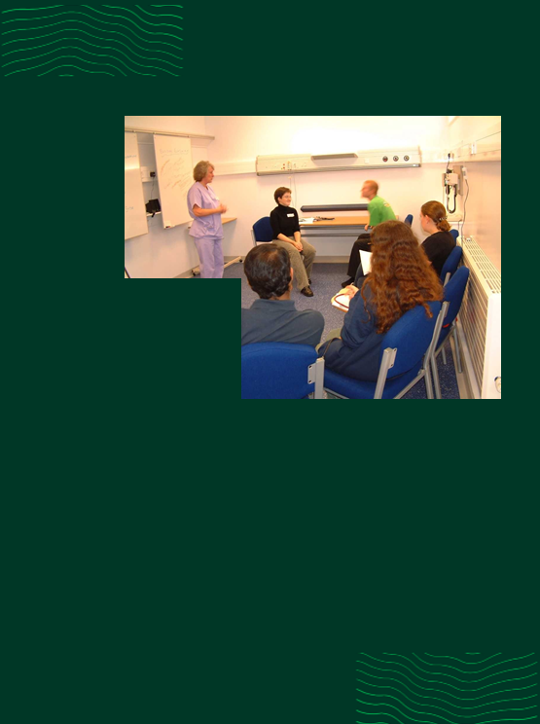
Monitoring students on clinical placement
To guide and monitor learning, students are assigned tasks and activities which should be completed during their placements.

- Prescribing workbook: While on placement you will be required to complete a workbook of prescribing scenarios. This is designed to be used in association with seminar and tutorial teaching on prescribing and therapeutics. These scenarios are designed to highlight some common and important dilemmas in relation to prescribing in general practice, and provide excellent learning opportunities based on real life clinical scenarios.

Completion of this workbook is a mandatory requirement to complete module BM4003. Completed workbooks are to be returned on completion of 15 weeks on placement.

- Electronic logbook: To ensure students encounter an appropriate range of clinical problems/conditions, they are obliged to maintain an electronic logbook of all patients with whom they have contact. This involves entering anonymised information such as subjective and objective findings on history/examination, the student’s assessment and the management plan (i.e. the ‘SOAP’ format); the anthology condition to which the cases relates and what the student learned from the encounter. Students are also asked to indicate whether their interaction was passive (e.g. observed Clinical Tutor/GP consulting) or active (e.g. took full history/performed an examination, presented case or problem list and management plan to Clinical Tutor for feedback). This logbook should be updated on a daily basis throughout the clinical placement. Data from individual students will contribute to a communal database, such that individual students will be able to compare their own clinical exposure with that of their classmates. When used properly, the logbook can be a powerful learning tool enabling reflection and professional growth.

We expect students and their Clinical Tutors to examine the logbook at regular intervals (i.e. 2-3 weeks) to ensure that the student experience is both broad (i.e. student encountered an increasingly wide range of clinical problems / conditions from the Anthology) and deep (i.e. increasingly ‘active’ interactions with patients).

During the clinical placements, students are expected to take regular detailed clinical histories for presentation to their Clinical Tutor or at case based formal teaching sessions. Appendix 3 provides a useful template to help students in this regard.

- Two way Student Feedback Form: Students and tutors are requested to complete the ‘Two Way Student/Tutor’ Feedback Form every three to four weeks throughout the clinical placement. (Appendix 7).

- Formative ITA Form: Completed at the end of 6 weeks on placement.
How students are assessed
Assessment of the General Practice/Primary Care module involves three domains, each contributing to approximately one-third of the overall mark. Students must attain a pass grade in each of these three domains.

In order to pass this module, students must achieve at least a C3 overall and a maximum score of
- 50% for the Knowledge of Health and Illness (KHI) element of the module assessment
- 50% for the Clinical Skills element of the module assessment
- 50% for the In-Training Assessment (ITA) element of the module assessment.

Table 6. Overview of assessment composition
Assessment type | Assessment description | % of total
Knowledge of Health and Illness | EMQ/MCQ written exams | 33
In-Training Assessment | Assessment during clinical placement (26% - see Appendix 4) and end of semester case presentation (8% - see Appendix 2) | 34
Long Case | Clinical exam | 33
Mini Clinical Evaluation Exercise (mini-CEX) | 3 to be completed over the entirely of Year 3 (refer to Year 3 course handbook) | Pass/Fail

Knowledge of Health and Illness exam: this is a 3-hour electronic written assessment with typically 85 multiple-choice questions/single-best-answer (MCQs/SBAs) and 11 extended matching questions (EMQs), each with five stems (so 140 items in total). The exact structure and number of questions on the exam is subject to change.

- The 6-week ITA is for formative purposes – i.e. its primary purpose is to highlight areas where students can improve during the second period of their placement. The form and its content can (and should) therefore be shared with the student. Students will not receive a numerical score on the 6-week ITA.
- Students who receive a ‘Red flag’ result on their formative ITA assessment are obliged to contact Prof. Patrick O’Dwyer for feedback on their result within 1 week of the result being posted. Failure to do so will result in a professional misconduct form being sent to the BMBS Course Director.
- Students who receive a ‘Yellow flag’ result are invited to make contact with Prof. Patrick O’Dwyer for feedback and are strongly encouraged to do so as soon as possible.
- The 18-week ITA is for summative purposes – i.e. this is counted in the end of year assessment. It is not shared with the student until final exam results have been processed and ratified by the University examination boards, after which the student will have access to all their assessment material. However, despite the fact that the mark awarded is not disclosed to the student at this time tutors are encouraged to give (and students are advised to seek) constructive detailed feedback.

In cases where students have two components to their 18-week placement, the tutor for the second period will complete the Summative ITA form. If there is a significant discrepancy between the ITA form submitted by the two supervisors, then such cases will be reviewed by Education and Assessment Lead or his nominee so that a consensus is reached on a student’s performance over the entire 18-weeks. The template summative ITA form to be used in Academic Year 2020-21 is contained in Appendix 4.

Please note that if attendance on a clinical placement, at Wednesday teaching sessions, and at Small Group Tutorials is inadequate or in any case where a student’s behaviour contravenes regulations/guidelines on professional behaviour, the Module Lead (BM4003) may at his/her absolute discretion attribute a grade of ‘Fail’ to the overall ITA score. This award of ‘Fail’ will over-ride the overall ITA score awarded by the GP Tutor.

The level of student engagement with the electronic logbook will be assessed by Module Lead (BM4003) or by his nominee and may be taken into consideration in relation to the students’ overall performance.

The Long Case Clinical Exam: Students are instructed to interview and examine a patient for a period of 30 minutes in the presence of an examiner or pair of examiners.

Students may be asked by the examiner(s) to:
- Summarise their findings
- Communicate with the patient in the presence of the examiners
- Demonstrate a physical exam skill if relevant
- Discuss their diagnosis and list of differentials
- Discuss the patho-physiology of the condition, appropriate investigations and
management, and (if time allows):
- Discuss relevant research in the area.

Students are assessed on the following competency areas:
- History
- Physical examination skills
- Presentation
- Communication skills
- Diagnostic skills
- Appropriateness of investigations
- Appropriate management
- Clinical acumen (problem identification/problem-solving ability)

The General Practice/Primary Care module is worth 24 ECTS credits which equates to 20% of the student’s overall degree award.

Assessment methods are routinely reviewed at both modular and School level and all assessment procedures and results are externally validated. The external examiner for BM4003 General Practice/Primary Care for academic year 2023/24 is Dr. Robert Scully, University of St Andrews.

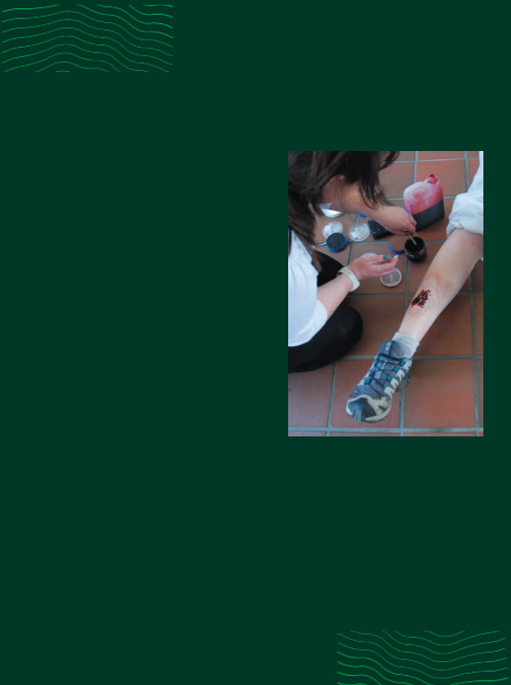
Injuries
sustained
while on
placement
All healthcare facilities should have a policy on the management of needle stick and other sharps related injuries and blood and body fluid exposure. This guideline should include:
- First aid procedure
- Immediately reporting the injury/exposure to relevant line manager
- Medical risk assessment and screening of source service user (if known)
- Medical risk assessment for post-exposure prophylaxis (PEP)
- Counselling and follow-up testing.

Examples of sharps injury / Blood and body fluid exposure:
√ Accidental inoculation of blood by a needle or other sharp*
√ Contamination of broken skin with blood
√ Splashes of blood/body fluids onto mucous membranes (e.g. mouth, eyes)
√ Human scratches/bites (where blood is drawn)

Sharps may include:
- Needles
- Scalpels
- Sharps tips of IV sets
- Contaminated slides
- Stitch cutters
- Guide wires
- Razors
- Blood stained/contaminated glass

Management of Sharps Injury and Blood and Body Fluid Exposure:
Immediate action should be taken following sharps injury and/or blood and body
fluid exposure. The following procedure should occur in the event of exposure:
• Encourage bleeding from the wound
• Wash the wound in running water, do not scrub
• Cover the wound with a dressing
• Skin, eyes, mouth – wash in plenty of water
• Ensure the sharp is disposed of safely
• Report incident immediately to GP Tutor and GP Co-ordinator.
• Complete an incident report form as per local policy
• The injured person should attend either the occupational health service or their
ED department for prompt risk assessment. Urgent treatment may be required for high risk injures (PEP).

Research opportunities in General Practice
We would encourage any students to consider the opportunity to carry out high quality research as part of their General Practice placement, especially those considering a career in General Practice or Family Medicine.

As General Practice in Ireland uses Electronic Medical Records (EMRs) for patients nearly universally on this placement, students have access to the EMRs of many thousands of patients and this data access can enable high quality research to be carried out.

The Professional Competencies modules have two research related assignments, one in Year 3 and the other in the summer at the start of Year 4. These assignments can be linked to the same project to allow students to carry out a meaningful piece of research in General Practice over the course of Year 3 and 4.

Recommended resources for students
Texts

- ‘Anthology of Medical Conditions’ published by the Australian Medical Council. ISBN: 1875440 28 3
- Murtagh J. General Practice 3rd edn. Sydney: McGraw-Hill; 2003. ISBN 0074711776. (2007 edition)
- ‘Practical General Practice’ by Khot and Polmear, (Butterworth and Heinemann)
- Talley NJ, O’Connor S. Clinical examination: a systematic guide to physical diagnosis. 4th edn. Sydney: MacLennan and Petty; 2001. ISBN 0864331444
- Oxford Handbook of General Practice (Oxford Handbooks Series) by Chantal Simon, Hazel Everitt, and Tony Kendrick
- John Murtagh’s ‘General Practice Companion Handbook’, by John Murtagh (McGraw Hill).
- Textbook of Family Medicine, by Ian R McWhinney, Publication Date: April 8, 2009, ISBN-10: 0195369858, Edition: 3
- The Clinical Skills Text Book ‘Clinical Skills’, Second Edition, Edited by T. A. Roper 978- 0-19-957492-6 | Paperback | 16 January 2014; Also available as: eBook
- 100 Cases in Clinical Pharmacology, Therapeutics and Prescribing 1st Edition by Layne and Ferro, 1st edition

Online Resources/General Points of Reference

- Health Service Executive
- Department of Health
- Health Protection Surveillance Centre
- World Health Organization
- European Centre for Disease Prevention and Control
- Irish College of General Practitioners
- GP Notebook
- US National Library of Medicine
- European Society of Cardiology
- Pre-Hospital Emergency Care Council
- NICE Clinical Guidelines
- SIGN Scottish Intercollegiate Guidelines Network
- College of Family Physicians of Canada
- Canadian Family Physician
- Australian Family Physician
- Cochrane Library
- Medscape
- St. George’s University London Clinical Skills Online Videos/Resources
- Toronto Notes
- COVID-19 Student Resources
- Emory University COVID-19 Elective
- Principles of Disaster Preparedness & Infectious Disease Outbreaks (University of Minnesota)

Medical Apps

Category | App name | Description
Calculators | Archimedes | Over 150 medical tools
 | Medical Calculator | Risk calculator
 | Medical Observer Mobile Dr | Risk and screening calculator
Medical reference | Skyscape | Clinical decision-making support tool
 | Outlines in Clinical Medicine | Evidence based summaries on 850 Family practice/internal medicine topics
 | Medical Encyclopedia app | University of Maryland
Therapeutics | RxDrugs | Formulary information on 1,000s of drugs
 | Epocrates | Formulary info and drug interactions
Research | MedAlert | Regular updates on clinical trials
 | PubMed On Tap Lite | Find and display reference information
 | New England Journal of Medicine app | Results of trials and review articles
Paediatrics | STAT Growth Charts Lite | Centile chart plotting
Psychiatry | Clinical Scales | Screening and clinical tools such as CAGE etc
Anatomy | Human Anatomy | Quick reference app on 16 biological systems
Clinical skills | Clinical skills | History, exam, basic ECG
Ophthalmology | Eye emergency manual | Summaries on most common eye presentations
Simulation | Prognosis: Your Diagnosis | Medical Cases simulation game

Journals

- British Journal of General Practice (access via Glucksman Library)
- British Medical Journal (access via Glucksman Library)
- JAMA (access via Glucksman Library)
- Biomedical Central Family Medicine (access via Glucksman Library)
- Oxford Family Practice (access via Glucksman Library)
- PubMed (open access)
- Trip Database (open access)

Prescribing Resources

- Medicines.ie (open access)
- BNF (access via Glucksman Library)
- HSE Antibiotic Prescribing (open access)
- Up to Date Prescribing (access via Glucksman Library)

Other Useful Links

Patient Orientated
Patient.co.uk | Patient information leaflets | www.patient.co.uk/
Asthma Society of Ireland | Videos on inhaler technique and practical advice on asthma | www.asthmasociety.ie/
Emergencies in the Community
Pre Hospital Emergency care council | Clinical guidelines and info on medications | http://www.phecit.ie/
Public Health
Health Protection Surveillance Centre | Public health and infectious diseases | http://www.hpsc.ie/
Dermatology
Dermnet | Open access encyclopedia of dermatology | http://www.dermnetnz.org/
Mental Health
Reach out | Webpage for young adults | www.reachout.com/
Aware | Webpage for adults with depression | www.aware.ie/
Grow | Mental health and personal growth | www.grow.ie/

Appendices

Appendix 1A - Checklist of ‘procedural skills’ which students are expected to commonly encounter during clinical placements

Can your student… | Has observed procedure / examination | Has performed under supervision
Intramuscular injection
Paediatric centiles
BP / ABI
PNS examination
ENT exam
Phlebotomy
Demonstrate inhaler technique to patient
Peak expiratory flow
Nebuliser
Paediatric developmental exam
Antenatal examination
Cervical smear
ECG
Fundoscopy with an ophthalmoscope
Urinalysis / pregnancy test
Glucometer
Use a pen torch
Oxygen / face mask
Repeat / acute prescription
Referral letter

Note: Clinical Tutors/GPs could use this checklist to help monitor a student’s progress in performing common diagnostic and procedural skills.

Appendix 1B – Tasks which make students feel an active part of the clinical team

- Assist with diagnostic procedures (phlebotomy, ECG, 24h ABPM, eye tests, MMSE)
- Assist with therapeutic/preventative procedures (dressings, immunisations)
- Perform a clinical audit of relevance to, and in collaboration with, the practice
- Visit other community care providers (nursing home, pharmacy, PHN)
- Help with chronic disease management/preventative health (Heartwatch, Diabetes, COPD, Antenatal/Postnatal Care, developmental assessment)
- Routinely perform observations/vital signs on every patient before consultation with GP
- Attend team meetings (practice, PCT)
- Participate in ‘special clinics’ (diabetes, leg ulcers)
- Assist with electronic information management (e.g. disease coding, clinical record keeping, repeat prescribing, referral letter writing)
- Triage of ‘walk-in’ cases
- Spend time with other clinical teams (e.g. psychiatry)
- Assist with other information management (screen post, blood results)
- Sourcing clinical information as part of on-going patient care (e.g. hospital OPD appointments, results etc.)
- Student delivers the tutorial!

Appendix 2 – End of Semester Case Presentations

Aim: The overall aim of this educational activity is to provide students with an opportunity to deepen their understanding of chronic illnesses, particularly in relation to the presentation and management of common chronic illness in the General Practice Primary Care setting.

Objectives: At the end of this educational activity students will:
- Be able to recognise the presenting clinical symptoms and signs of common chronic illness in General Practice and have a deep understanding of the nuances of their presentation.
- Have an up to date knowledge of the management of common chronic illness in general practice.
- Be able to compare the General Practice approach to managing chronic illness with the hospital approach to managing of chronic illness.
- Deepen their understanding of the different impacts that chronic illness has on the patients.

Presentation Format:
- Students are assigned to groups by the GP academic team and each group will be given a specific system from which they can then select a clinical case for presentation.
- Each group is asked to prepare and give a presentation which describes the case and outline the key issues in management:
- Each presentation will last for a maximum of 15 minutes, followed by 10 minutes for Q+A (Total time allocated: 25 minutes)
- The presentations will take place on a Wednesday.
- Note: this exercise is to conform to a case presentation linked to a specific patient and not a lecture on a specific clinical condition

Attendance is compulsory.

Presentation should involve a patient with disease(s) from following physiological system:
- Metabolic / Endocrine
- Neurological
- Psychological
- Cardiovascular
- Respiratory
- Gastrointestinal
- Musculoskeletal
- Dermatological

Marks will be allocated out of 100 using the following mark sheet:
BM4003 End of Semester Case Presentations
Group Number:
Group Topic:

Please circle the appropriate rating box to award your mark and provide comments on the group’s achievement in each of the general categories below.

Examiner (please sign): __________________________________

PRESENTATION:
VISUAL AIDS (overheads/powerpoint: clearly well used) : 10  Comments: | 0 | 1 | 2 | 3
 | 4 | 5 | 6 | 7
 | 8 | 9 | 10
PACING (speech clear, not too fast or slow, content delivered evenly): /10  Comments: | 0 | 1 | 2 | 3
 | 4 | 5 | 6 | 7
 | 8 | 9 | 10
ENGAGING (good use of eye contact, smiling, mannerisms): /10  Comments: | 0 | 1 | 2 | 3
 | 4 | 5 | 6 | 7
 | 8 | 9 | 10
CONTENT:
OBJECTIVES (clearly stated): /10  Comments: | 0 | 1 | 2 | 3
 | 4 | 5 | 6 | 7
 | 8 | 9 | 10
CLEAR EXPLANATION: /10  Comments: | 0 | 1 | 2 | 3
 | 4 | 5 | 6 | 7
 | 8 | 9 | 10
STRUCTURE: /10  Comments: | 0 | 1 | 2 | 3
 | 4 | 5 | 6 | 7
 | 8 | 9 | 10
ACADEMIC CONTENT (background reading and in-depth knowledge): /40  Comments: | 0 | 5 | 10 | 15
 | 20 | 25 | 30 | 35
 | 40
Appendix 3 – Case Report Template

Students are encouraged to use this template when preparing a case for presentation to their Clinical Tutor/GP or at formal teaching sessions (Wednesday mornings).

Initial visit:
Student’s name: | GP tutor’s name: | Date:
Patient initials: | Age: | Gender:
Relevant history:

Relevant physical signs:

How was patient diagnosed with illness?

Management of Illness:
A. Medical management/Surgical management

B. Other management (self-care - lifestyle changes, physiotherapy, diets, etc.)

Current management:

What do you consider a priority in the future care of this person?

Subsequent visits:
Any new information (clinical / non-clinical)

Contacts with GP in the past year (visits to surgery, house calls etc.)

Non-clinical effects of illness (e.g. effect on family, housing, occupation, work, etc.)

Contact with community services (public health nurse, social worker, meals on wheels, etc.)

Appendix 4 – Summative In-Training Assessment (ITA) Mark Scheme
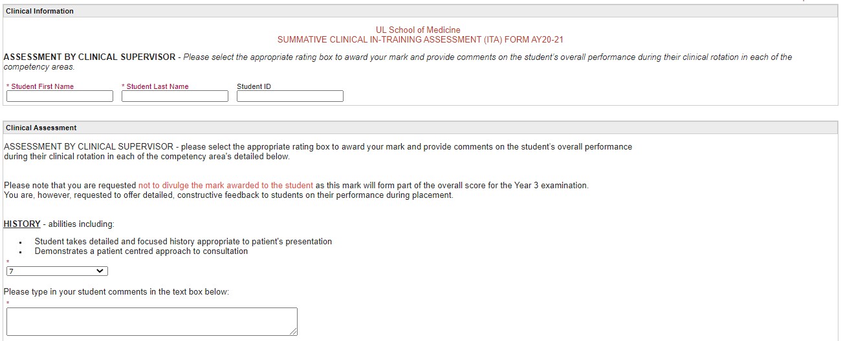
These boxes show the maximum mark (expressed as a percentage of the entire module) that can be allocated to each domain
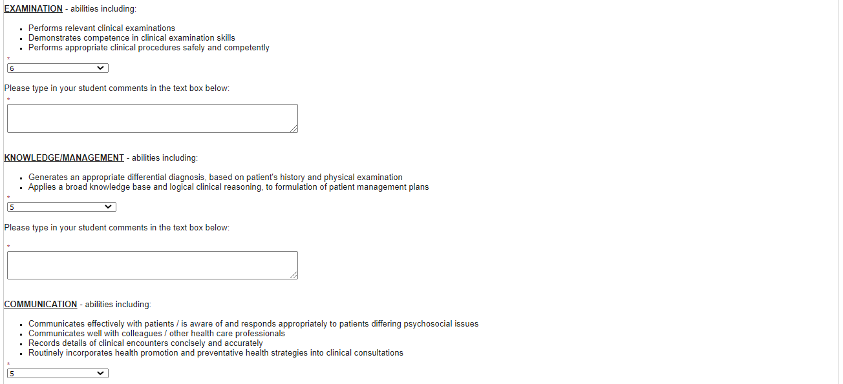
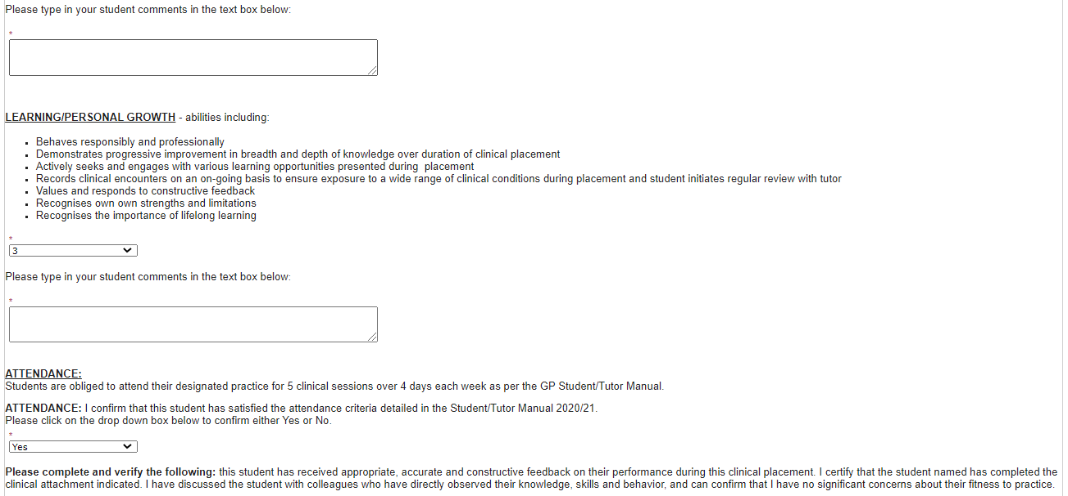
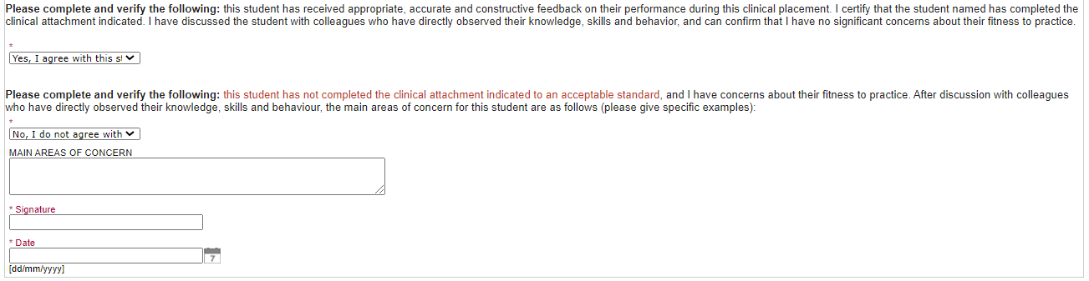
Appendix 5 – What GP Tutors have found works in helping students achieve their goals

- To orientate the student to the practice (and vice versa):
  - Explain to practice colleagues (especially manager/secretaries/nurses) the reasons for having a student and their role at the outset.
  - Make patients aware that there is a medical student in the practice through the use of practice notices/practice leaflets and that engagement with medical students is on a voluntary basis.
  - In the first week, ask the student to spend some time with each member of the practice team and as an exercise to write a descriptive account of each person’s role and of the services the practice offers.
  - Consider taking a student for longer attachments: many GPs find longer attachments easier for the practice, especially as orientation/induction usually form the focus of the attachment’s first few weeks. Students really develop in confidence after nine weeks on attachment and in the second nine weeks the practice may see a ‘return’ on the time they have invested in the student.

- To enhance students’ consultation/communication skills:
  - Developing history taking and clinical examination skills should be the foundation of a medical student’s clinical attachments.
  - ‘Parallel consulting’ is a very powerful mechanism by which students can develop these key skills. ‘Productive diversion’ (GP asks student to carry out a task while they conduct other consultations) is a useful variant.
  - As well as parallel consulting, observation (student observing or being observed) is a valuable learning experience. Good examples are:
    - ‘Hot seating’, where the GP asks the student to carry out part of the consultation under their supervision.
    - ‘Directed observation’, where the GP asks the student to observe one aspect of a consultation is another.
  - Consider video-recording students while consulting (if both practice technology permits and a protocol for giving information and obtaining patient consent is in place).
  - Frequently remind students to ‘just listen to what the patient is saying’.
  - Suggest students take histories alone from a series of patients and for each history, formulate patient problem lists, outline potential diagnoses and prioritise problem lists.
  - ‘Why is this patient here today?’, ‘how do psychosocial issues impact on patients?’ are key learning outcomes for students when in General Practice.
  - For difficult cases/dilemmas, don’t be afraid to ask the student what they would do…and why. Doctors are frequently surprised by a student’s ability to elicit a new piece of information or discuss an issue which they have found challenging.

- To enhance students’ ability to work as part of a team/with colleagues and to understand how the healthcare system works:
- Consider arranging attachments with colleagues within and outside the practice (e.g. Primary Care team members).
- Ask students to assist with procedures (e.g. phlebotomy, ECG, minor surgery etc.) if these are happening in the practice.
- Involve the student in activity that may appear to have an organisational or administrative focus. Reading the post, reviewing laboratory/diagnostic imaging results, taking telephone calls, drafting referral letters (under supervision) are examples of activity which students both enjoyable and educational.
- Visits to patients’ homes, the local ‘out of hours co-operative’, nursing homes, district hospital, factories, community residential services are extremely valuable learning experiences for students. Please note: if the student attends a house call without being under the direct supervision of the GP tutor, they must attend on an observational basis only (i.e. they are not permitted to perform physical exams).

- To enhance students critical analysis, problem solving, self-directed learning and presentation skills:
  - Students can teach us: Ask the student to teach you/your colleagues something that they have studied during a weekly staff meeting, CME session etc.
  - Don’t be afraid to give the student homework.
  - Encourage students to keep a logbook to guide their learning (but remind them of the importance of its entries remaining anonymous).
  - While students like tutorials, these should be both driven by what has been encountered in practice and should involve the student preparing material for discussion.
  - ‘Hot review’ (teacher and learner reflect on a recent case or experience) and ‘educational prescriptions’ (teacher asks learner to carry out a specific task for some time in the future) are good examples of this ‘just in time learning’ which clearly links autonomous learning with clinical experience.
  - Asking students to share this information with you at regular intervals will help you (both) to monitor progress.

- And finally, all that counts in medical education, as in General Practice, cannot be counted. Be prepared for the unexpected!
  - Students (and the relationship with colleagues in the local medical school) can bring a new focus to your work and that of your colleagues.
  - The considerable ‘role modelling’ is a key experience for students, especially during longer attachments.
  - Help the student to appreciate there are many aspects of General Practice which can neither be taught nor clearly expressed as ‘learning outcomes’.

Appendix 6 - Template to enable two-way feedback between tutor and student

Clinical Placement in General Practice
TWO-WAY (STUDENT/TUTOR) FEEDBACK FORM

Regular communication between student and tutor is key to successful placements. This form is to facilitate feedback during clinical placements in General Practice. The Student and Tutor should complete and discuss this form at regular intervals (week 4, 8, 12). The purpose of this form is to identify activities which will help student learning and should remain in the practice for exclusive use by the student and tutor only. NB: This form is not intended to replace the Formative or Summative In-Training Assessment forms.

Part A: For completion by the student:
At this stage of your clinical placement how would you rate your exposure to the following: | Too little | Just right | Too much
Learning by Observation
Parallel consulting
Opportunistic teaching (e.g. on the spot teaching, observed examinations, case studies)
Number of patients seen daily
Time spent in private study in the practice (examining case files, blood results etc.)
Placement with other Primary Care services (e.g. PHN, Physio, Pharmacy etc.)
Practical procedures (e.g. immunisations, phlebotomy, ECG, nebulisers, etc.)
Opportunity to talk with/examine patients unobserved
Encounter various medical conditions (as recommended in the Anthology)

Give three examples of educational activity/teaching that you found of value:
Part B: For Completion by Tutor:
At this stage of your clinical placement how would you rate your student’s engagement with the following learning activities: | Too little | Just right | Too much
Learning by Observation
Parallel consulting
Opportunistic learning activities (e.g. on the spot teaching, observed examinations, case studies)
Number of patients seen daily
Time spent in private study in the practice (e.g. examining case files, reviewing blood results, etc.)
Involvement with other Primary Care services (e.g. PHN, Physio, Pharmacy etc.)
Practical procedures (e.g. immunisations, phlebotomy, ECG, nebulisers, etc.)
Opportunity to talk with / examine patients unobserved
Encounter a broad range of medical conditions (as recommended in the Anthology)

Give three examples of student’s educational activity/learning that you found of value:

Part C: For Completion by Student and Tutor:
Agreed three priority activities for the next three weeks:

Week (please circle): 4 8 12
Student:

Tutor:

Date:
Appendix 7 – Anthology of Medical Conditions

002 Abdominal Mass  003 Abdominal Pain  006 Abnormal serum lipids  012 Anaemia  018 Burns  019 Cardiac Arrest / Respiratory Arrest  020 Chest discomfort  024 Dementia/memory disturbances  027 Diarrhoea / Constipation  028 Diplopia  029 Dizziness / Vertigo  030 Dying Patient  031 Dysphagia  032 Dyspnoea / Cough / Prevention of Cancers / Chronic Respiratory Diseases  033 Ear Pain  035 Eye Redness  037 Falls  038 Fatigue  040 Fever and Chills  046 Headache  053 Hyperglycaemia / Diabetes Mellitus  054 Hypertension  056 Insomnia / Sleep Disorders / Sleep Apnoea  059 Joint Pain, Mono-articular (Acute, Chronic)  060 Joint Pain, Poly-articular (Acute, Chronic)  065 Mood Disorders | 071 Painful Limb  073 Panic and Anxiety  077 Periodic Health Examination / Growth and Development  081 Pregnancy  082 Contraception / Pregnancy Prevention / Termination  089 Regional Pain  092 Rhinorrhoea / Sore Throat  093 Scrotal Mass  094 Scrotal Pain, Acute  100 Skin and Subcutaneous Lesions  101 Skin Blisters – Boils – Comedones – Ulcers  102 Skin Rash / Dermatitis  103 Speech and Language  Abnormalities / Dysphonia / Hoarseness  107 Substance Abuse / Addiction  114 Urinary Frequency  118 Vaginal Discharge / Urinary Symptoms, Vulvar Lesions, Sexually Transmitted Diseases  119 Violence / Aggression and Mental Illness  124 Weight Gain / Obesity  129 Deformities / Malformations  130 Travel Medicine and Tropical Infections  131 Medical Emergencies

Appendix 8 – Important dates to note
Week | Activity
1 | GP Orientation (in-person, UL Campus)
2
3
4 | Students should now be parallel consulting with patients on their own
5
6 | Tutors to complete formative ITA in presence of student; student should use this to seek constructive feedback on areas for improvement/plan for remaining 12 weeks
7
8 | PPI Exam
9 | MSK Workshop (UL Campus)
10 | MSK Workshop (UL Campus)
11
12
13
14 | Group Case Presentations (worth 8% of module grade, UL campus)
15
16 | Reminder: Mini-CEX– if completing one of the three assignments in GP, get it filled out before end of placement
17 | Submit GP prescribing workbook assignment (via Brightspace)
18 | Tutors to submit summative ITA to School (this result is not shared with student until release of results in June following exam board ratification)

*Note: all the above information was correct at time of publication (August 2023) but is subject to change

ul.ie/medicine

Where two practices agree to host a student placement for nine weeks each by mutual agreement and approved by the School.

