Recording and Upload Options – Using Panopto Capture Tool
Panopto Capture allows a user to easily record audio, video, and entire screens, or application
windows. A user can access Panopto Capture from directly within their browser, and no
download is required.
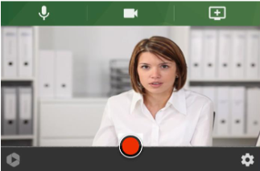
Figure 1 Panopto Capture Tool
Full details on how to use Panopto Capture are available at this link:
https://support.panopto.com/s/article/How-to-Create-a-Video-Using-Panopto-Capture

