Academic year 2023/2024

FACT SHEET
STUDY AT EIGSI
WITHIN AN EXCHANGE PROGRAMME

Name of the institution | EIGSI La Rochelle-Casablanca
(European) University code  Erasmus University charter  PIC Code (Erasmus +) | F LA-ROCH09  68237-LA-1-2014-1-FR-E4AKA1-ECHE  994700081
Website | www.eigsi.fr - www.eigsi.fr/?lang=en (exchange students)

Address  International Relations Office | 26 rue de vaux de Foletier  17041 LA ROCHELLE Cedex 1 - FRANCE
Head of the office | Ms Hannelore GUERRAND – mobility@eigsi.fr
Incoming students | mobility@eigsi.fr  Phone: +33 5 46 45 80 09

  - ADMISSION PROCEDURE
1. The Home Institution nominates the students to EIGSI - mobility@eigsi.fr
2. The Home Institution or the students send the application documents - mobility@eigsi.fr
3. The decision on your application will be communicated within 2 weeks after the application deadline.

  - NOMINATION: Deadlines and procedures
For Universities :
The home university sends an email with the name and email address of selected students to mobility@eigsi.fr
DEADLINE FOR NOMINATION | DEADLINE FOR APPLICATION DOCUMENTS
Fall semester – 15 May | Fall semester – 31 May
Spring semester – 13 October | Spring semester – 31 October

For Students:
Nominated students apply for admission by sending an email with the following documents :
- Application form – Link google form → INCOMING 23-24 - STUDENTS REGISTRATION
In the google form the following documents are requested:
- Curriculum vitae
- Transcript of records
- Copy of ID card or passport
- Photograph (passport size)
- English test proficiency (official certificate): B2 Level – mandatory
- French test Proficiency (letter from a French teacher): A2 level - minimum recommended for daily life

Concerning the learning agreement:
- Learning agreement Typewritten - for non-Erasmus+ Students
- Online Learning Agreement for Erasmus+ Students : https://learning-agreement.eu/

(for approval of the study programme, a learning agreement with the courses selected and the number of credits needs to be sent and signed by students, their home institution and EIGSI before the exchange period starts.)
  - ACADEMIC CALENDAR 2023-2024
LA ROCHELLE CAMPUS
Autumn Semester – S7 - 4th year Spring semester – S8 – 4th year
Semester in English : GEP Semester in French : Core programme and/or Major
Beginning of term Core Programme: First week January 2024
Beginning of term: 01 Sept. 2023 Beginning of term Major: 27/02/2024
End of term: 22 Dec.2023 End of term: Mid May 2024
Exam period: continuous assessment+ week 50 Exam period: continuous assessment + week 19
Semester break: weeks 44/2023 Semester break: week 7 (only if all academic unit validated)

CASABLANCA CAMPUS
Autumn Semester – S7 - 4th year Spring semester – S8 – 4th year
Semester in French: GEP Semester in French: Core programme and/or Major
Beginning of term: 04/09/2023 Beginning of term Core Programme: 02/01/2024
End of term: End/12/2023 Beginning of term Major: 27/02/2024
End of term: Mid May /2024
Exam period: continuous + week 50 Exam period: continuous + week 19
Semester break: none Semester break: week 7 (only if all academic units validated)

  - ACADEMIC INFORMATION
FIELD OF STUDY:
  - 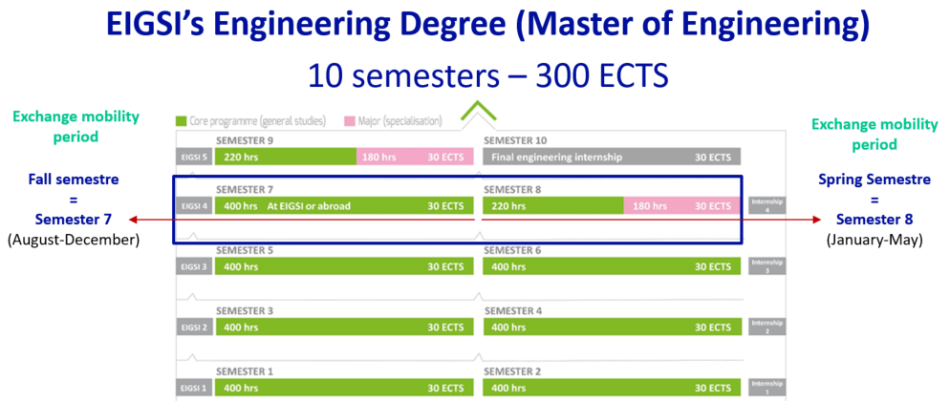

  - Students have the choice between several programmes offered during the 4th year of Engineering degree (equiv. Second cycle / 1st year of Master’s degree or equivalent).

  - A full-time workload amounts to 60 ECTS credits per academic year.
Each Academic Unit (or Teaching Unit) includes several modules.
Validation of one Academic Unit (A.U) is granted if the weighted average of modules of this A.U. is greater than or equal to 10/20.

One semester exchange:

Fall semester – from September to December (semester 7)
- Global Engineering Programme GEP - in English
- 100 % Courses taught in English with 2 options Data Science or Mechanical & Energy Engineering
- French as Foreign Language course
- The student must take a minimum of 2 Academic Units - Courses of an academic unit cannot be divided.

- Research Project - in English
Main Areas of Research: Mobility (Intelligent and Integrated Mobility) and Energy (Energy and Sustainable Urban Coastal development)
- Electrical Vehicle & Batteries
- Alternative Energy Sources, storage & transport
- Sustainable Design in Research and Development of Product
- Industrial Processes & Organization
- Transport and Urban Mobility

Spring Semester – from January to May (semester 8)
- Core programme
- Courses taught in French
- Courses of an academic unit cannot be divided.

- 1 Major
- 10 majors taught in French
- 1 Major taught in English => “Industrial performance”
- 1 Major = 15 ECTS – it cannot be divided. The student must take all the courses.

- Research Project - in English
Main Areas of Research: Mobility (Intelligent and Integrated Mobility) and Energy (Energy and Sustainable Urban development)
- Electrical Vehicle & Batteries
- Alternative Energy Sources, storage & transport
- Sustainable Design in Research and Development of Product
- Industrial Processes & Organization
- Transport and Urban Mobility

One academic year exchange:
Fall semester – from August to December (semester 7) + Spring Semester – from January to May (semester 8)

- Courses taught in English (S7) and mostly in French (S8), except projects and the major “Industrial performance” in English (S8)!

Limited number of places for the majors

  - LIST OF COURSES
ENGLISH COURSES CATALOGUE

EIGSI La Rochelle Campus – France

Language requirements:
B1 level in English + A2 level in French (recommended for all day life)

Fall semester (Semester 7 – 4th year)
- Global Engineering Programme – in English
SEMESTRE 7 | MODULES | COEF / ETCS
ACADEMIC UNIT (A.U) |  | Coef / MODULE | Credits / A.U
1 - ORGANISING & MANAGING | Business Game | 1 | 6
 | Corporate Finance | 2
 | Company Management | 2
 | International Project | 1
2 - INDUSTRIAL ENGINEERING | Risk management | 2 | 6
 | Operating reliability | 1
 | 6 SIGMA Project | 3
3 - PROJECT | Company Challenge | 5 | 5
4 - LANGUAGES & HUMANITIES | French as foreign Language (INCOMING) | 2 | 5
 | Cross-cultural Awareness | 2
 | Diversity management | 1
5 - OPTION 1 - DATA SCIENCE | Data Visualization | 3 | 8
 | Multicriteria Optimization and Goal Programming | 2
 | Information Systems | 3
5 - OPTION 2 - MECHANICAL & ENERGY ENGINEERING | Computational Methods in Mechanics | 3 | 8
 | Heat Transfer | 3
 | Mechanical Vibrations | 2

Spring semester (Semester 8 – 4th year)
- 1 Specialization (major)
- Industrial Performance (in French or in English)

One academic unit cannot be divided. The student must take all the courses of a same academic unit.

Semester 7 or 8 – 4th year (Fall or Spring semester)
- Research Projects
At EIGSI, research is organised around two strands:
  - Mobility (Smart and Integrated Mobility)
  - Energy (Energy and Sustainable Urban Coastal Development)
https://www.eigsi.fr/engineering-school-france-research/research-at-eigsi-2/?lang=en
Should you be interested in other subject areas, please do not hesitated to contact us.
FRENCH COURSES CATALOGUE

Language requirements:
B1 level in French (mandatory)

Campus EIGSI Casablanca - Morocco
Fall semester (Semester 7 – 4th year)
- Global Engineering Programme – in French

Spring semester (Semester 8 – 4th year)
- Specialization (major) – 15 ECTS
- Construction & Public Works (in French)
- Supply Chain Management and International Transport (in French)
- Artificial Intelligence and Big Data (in French)

Campus EIGSI La Rochelle – France
Spring semester (Semester 8 – 4th year)
- Specialization (major) – 15 ECTS
- Mechanical Design & Industrialization (in French)
- Industrial Performance (in French or in English)
- Energy & Environment – Sustainable Housing or Sustainable Mobility Option (in French)
- Network Architecture & Information Systems (in French)
- Mechatronics (in French)
- Industry 4.0 (in French)
- Green Computing (new in 2022) (in French)
- Health Care Systems Engineering (new in 2022) (in French)

Campus EIGSI La Rochelle – France & Campus EIGSI Casablanca -Morocco
Spring semester (Semester 8 – 4th year)
- Core programme
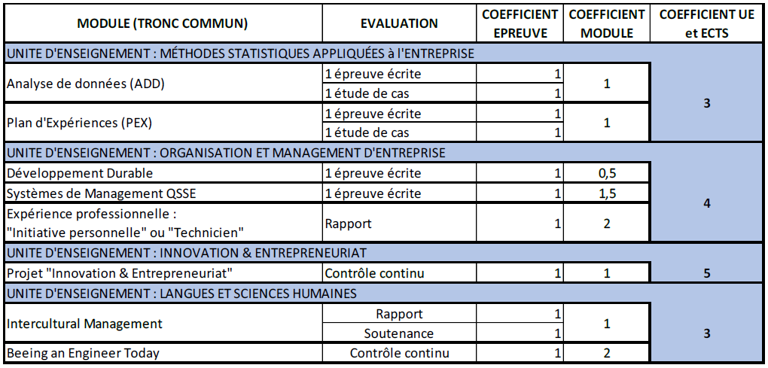

One academic unit cannot be divided. The student must take all the courses of a same academic unit.

PRACTICAL INFORMATION

ACCOMMODATION
EIGSI does not offer housing for exchange students but provides information and a list of external accommodations.
Useful address :
All the information related to accommodation in La Rochelle is available on the school website:
https://www.eigsi.fr/campus-life/accomodation/?lang=en
Contact:
Housing department - Phone. +33 5 46 45 80 05 – email : logement@eigsi.fr

STUDENTS FROM A COUNTRY WITHIN THE EUROPEAN UNION
VISA
Resident permit
Students from a country within the European Union do not need residency permits but must have a valid ID Card and/or passport

INSURANCE
Students Social Security
They are exempted from registration with the general national healthcare system through the Caisse d’Assurance Maladie website as long as they hold either a European health insurance card (or temporary certificate) and an international private insurance valid for the entire academic year.

Students should send social security documents to the International Relations Department by email at mobility@eigsi.fr once accepted:
- Copy of the European Health Insurance Card (EHIC - CEAM in French) - Compulsory
- Proof of coverage by a conventional healthcare system or private insurance, translated into French or English.

Students without European Health Insurance Card (EHIC) must be registered with the general national healthcare system through the Caisse d’Assurance Maladie website.

Additional insurance

All students are required to take out civil liability insurance.
This insurance is included in renter's insurance, but the coverage is very limited. It is preferable to take out a more complete policy through the “vie étudiante” insurance.

STUDENTS FROM A COUNTRY OUTSIDE THE EUROPEAN UNION
VISA
Resident permit
International students from a country outside the European Union must have a long stay visa.
A pre-registration certificate is provided at the start of Campus France procedures.

The procedure to validate their residence permit must be made ONLINE within 3 months at the latest after their arrival; They must have a personal postal address in France and a French bankcard (the opening of a bank account will be done on their arrival. This validation is essential to stay in France on a regular basis.

The visa is usually valid for one year.

Office Français de l’Immigration et de l’Intégration (OFII - French Immigration Office):
Immediately upon arrival at EIGSI, and also within 3 months after their arrival, students will carry out procedures required by OFII, pay the tax online (tax of 1st issue: 50 €) and validate their Long Stay Visa.
This is done on the validation website: https://administration-etrangers-en-france.interieur.gouv.fr/particuliers/#/
Online payment by Credit card (visa/Mastercard)

After payment of the fee, the visa will be validated. A certificate will be sent by email.
Students must keep this certificate carefully. It will be necessary for the procedures of registering for Social Security (CPAM), application for housing benefits (CAF) and renewal of residence permit.

INSURANCE
Students Social Security

Students from a country outside the European Union must be registered with the general national healthcare system through the Caisse d’Assurance Maladie website.
This registration is free of charge.
This affiliation only covers part of the health costs (up to 70%). Some expenses are not covered: hospitalization, optical and dental expenses.

Their birth certificate translated into French is necessary to complete these procedures (Social security, CAF..)

Exception: Quebec
Presentation of a valid form SE 401 Q 106 exempts students from registering with French social security.
Students who come to EIGSI for less than 3 months are not covered by the student health insurance plan. Therefore, they must take out insurance in their home country that is valid in France.

“Mutuelle” : Additional healthcare and insurance

All students are required to take out civil liability insurance.
This insurance is included in renter's insurance, but the coverage is very limited. It is preferable to take out a more complete policy through the “vie étudiante” insurance.

The mandatory state insurance does not cover all healthcare costs. Only 70 to 80% of medical costs are covered. Hospitalisation costs, dental care and optical costs are not covered and are very expensive.

In addition, students must take out civil liability insurance. This insurance underwritten in the framework of an insurance company is very limited. It is better to subscribe to a student life insurance, which is more beneficial.

EIGSI also has an agreement with a healthcare insurance provider for students, SMERRA, for 2 Packs Santé.

  - ESTIMATED COST OF LIVING
The budget of a student in La Rochelle is around € 850 per month.

Example of monthly budget in Euros €
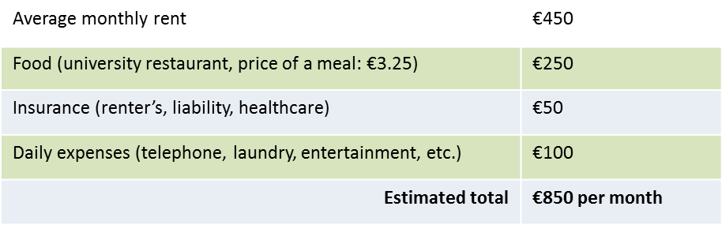
  - LA ROCHELLE ACCESS
Population of the city: 80,000 residents (174,000 including the surrounding areas) - prefecture of the Charente-Maritime department.
The town is located on the Atlantic coast.
Weather: Temperate and humid, it is mild in winter and cool in summer.
Activities : cinemas, theaters, concerts, festivals, sports, water sports, aquarium
More information : http://www.larochelle-tourisme.com/
https://www.eigsi.fr/campus-life/rochelle-beautiful-and-rebellious/?lang=en

Getting to EIGSI :

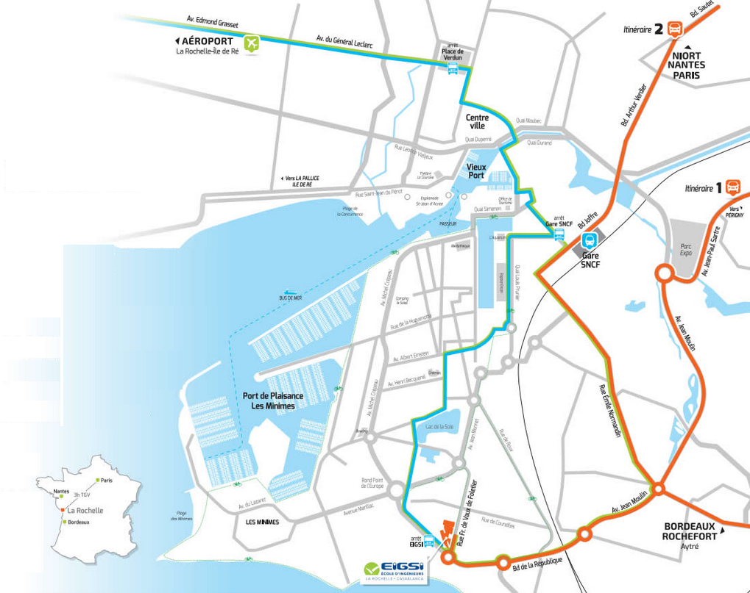

By train : http://www.voyages-sncf.com/ By bus
Paris (TGV high speed train): 2 hours 30 minutes Bus illico 3 “EIGSI” stop
(towards La Rochelle - Bongraine)
Nantes: 90 minutes For more information :
Bordeaux: 90 minutes http://yelo.agglo-larochelle.fr
Poitiers: 75 minutes www.rtcr.fr
By plane : http://www.larochelle.aeroport.fr/

