‘Quick Tips for Teaching Online’: Blog Post Outline Template and Anatomy

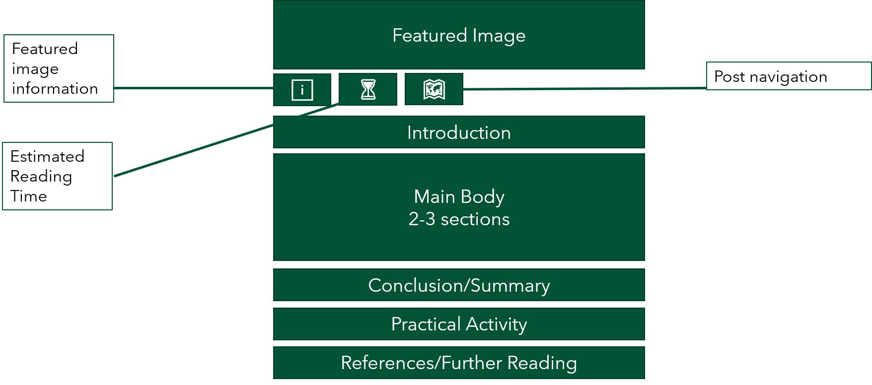
Figure 1: The above graphic provides a webpage view depicting the structure and most common sections of a typical blog post to the series.
The post author should fill in details below beneath all headings provided.
Posts should be approx. 700 words in length and, where possible,
take approx. 5 minutes to read.

Post Title:
Insert your post title here.

Insert the Featured Image/Media you want to use for your post here:

Featured Image Source Information:
Include information about the featured image/media here: 1) the image creator/owner, 2) the source of the image, and 3) the license information for the image that means it is permissible to use as part of this post (Creative Commons license). e.g. Image by Pixabay on Pexels (CC0).

Alt-text for your chosen image:
For accessibility purposes please insert a brief alt-text description of your featured image here.
If you include other images, graphics, videos, or animations in your post, please also include alt-text describing them.

Audio playback option:
To offer alternatives for visual information, including text, and to support decoding of text and symbols, we want to provide our readership the option of listening to each blog post via audio playback (Universal Design for Learning checkpoint 1.3 and checkpoint 2.3).
Using the checkboxes below, please indicate your preferred option to cater for this.
☐ I will make an .mp3 audio recording of me reading my final blog post aloud.
☐ I consent to the blog coordinator making an audio recording using a text-to-speech alternative to read my final blog post aloud.

Post By:
Insert your name here.

Reading time:
~ X minutes.

Post Navigation:
Please add/edit/delete section headings below as appropriate to your own post. There is no requirement for the post to have 3 sections, it can have more than or less than that.
Below are some macro-level sections people can expect to see in your post.
Explore some existing examples on the blog by following these links: 1 | 2 | 3 |
- Introduction
- Section 1
- Section 2
- Section 3
- Conclusion/Summary
- Practical Activity (if including one for readers to engage with)
- References/Further Reading
Beneath your blog post section headings try to include information about
The Context and Skill example: The story behind what you did and how you did it (your practice/innovation) in your particular context (module, programme, etc.).
The Learners: A description of the learners in this context.
The Tips: A set of instructions (step-by-step, or narrative) for how you deployed a skill (or similar) to do what you did in your practice/innovation.
Associated Multimedia: Any images, audio, or video that has been captured as part of or associated with the practice/innovation. Remember to include alt-text describing them.
The Evaluation: How things worked, how things could have been better, any plans to amend the practice/innovation in the future.

Introduction
…

Section 1
…

Section 2
…

Section 3
…

Conclusion/Summary
…

Practical Activity
…

References/Further Reading
…

Links to related LTF resources (LTF members can fill this section in on behalf of the author)
…

