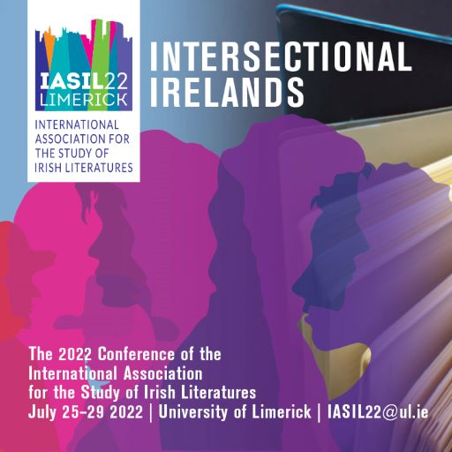

WELCOME/fÁILTE!
On this page, you will find a list of restaurants, pubs, eateries & cafes to eat and relax in while you are attending the IASIL 2022 Conference on Intersectional Irelands in the University of Limerick.
The IASIL crew hope you enjoy the conference!

- eateries we like on UL campus
____________________________________________________________________
☼ UL FOOD MARKET (in the courtyard, Tuesday only 10-3)

H₂O PAVILION RESTAURANT (over the River Shannon and the “living bridge”. You have now entered County Clare).

- STABLES (near the courtyard) 9AM-5PM

*STARBUCKS (in the main building) 8AM-3PM

CAFÉS/RESTAURANTS THAT TICKLE OUR TASTE BUDS OFF-CAMPUS near u.l.
Crate, Kilmurry Lodge Hotel https://www.kilmurrylodge.com/upload/docs/crate-official-menu.pdf
Tuscany https://tuscany.ie/
Hook and Ladder https://hookandladder.ie/
Locke Burger (castletroy) https://lockeburger.ie/
The Hurler’s Pub (no name on door: just ask a local!) https://the-hurlers-bar.business.site/
La Cucina (castletroy) http://lacucina.ie/
Factory 13 (at back of campus) https://www.limerick.ie/discover/eat-see-do/food-drink/cafes/no-13-factory
Lana Thai (castletroy) https://lanathai.ie/
Bella Italia (castletroy town centre) https://www.bellaitalia.ie/castletroy/
Delish (castletroy) https://www.delish.ie/
Coqbull (castletroy) https://coqbullcastletroy.ie/
The Top House (newtown, castletroy) https://thetophouse.ie/
A taste of an irish proverb
ar scáth a chéile A
MHAIREANN NA DAOINE
We live in one another’s shadow
Or: we are community

AN IRISH TOAST
“SLÁINTE NA bhFEAR AGUS GO MAIRE NA MNÁ GO DEO”
Health to the men and may the women live forever

WHERE THE IASIL CREW LIKE TO EAT OUT IN LIMERICK CITY
DOLANS https://www.dolans.ie/
TREATY CITY BREWERY https://treatycitybrewery.ie/
MEJANA RESTAURANT http://www.mejana.ie/
THE CORNSTORE https://cornstore.ie/
AROI ASIAN STREET FOOD https://aroi.ie/
BELLTABLE CAFÉ https://limetreetheatre.ie/belltable-x/
CANTEEN https://wearecanteen.com/
ZEST https://www.zestfood.ie/
RIFT https://www.riftcoffee.com/
CORNSTORE https://cornstore.ie/
CURRAGOWER PUB https://curragower.com/
KYOTO SUSHI https://www.kyoto.ie/
THE LOCKE BAR https://lockebar.com/
SPITJACK https://www.thespitjack.com/menus
CHICKEN HUT https://www.facebook.com/chickenhutlimerick
MILKMARKET https://www.milkmarketlimerick.ie/
ONE PERY SQUARE https://oneperysquare.com/

Bain súp as! Enjoy!
Sorcha 2022.

