The Rubrics tool in Sulis.
Contents
The Rubrics tool in Sulis. 1
1. Introduction: What is a Rubric? 1
2. What does a rubric look like for a student? 2
3. Create a rubric 2
4. Customise/edit the rubric to add criteria/scoring 3
5. How to remove your rubric from public view 5
6. Associate a rubric to an assignment 5
7. How to grade an assignment using a rubric. 6
8. Student view of their feedback and grade 9
9. More information and guidance 9

Introduction: What is a Rubric?
The rubrics tool allows you to create and share grading rubrics for use in Sulis. Other assessment tools like assignment, forums, quizzes and gradebook can link to Rubric, which makes it a versatile tool to use.
A Rubric consists of a list of criteria on the left hand column, the standards associated with each from left to right, and mini descriptions around the different levels of performance. Your criteria should link to your learning outcomes. You should number the standards, giving a point value to each standard, and develop descriptions for each grade level, increasing the points as you move from left to right (see image below). On the example rubric below, criteria 1 has a max score of 5 points (see far right), criteria 2, max score of 5, and so on.
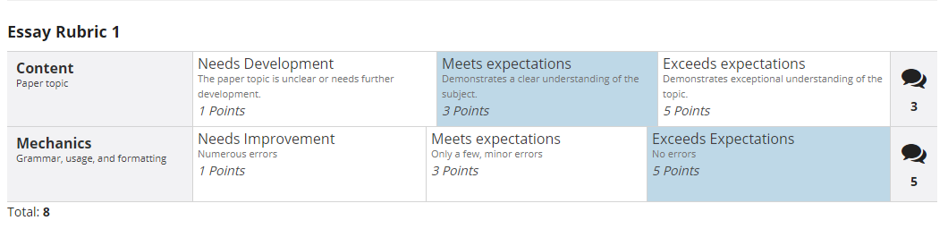
Figure 1: Example of a grading rubric in Sulis
Some things to know about rubrics in advance:
- In order to copy a rubric across your own sites, you have to share it, but the whole institution will see it. To overcome this, you can temporarily share, then un-share it. It is good for lecturers to be aware that their rubrics are visible to all lecturers unless you remember to unshare. More information on these steps are below.
- Rubric tool doesn’t allow you to download all of your grading and comments into a summary file, to give to the external examiner or course leader. So it has to be done separately, unless you link to the gradebook. Comments from gradebook can be exported. Some people choose to grade using rubric but add their further comments via the assignment.
- Rubric doesn’t allow you to use letter grades.
- Once a rubric is linked with an assignment, it becomes harder to edit. Therefore, ensure that you are happy with the layout of a rubric before linking it to your assignment.
- Make the assignment expectations explicit before submission, and give students the rubric in advance. Put as much detail into the criterion descriptions as possible, but do not depend entirely on the rubric for student guidelines. Always Include a full descriptive document of the assignment in advance. When a rubric is made available to students in advance, be prepared to answer questions about it. Having a clearly laid out rubric should limit questions.
- You can add comments as well as choosing a rubric criterion- keep a word document handy of the most commonly used comments. Use Comments at the end of the rubric to focus on strengths and areas of development. The comments box turns yellow when you’ve added comments and saved feedback.

What does a rubric look like for a student?
A student can see what score they get on a grading rubric, from the areas that are highlighted in dark blue. This is one way for them to receive feedback from you.
You should also add a detailed instruction file for students on how they should complete the assignment. Don’t rely completely on the rubric as the only point of student information.
In the image below, the student’s overall feedback is marked with the blue boxes. They received 3 points for criteria 1, and 5 points for criteria 2 (NOTE the lecture can manually adjust the score between two standards. For example 3 can be made into 4). The total score adds up to 8 points in the image below but the lecturer can also edit the total score this to bring it up or down. A teacher can also grade a group in the same way.
Figure 2: Rubric from Individual grade student point of view

Create a rubric
- Ensure the rubrics tool is turned on in the left hand panel of Sulis. If it is not visible, you can add the rubrics tool as follows;
- Go to Site info/Manage tools and choose the rubrics tool.
- Press save.
- Click on the Rubrics tool in the left hand menu to get into the rubrics edit area.
- You can create a new Rubric and give it a title (see image below).
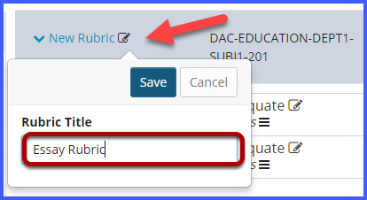
Figure 3: Location of New Rubric Button
OR, you can choose an existing rubric from the list of ‘Shared Rubrics’, copy one from the public area and then edit it. This will not affect the original rubric.

Customise/edit the rubric to add criteria/scoring
- Select the pencil icon next to the rating criteria that you wish to edit and change text and points (see image below)
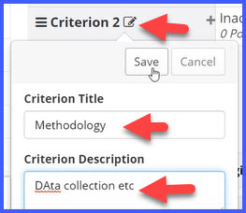
Figure 4: Add criterion to the rubric
- To add a new standard, mouse over the line between standard and press the + button.
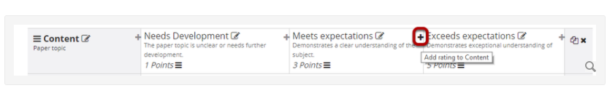
Figure 5: add a new standard
- Create a new criterion row by pressing the ‘Add Criterion’ button (see image below bottom left), Or else duplicate an existing criterion and edit it (see image below right).
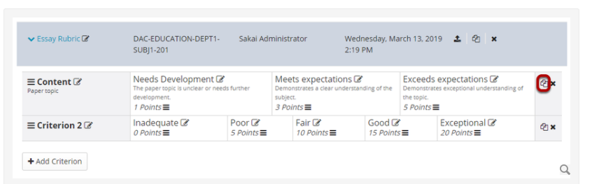
- Add criterion
- Duplicate
Figure 6: adding new rows
Make sure that the points start very low on the left and increase as you move to the right.

How to remove your rubric from public view
- In order to stop sharing a rubric site wide, go to the sulis site of origin, (where you created the rubric initially). The ‘revoke share’ button is in the same location as the ‘share’ button.
- If you had a private rubric and wanted to reuse it, then you must share it temporarily, copy it in your new site, and then revoke sharing. To do this, go to the site of origin, (where you created the rubric initially) and share it temporarily by pressing the share button opposite the rubric title (see image below).
- When it is shared, you can go to your current site. Go to the rubrics tool, and the area where all of the rubrics shared with the institution are visible. Your temporary shared rubric is one of them. Copy your rubric using the ‘copy’ button which is to the right of the ‘share’ button. You then have a copy sitting in the current site.
- After you’ve copied it, go back to the original site to revoke sharing. The copy sits in your second site but the rubric is no longer visible to the institution. The ‘revoke share’ button is in the same location as the ‘share’ button.

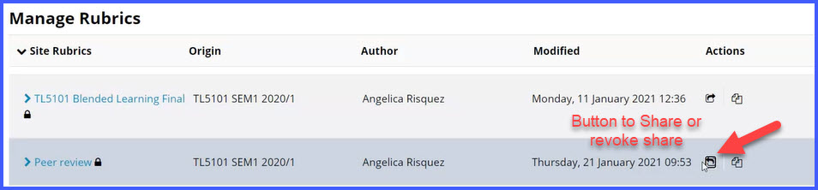

Associate a rubric to an assignment
- Once you have edited your rubric and are happy with it, it is time to associate it with an assignment. NOTE: you can only edit rubrics before they are associated with the assignment. Once it is linked to an assignment, further edit is locked. It can be undone but it is cumbersome.
- To add the rubric to quiz or other grade element, look in the sakai documentation linked below for a full set of instructions.
Sakai Documentation on Rubrics
- To add the rubric to an assignment, go to the assignment and edit it.
- Go ‘Grading scale’ and convert it to ‘points’. At that stage, the assignment settings change and update, and you will see the option for rubrics. Only then will it appear, and you can link it to the assignment.
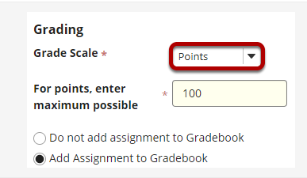
Figure 7: adding rubrics to an assignment
Top Tip: When attaching the rubric, make sure you tick ‘adjust individual student scores’, so that you can give students the score in between scales. It allows for greater flexibility in grading (see image below)
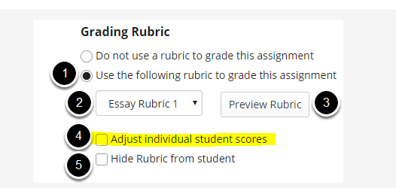
Figure 8: adding rubrics to an assignment

How to grade an assignment using a rubric.
Now that the rubric is created and linked to an assignment, it is time to grade the submitted assignments.
- Go to ‘assignments’ and choose the assignment you want to grade. Opposite the assignment title, press ‘Grade’.
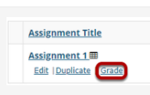
Figure 9: press Grade button
- You will then see a list of assignments submitted by students. Don’t click on the rubric icon on the far right, it doesn’t seem to do anything. Instead, click on the assignment document submitted by the student.
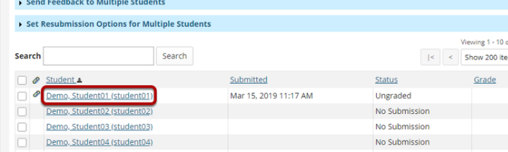
Figure 10: grade assignments
- Then click on the grading rubric tab inside where the assignment submission is located.
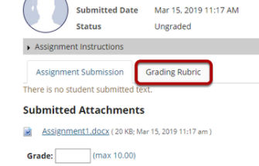
Figure 11: grading rubric tab

- Choose your general scores (items in blue), and tweak the scores at the end and comment, and press ‘done’.
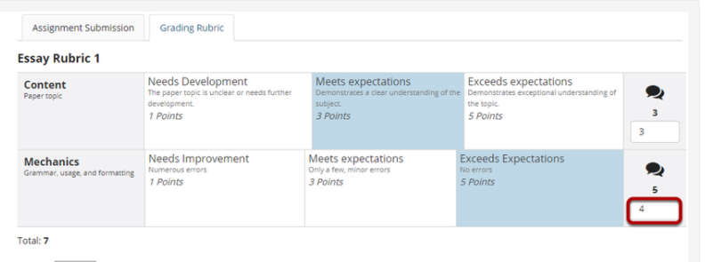
Figure 12:Choose general scores
- When a comment is added, the comments bubble goes orange.
- Note, you could always add your comment as an audio file. Just click on the comments file and press the mic button (see image below).
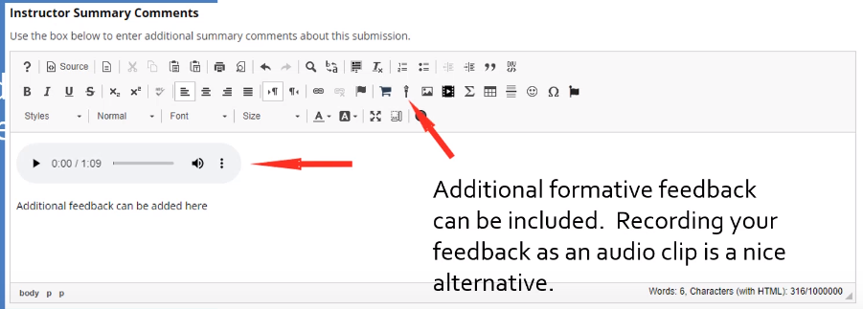
Figure 13Adding additional feedback
- Choose ‘save and don’t release to student’ button (see image below).
- You can always go back later to release to students
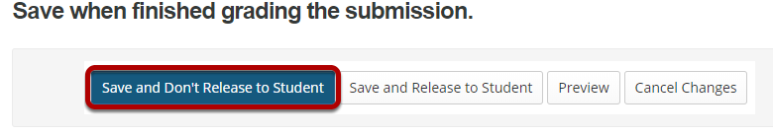
Figure 14:location of save buttons

Student view of their feedback and grade
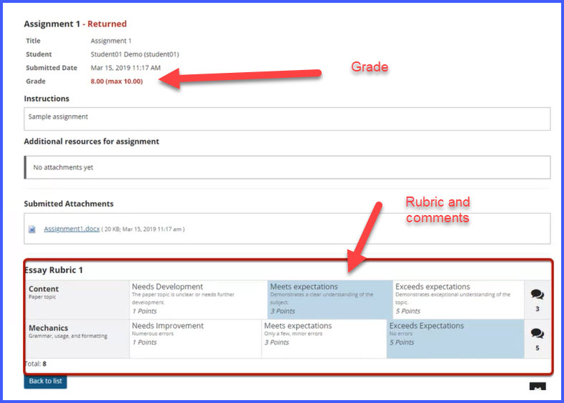

More information and guidance
Do take the time to go through this excellent workshop, chaired by Dr. Angelica Risquez, whereby UL lecturers outlined how they used Rubrics in their grading and feedback. (1hr)
More information on rubrics in:
https://www.ul.ie/ltf/supported-tools/sulis/rubrics
Sakai Documentation on Rubrics
https://sakai.screenstepslive.com/s/sakai_help/m/81161/c/253501
Using rubrics- check this out too- good practices around rubric creation by Dr Ide O Sullivan. Topics covered are applying grading criterion, linking to learning outcomes and using Blooms taxonomy.

