PostEm Tool in Sulis
Note: This file and other documentation on Postem Tool are available on the LTF website under the Sulis resources section
Table of Contents
Postem Tool in Sulis 1
1. Introduction 1
2. Layout guidelines for the feedback file 2
3. Uploading your feedback file to Sulis 2
4. Set the feedback release 5
5. Verify the upload. 6
6. View uploaded feedback item. 7
7. Student View of their Feedback 7
8. Additional Information 8

Introduction
The Postem tool is a way for you to bulk upload feedback from an excel (CSV) sheet to Sulis in one go. Using the gradebook feature in the Sulis module page, you can download a class list of your students registered on that sulis module. You can use this as the starter file, from which to build your feedback file. Alongside each student name, you can type in some feedback for a given assignment. The same class list file can then be reimported back into Sulis via the Postem tool, and posted as feedback. Even though a file with all feedback is posted, each line of feedback is private, and only visible to the individual student whose username is associated with that feedback. As long as the username is correct, that feedback is visible to that person only. For this reason, file layout is important.
Please view the accompanying Video by Jess Beeley:
Sulis Tutorial: How to grade using Postem tool (4.5 mins)
After you have viewed the video above, replay the video a second time and follow along with the steps below. You should then be ready to implement these steps on your own module.

Layout guidelines for the feedback file
Instructors may use a comma-delimited (CSV) spreadsheet file to present individual feedback and/or grades to students. This spreadsheet file must follow a particular format:
- Your file must be saved in .CSV format. You can save Microsoft Excel spreadsheets as CSV files. File/Save As/ Choose type of file as CSV.
- The first row of your file must contain column headings; every column must have a heading. Each heading may be an assignment name, underneath which the lecturer can type in the assignment grade, and the the next heading may be the assignment feedback which accompanies the grade.
- The first column of your file must contain individuals' usernames in lower case. This is usually the student ID number
- Once you have created your file, you can modify and update it as you wish, as long as you stay within the guidelines above.
Tip: You can download a CSV file that includes the student usernames under Gradebook > Import/Export > Export Gradebook. You can also download a CSV file that includes the student usernames under Roster > Export.
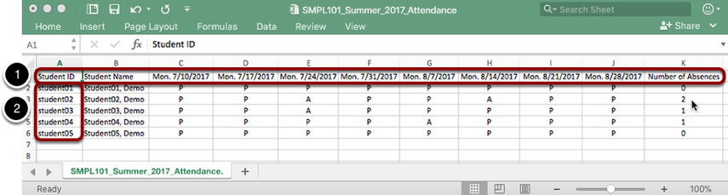
Figure 1:Example of a properly formatted CSV file.

Uploading your feedback file to Sulis
- Log into your Sulis module and go to the PostEm tool in the left hand menu. Tip: If the Postem tool is not visible, please go to Site info/Manage tools, and find ‘Postem’ in the list. Tick on the tool to switch it on and press ‘save’.
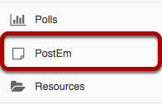
Figure 2:Location of Postem tool in left hand menu

- Click on the Postem tool on the left hand menu, and Click ‘Add’. (see image below)
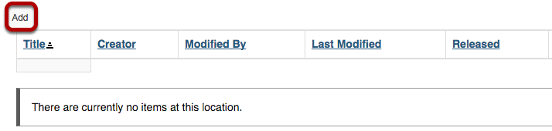
Figure 3:location of 'Add' button
Enter a Title of the feedback that you are posting, example ‘Grade and feedback for assignment 1’, or ‘class attendance’, (see image below). This is the title students will see when they go to PostEm to view their feedback.
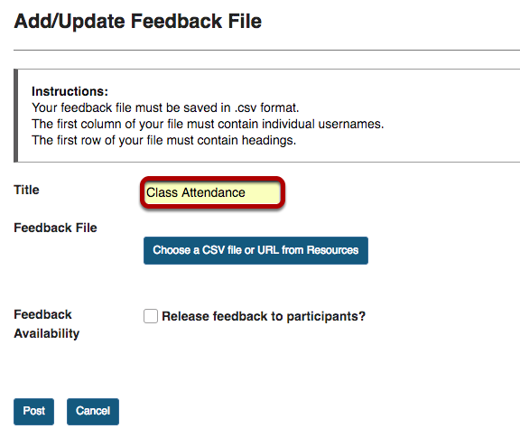
Figure 4: title of feedback

- Click the Choose a CSV file or URL from Resources button to select your file (see image below).
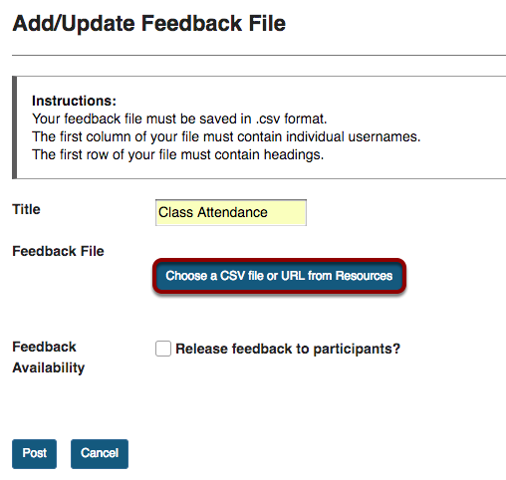
- OR, to upload a CSV file from your computer, click the Choose File button which will prompt you to browse for the file on your computer. Select the file to upload.
- Click continue (see image below).
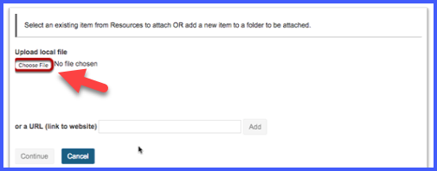
Figure 5: choose file from computer

Set the feedback release
- Adjust Feedback Availability and Post, by Checking the box next to Feedback Availability if desired, and then click Post.
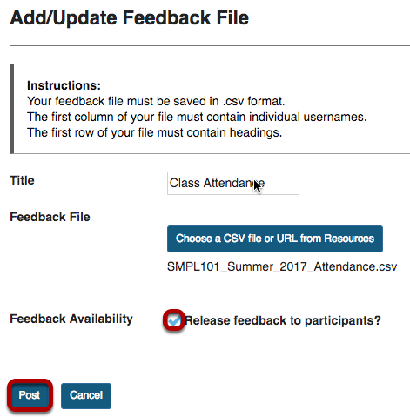
Figure 6:Post feedback to make it visible to students

Verify the upload.
You will be prompted to verify your file upload. The first row of data will be previewed for you. If everything looks correct, click Save; if not, click Back, make changes to your CSV file, and upload it again.
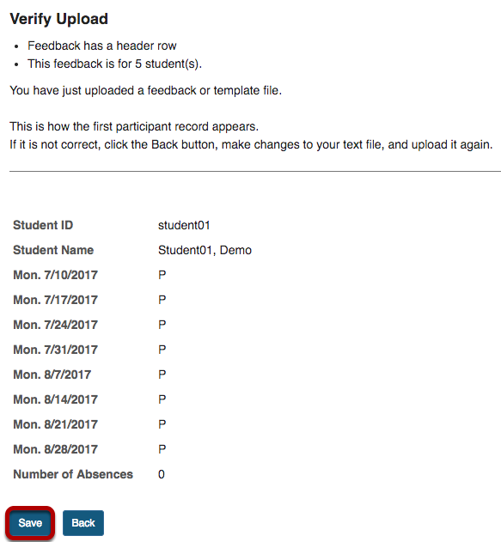
Figure 7:verify the upload

View uploaded feedback item.
To view what you have uploaded for each student, click on the Postem tool and view link (see image below).
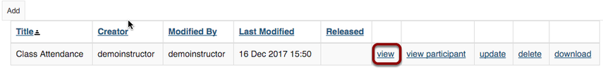
Figure 8: view feedback
The feedback will appear in a table like that in the image below. You can also click on ‘view participant’ in the image above and using that feature, you are able to see exactly what a student will see.
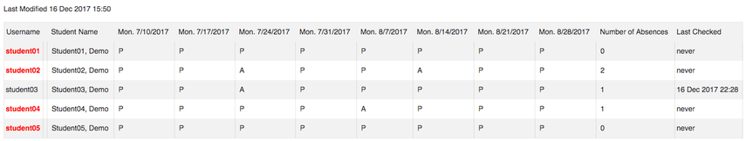
Figure 9: view feedback

Student View of their Feedback
At this point, you can place an announcement on Sulis, asking the students to log in and click on the ‘Postem’ tool on the left hand menu, to see their feedback. An individual’s feedback will look like the image below, and will have their username and the contents of the boxes opposite username.
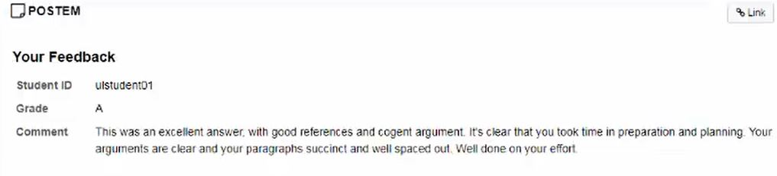
Figure 10: Student view of feedback

Additional Information
Please see the following links for the Sulis site information on this tool
How do I update a Postem Feedback item?
How do students see postem feedback?
This file and other documentation on Postem Tool are available on the LTF website under the Sulis resources section.

