Presentation Support – Resource File

Slide 1
Padlet Link
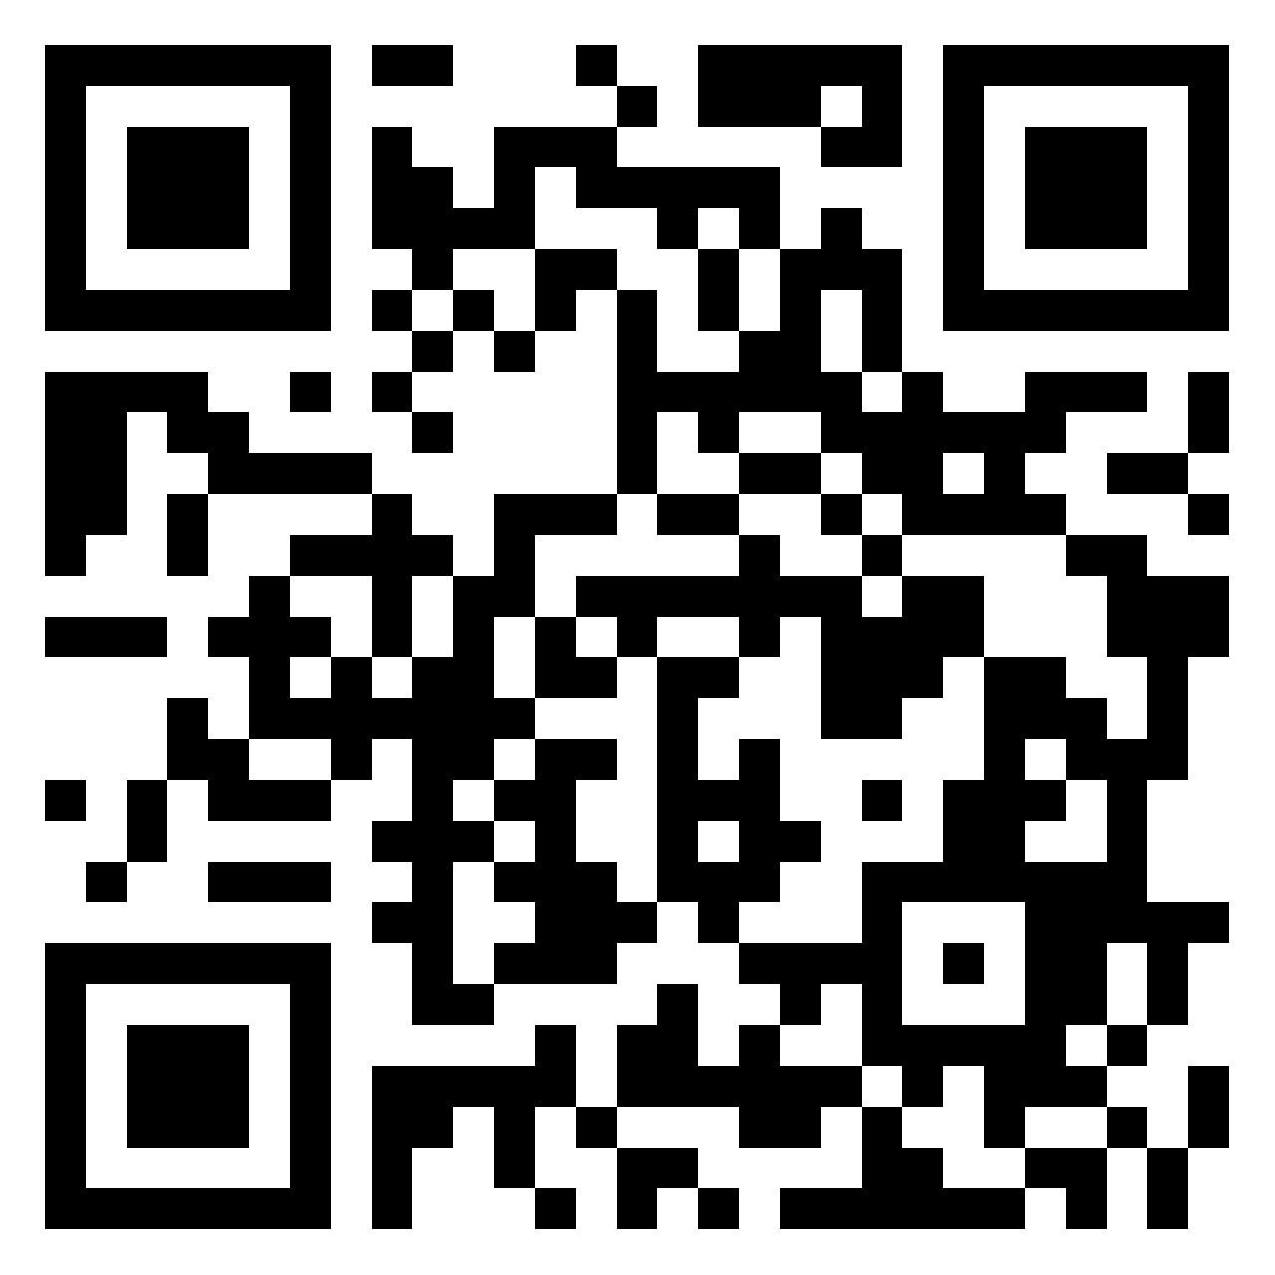

Slide 5
Reading PDF's and Web Content with Microsoft Edge Browser
Copyfish 🐟 Free OCR Software (Chrome)
Copyfish - Free OCR Software - Microsoft Edge Addons
PDF OCR - Recognize text - easily, online, free - PDF24 Tools
OCR software: see Additional Information & Useful links

Slide 6
Sample text command ‘=rand()’ and press enter
Get access to Office 365 (Student Licence)
Accessibility Features in Office 365 (Immersive Reader & STT)
Office 365 Online Accessibility including STT and Immersive Reader
Using Inbuilt TTS Office Word 365 on Mac (Catalina)
Utilising Inbuilt TTS on MacOS (Catalina)
Using TTS & Scanning Features on ClaroRead for MacOS (Catalina)

Slide 8
Reader Mode - Distraction-free reader

Slide 9
Safari Reader - Text to Speech (TTS) Options for iOS (iPad or iPhone)
WhisperSync

Slide 11
How to use Dictation and voice commands in Microsoft Word (2021)
Dragon Naturally Speaking Homepage

Slide 13
Grammarly Homepage

Slide 14
LightKey Website
Light Key Free-Text-Editor
LightKey Typing

Slide 16
Coggle: Simple Collaborative Mind Maps & Flow Charts
Mind Genius
Download MindGenius 20 from the link below:
https://www.mindgenius.com/download-archive/
Contact thomas.oshaughnessy@ul.ie for a licence code.

Slide 19
Keyboard shortcuts in Windows
New Keyboard Shortcuts Every Windows 11 User Should Know
Keyboard shortcuts in Word
Use keyboard shortcuts to create PowerPoint presentations

Slide 21
Microsoft Lens - PDF Scanner (android)
Microsoft Lens: PDF Scanner (iOS)
Seeing AI
Adobe Fill & Sign: Easy PDF Form Filler (android)
Adobe Fill & Sign: Easy PDF Form Filler (iOS)
How to - Adobe Fill & Sign App for Mobile Devices - YouTube

Slide 23
Reader Pen (Scanning Pens UK)
C-Pen ReaderPen Windows Quick Tutorial

Slide 18
How to Record & Transcribe Audio in Microsoft Word

Slide 26
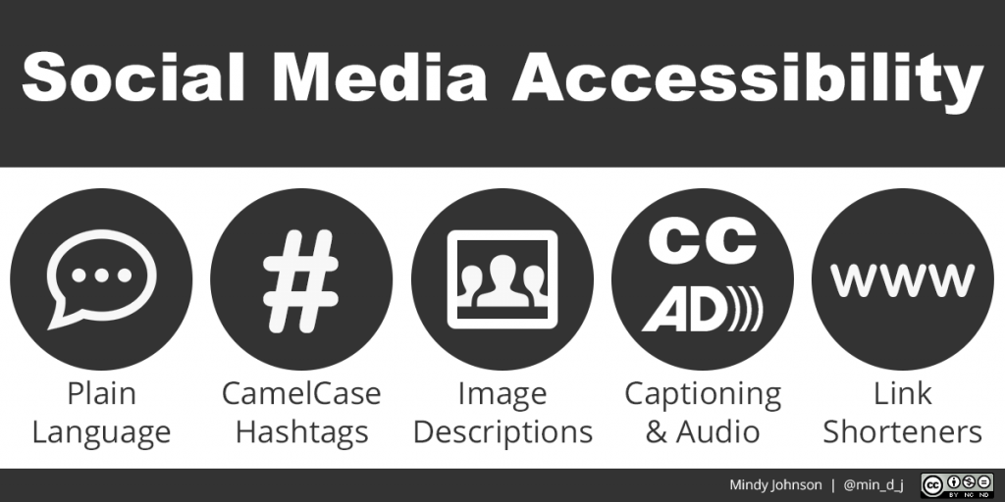

What is plain English?

Camel Case Example - #hotdog #HotDog

Simple Caption Options (first two examples are iOS only)
- Clips
- Clipomatic (multiple languages)
- Live Caption (Android)

Link shorteners - Bit.ly Website
Dyslexic Friendly Fonts
- Dyslexie Font Link
- OpenDyslexic Font Link

Slide 29
My Details
- Thomas O Shaughnessy
- Assistive Technology Officer / UDL Lead
- Educational Assistive Technology Centre
- Twitter Handle: @tjoshaughnessy
- Email: thomas.oshaughnessy@ul.ie
- www.ul.ie/EATC

Additional Information & Useful links:
- Universal Design for Learning - AHEAD
- Center for Applied Special Technology (CAST)
- What is a screen reader?
- ClaroRead Software - Free OCR software for UL Staffa and Students (contact Thomas.oshaughnessy@ul.ie for software and licence)
- European Union (Accessibility of Websites and Mobile Applications of Public Sector Bodies) Regulations 2020
- Improve accessibility with the Accessibility Checker
- 10 Student-Tested Chrome Extensions
- Typing.com - Learn to Type

