Sample Questions for use with Student Feedback Questionnaires
- Student Check-Ins.
The following two images are examples of what lecturers are using with their class. Although these questions are posed weekly rather than after a few weeks, the general rule of thumb would be to allow your students to settle with the workload for several weeks before asking how they are getting on.
The following image is courtesy of DNM Lecturer AnnMarie Bright 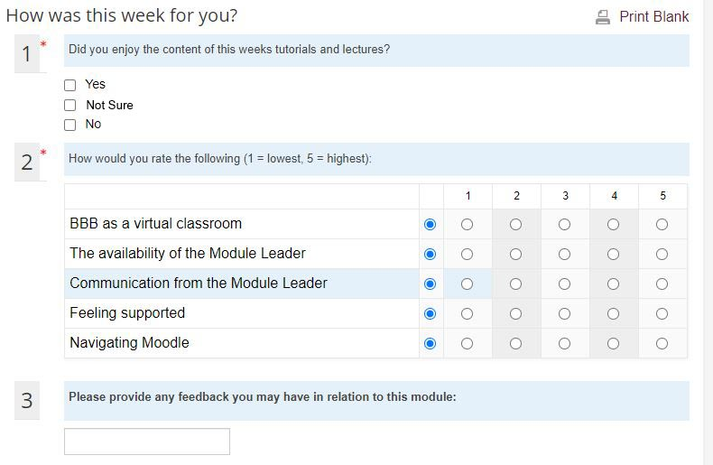

The following set of questions were originally created by Jess Beeley (Educational Technologist based in AHSS) and are inside the Sulis module templates. To access a Sulis module template, contact your faculty Ed Tech.
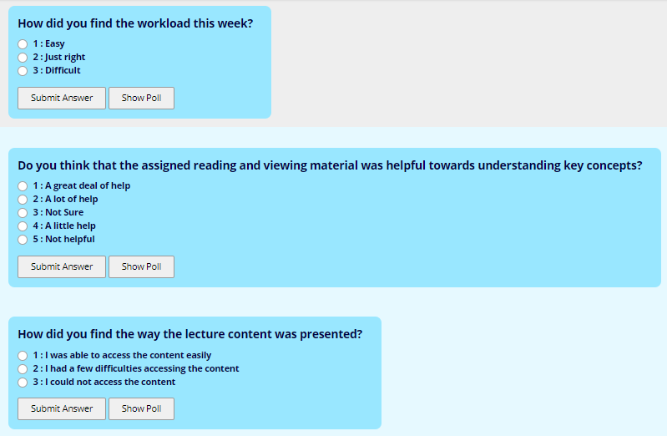

- Example question for checking rating understanding during a live presentation
This image is free to share and available from @MrsParkShine on Twitter
https://twitter.com/mrskbarbree/status/1308134692080824320

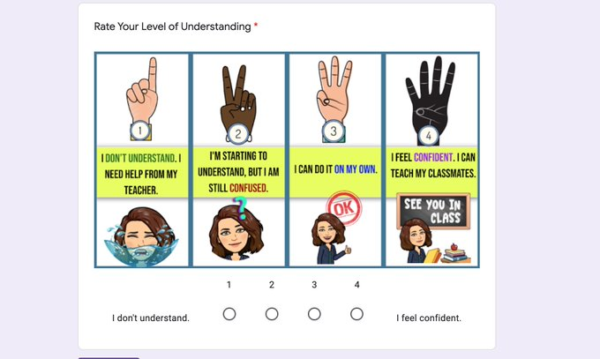

- Example end of semester student feedback quiz
It is best to set these quizzes as anonymous to allow for genuine feedback.

Introduction for students
We are eager to take any opportunity to improve the learning experience for you. Please take a few minutes to complete this questionnaire and let us know what worked for you and what you would like to change. All responses are anonymous. There are 10 multiple choice questions which will only take a few minutes.
Click in the text link below.

Q1. I found that the workload required to complete this Module was:
Easy
Moderate
Difficult
Very Difficult

Q2. Studying this Module has significantly increased my knowledge in the subject areas
Strongly agree
Agree
Not Sure
Disagree
Strongly Disagree
Other (please specify - max 25 characters)

Q3. This module was organised and sequenced well
Strongly Agree
Agree
Not Sure
Disagree
Strongly Disagree

Q4. Do you think that the assigned reading & viewing material was helpful towards understand key concepts?
A great deal of help
A lot of help
Not Sure
A little help
Not helpful

Q5. Which assignment did you find most useful or relevant to you (and why?)
Essay Type Answer box

Q6. Grading: Was it clear how your assignments were graded? (i.e Did Assignments contain clear descriptions, due dates, and grading rubrics. Additionally were assignments linked to the module learning outcomes?)
Essay Type Answer box

Q7. If relevant, can you identify an assignment which you felt was not clear?
Essay Type Answer box

Q8. Were you satisfied with your lecturer's engagement overall? (Enter name of Lecturer)?
Very satisfied
Moderately satisfied
Not Sure
Moderately dissatisfied
Extremely dissatisfied
Q9. What aspect of participating on the online module did you enjoy the most?
Engagement with other students
Engagement with your module lecturer
E-tivities
Reading & Viewing online
Assignments
Discussion Forums
Other (please specify - max 500 characters)
Q10. Please add any further comments here.
Essay Type Answer box

