One Drive: How to Manage
Your Recordings in One Drive

Contents

1. Introduction 2
2. Record your MS Teams Video 2
3. Locate and Share your recording from One Drive 3
3.1 Locate your recording 3
3.2 Set the ‘share permissions’ for your recording 4
3.3 Find the ‘Share link’ to your recording 7
4. Conclusion 7
5. Appendix 8
5.1 Sharing your recorded MS Teams video from MS Stream 8

Table of figures

Figure 1: Location of the 'start recording' button in MS Teams 2
Figure 2: Location of One Drive App in Office.com 4
Figure 3: Location of 'Recordings Folder' in One Drive/My Files 4
Figure 4: Tick to the left of the recording title to choose it 5
Figure 5: Location of 'Share' button in top menu bar, One Drive 5
Figure 6: How to edit share options in One Drive 6
Figure ７Link settings 7
Figure ８: Location of the share link in One Drive 8
Figure ９Share Link 8

Introduction
Previously, all recordings made in MS Teams were automatically stored on the MS Stream server. (https://web.microsoftstream.com).
From August 2021, video recordings from MS Stream are stored on OneDrive and SharePoint.
Note: any recordings you made that are stored on MS Stream are still available. See Appendix 1 for information on how to share a video that you recorded in the past, located on MS Stream.

Record your MS Teams Video
For anyone that has not recorded a video on MS Teams, please watch the video guide here by Jess Beeley.
Watch: 2 min Video explaining how to record with Microsoft Teams

- As outlined in the video above, log into MS Teams, upload your files for sharing and turn on your webcam. When ready, select the three dots on the MS Teams toolbar and then select the Start recording button (see Figure below)
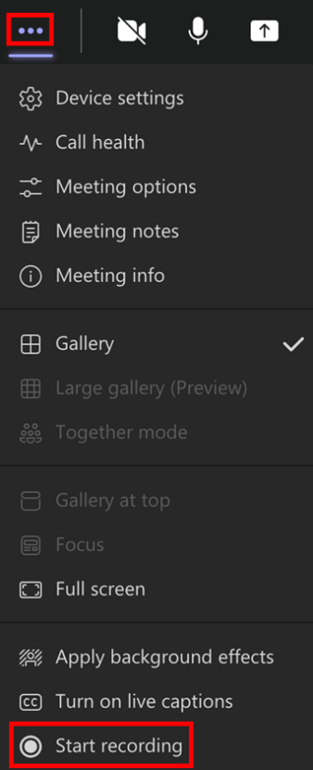
Figure 1: Location of the 'start recording' button in MS Teams
The recording from MS Teams will be available 30-60 minutes after the meeting is over. All recordings are located on OneDrive in a folder called Recordings.

Locate and Share your recording from One Drive

3.1 Locate your recording
- Sign into Office 365 and select the OneDrive app.
  - To do this, log into https://www.office.com and sign in with your UL username and password.
  - Once signed in, you will see a list of user apps on the left hand panel, including Word, Excel and PowerPoint. Choose the option for One Drive, symbolised by the blue cloud (see figure below).
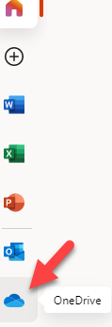
Figure 2: Location of One Drive App in Office.com
- Your video is located in the ‘Recordings Folder’ in One Drive. Go to OneDrive and the Recordings Folder (see image below).
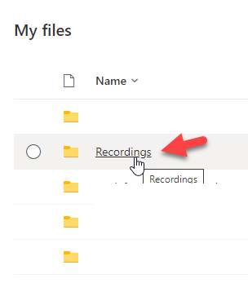
Figure 3: Location of 'Recordings Folder' in One Drive/My Files

3.2 Set the ‘share permissions’ for your recording
- Tick to the left of the recording you will share (see figure below).
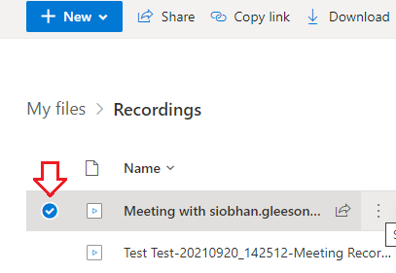
Figure 4: Tick to the left of the recording title to choose it

- Select the Share button in the top menu bar (see image).
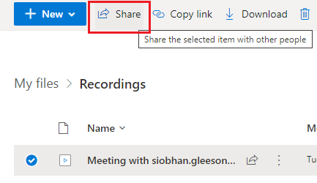
Figure 5: Location of 'Share' button in top menu bar, One Drive

In the next few steps, you can then choose the options for how you want to share the video. Those options range from
- Limited (just a few people),
- A module class,
- Available to people within UL (who have the link),
- Available to the Public (who have the link). This includes people outside of UL.

- On the next screen view the share options by clicking on the arrow highlighted in the image below.
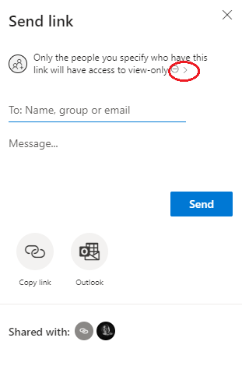
Figure 6: How to edit share options in One Drive

- In the share settings, you are asked ‘Who would you like this link to work for’?
The recommendation is to tick the following:
  - Choose ‘People in the University of Limerick with the link’. See the other share options listed in the image below.
  - Only tick the ‘Allow editing’ option if you would like the file to be edited by others.
  - Choose to allow or block download, depending on what’s appropriate. Remember that if students are in low bandwidth areas, you may want to ‘allow download’ so that they can view the video offline.
  - Click ‘Apply’ when ready. You have now set the share permissions.
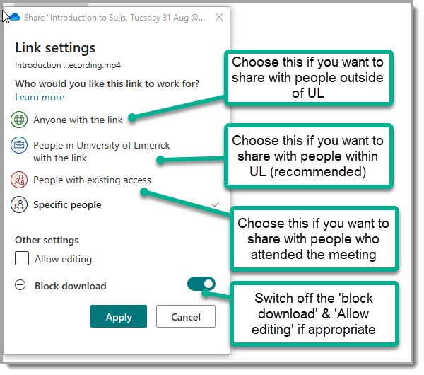
Figure ７Link settings

3.3 Find the ‘Share link’ to your recording
- On the next screen you will see the button for ‘copy link’ (see image below). Copy the link and paste it into your correspondence to your target audience. 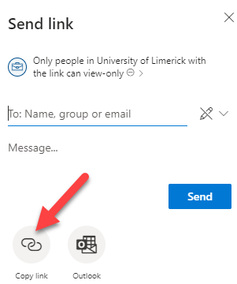
Figure ８: Location of the share link in One Drive
At any later stage you can find the share link again for new audience members.
- Locate the recording in One Drive. Choose the 3 dots to the right of the recording title
- Choose ‘Manage access’.
- You will see the video links and share settings that you applied earlier.
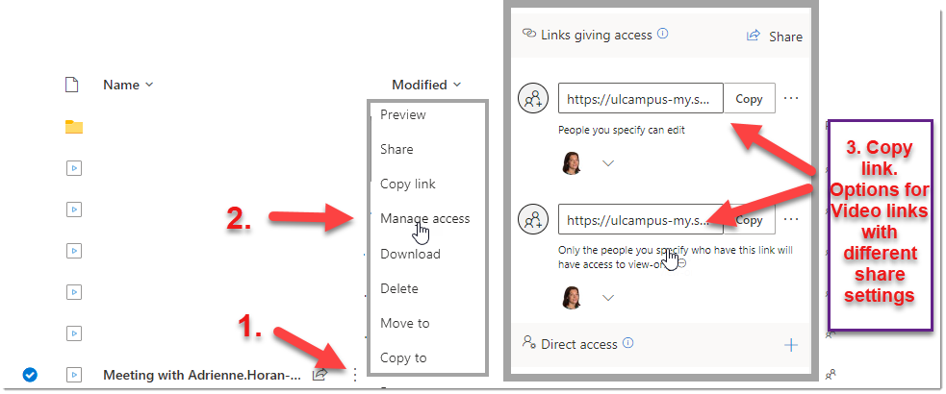
Figure ９: Share Link

Conclusion
This Guide demonstrated how to record on MS Teams, locate the recording in One Drive, set the Share Permissions and find the share link for your audience.

5. Appendix

5.1 Sharing your recorded MS Teams video from MS Stream

Share your recorded MS Teams video FROM MSStream to a class distribution list (Erin King)
This video discusses class distribution lists.
Class distribution lists can be entered on MS Stream in the following format:
'Students of module XX1234’.
XX1234 in this instance is your module code. For example: The distribution list for module EN4141 will be ‘Students of Module EN4141’. If you enter this in the relevant sharing area on MS Stream, all students registered for that module will be able to view the video link that was shared with them.

