Performance and Development Review System

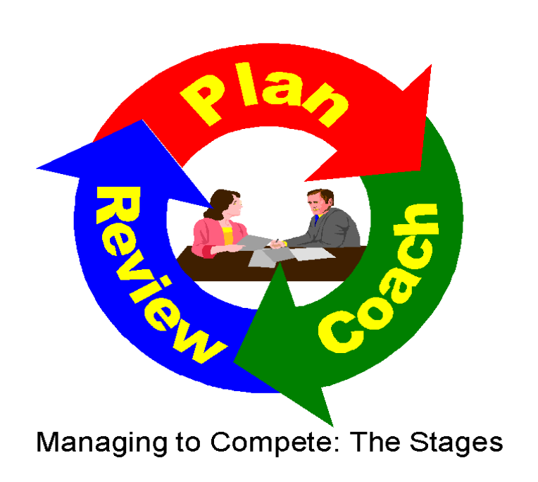
Performance and Development Review System –
Process at a Glance

Performance and Development Review System – Planning Process
Meet with Line Manager/Supervisor to discuss and agree on individual objectives

Feedback & Coaching
This is a two way communication process. This should happen informally on an ongoing basis.

Annual Review
Meet with Line Manager/Supervisor to review Achievements and challenges.
October/January
Ongoing
October/January

Introduction
The University of Limerick Strategic Plan 2019 - 2024 is currently in draft and consultation stages. The University of Limerick Strategic Plan informs the strategic planning process/operational plans/direction for Colleges/Divisions/Teams.

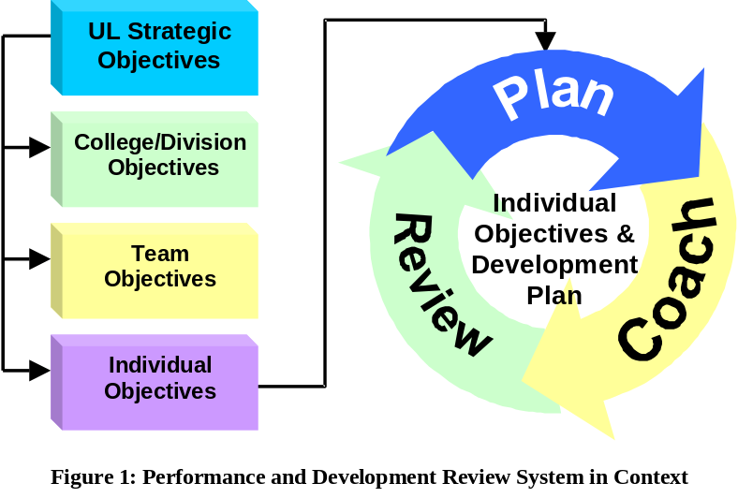‘Performance and Development Review System’ is designed to help you to translate the Organisations objectives into your Team and your own Individual objectives for the year ahead, it also helps to outline your role and contribution as an Individual and Team member to the overall achievement of these objectives/goals. It will help you to plan and track your achievements and keep a focus on the challenges ahead.
The purpose of Performance and Development Review System is to continuously improve the organisations effectiveness by:

- Aligning University/ College / Division / Team / Individual Objectives
- Promoting a culture of continuous improvement
- Understand our roles and what is expected of us
- Supporting personal development
- Developing critical competencies
- Recognition of staff achievements
- The process promotes communications between Line Manager/Supervisors and staff

The advantages for you are:
- You will know exactly what is expected of you
- You will have the opportunity to identify the key areas of your job in line with your team objectives.
- Feedback is a two way process so you will have the opportunity to give and receive continuous feedback on your and the teams achievements and the challenges ahead
- You will have the opportunity with your Line Manager/Supervisor to review and agree individual and team objectives for the year ahead.
- You will have the opportunity and support to develop a Personal Development Plan.
The process applies to all staff in the University of Limerick. A two-way – communication process through feedback and coaching should happen informally on an ongoing basis. You and your Line Manager/Supervisor throughout the year will review your objectives, achievements and challenges regularly and there will be a formal Annual Review in October. There are 3 stages:
- Performance and Development Review System Planning. This normally happens in October. Together you and your Line Manager/Supervisor agree Individual and Team Objectives for the year ahead. You will also identify development needs that are necessary for you to deliver your objectives.
- Feedback and Coaching. This should happen informally on an ongoing basis.
- Annual Review of objectives, achievements and challenges. This takes place in October in conjunction with the planning process. Therefore the October meeting will have one part dedicated to planning and the other part dedicated to review.

Performance and Development Review System - Planning

Purpose
Performance and Development Review System helps you to develop your own work objectives, development objectives and action plans for the year ahead. Before you do this, your Line Manager/Supervisor will translate organisational objectives into team objectives from which you can develop your own set of objectives.
Key
Action
A formal one to one meeting between you and your Line Manager/Supervisor should be held to discuss and agree Objectives for the year. Details should be recorded on the Performance and Development Review System Form.

Individual Objectives Setting Process
The best place to start planning is with your job. Every job can be looked at in terms of:
- What you do. In other words: what outcomes have you identified that need to be delivered by you? e.g. deliver lectures, conduct research, administration etc. These outcomes form the basis of your Objectives
- 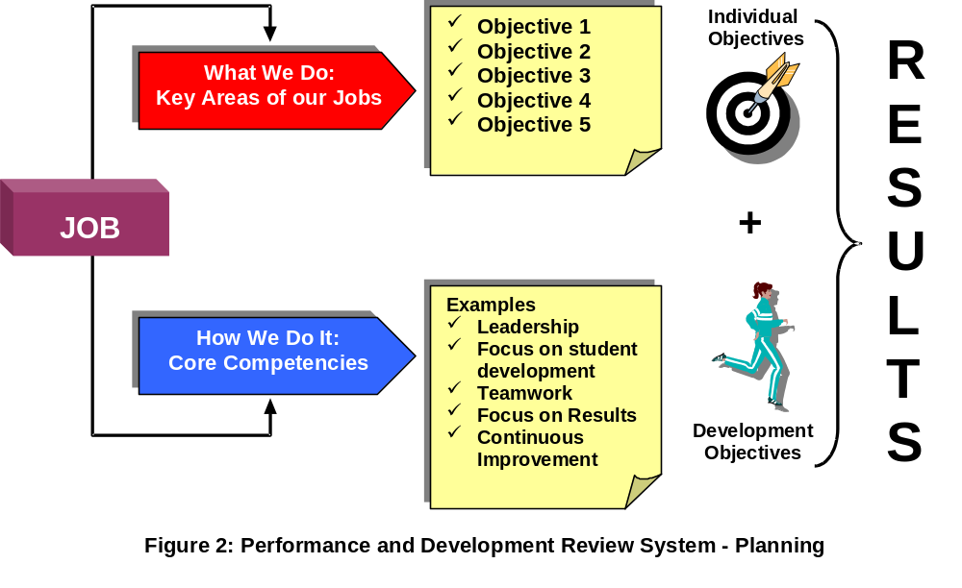How you do it. What are the skills and behaviours you use every day to best achieve your objectives? These skills and behaviours will serve as input into your Development Objectives.
The steps involved in the Planning Process are:
- Clarify the Key Areas of your Job
- Identify your Objectives for the key areas of your job
- Identify the Competencies i.e. skills and behaviours necessary for your job
- Identify your Development Objectives for the year

Key
Action
For each of the Key Areas of your job you should identify and record objectives on the Performance and Development Review System Form.

Prioritising Objectives
Key
Action
Not every objective set will be of equal importance. At the end of the planning process, you and your Line Manager/Supervisor should have agreed on the relative priorities between objectives.

SMART Objectives
SpecificClearly stating what must be achievedMeasurableObjectives can be made measurable by building in the following elements:Quantity: How many? How much?Quality:How well should the task be done, what standards must be metTime:By when will the objective(s) be achievedAchievableStretching but realisticRelevantAdd value to the service. Track ableWith specified review points and end results.

When you write your objectives, make sure they satisfy the SMART criteria:

So far you have looked at the results side of your job i.e. what needs to be done. You also need to look at how you can best achieve these results.

Competencies
By competencies we mean the Skills, Knowledge, and Behaviours you need to use in your daily work, which will help you to achieve your objectives.
Illustration Competencies

Leadership
Focus on Results
Focus on Student Development
Teamwork
Continuous Improvement
The list of competencies and behaviours is not exhaustive. There may be other competencies, which, you and your Line Manager/Supervisor feel are important for you e.g. professional and technical.

Development Objectives
Once you have identified the behaviours that are relevant to your job, you and your Line Manager/Supervisor should agree your Development Objectives for the coming year and what support from your Line Manager/Supervisor is needed. A Development Objective is an agreed action, which will help you to improve the competencies you identified as relevant to your job. Here are some examples of how you might do this:
Development Options

Workplace learning i.e. look for opportunities to practice new behaviours in day to day activities
Self-directed learning i.e. reading, watching videos
Learning by observing others. Find a suitable mentor
Coaching, professional counselling
Programmes and seminars, in-house training etc.

Record your Development Objectives on the Performance and Development Review System Form.
Don’t overdo it. Start with your top 3 or 4 priority objectives.

FEEDBACK AND COACHING
Throughout the year you and your Line Manager/Supervisor should give each other ongoing feedback on your progress against agreed objectives. This is part of normal day-to-day communication.

Key
Action

Annual Review

The Purpose of the Annual Review
The purpose of the Annual Review Meeting is to generate open discussion on objectives, challenges, outcomes and achievements.

Annual Review Meeting Guidelines
Personal Work Objectives
Discuss Achievements of the past year
Compare Achievements with the objectives set
Consider factors beyond your control impacting on Objectives
Development
Identify behaviours that helped/hindered achievement of objectives
Identify additional competencies (if necessary)
Discuss options to capitalise on strengths and address development needs

Recognition
Recognise all Achievements attained during the year
Record achievements on Performance Management and Development System Form.

