UNIVERSITY of LIMERICK

CHEMICAL AGENT RISK ASSESSMENT SHEET

TITLE OF ACTIVITY:________________________________________________________________________________________________________________________________________

ACADEMIC / PROJECT SUPERVISOR: ________________________________________________________ | LOCATION:_____________  (Room No.) | MODULE CODE:_____________________  (if relevant)

ASSESSMENT UNDERTAKEN BY:_______________________________ | ASSESSMENT DATE:______________________ | ASSESSMENT REVIEW DATE:_____________________

(Use GHS Safety Data Sheets (SDS) & Chem. Agent CoP to complete this table.) | HEALTH HAZARD CATEGORIES |  |  |  |  |  |  |  |  |  |  | OTHER HAZARDS |  |  |  |  |  |  |  | EXPOSURE
LIST  CHEMICAL NAMES | Toxic Cat 1,2, or 3 | Toxic Cat 4 | Corrosive Cat 1 | Corrosive Cat 2 | Sensitising Resp. | Sensitising Skin | Carcinogenicity Cat 1 or 2 | Mutagenicity  Cat 1 or 2 | Reproductive Toxicity Cat 1 or 2 | Specific Target Organ Toxicity | Aspiration Toxicity | Flammable Sol,Liq or Gas, | Self-Reactive  Organic Peroxide | Pyrophoric/  Self-Heating | Oxidising (Sol./Liq or Gas) | Explosive Div 1.1-1.6 | Gas under Pressure | Haz. To Aquatic Env. | Ozone Layer Hazard | Inhalation | Skin | Eyes | Ingestion | Amount Used.  (L or Kg) | Dustiness/ Volatility  (High, Med, Low) | Duration of Contact) Hr/Day) | No. of People Exposed. | OELV/BLV
GHS Pictogram | 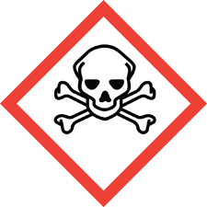 | 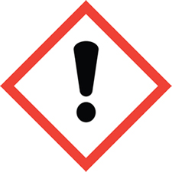 | 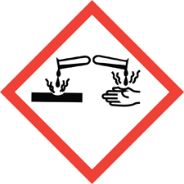 |  | 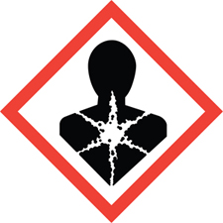 |  |  |  |  |  |  | 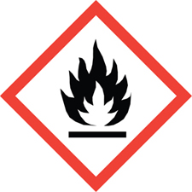 |  |  | 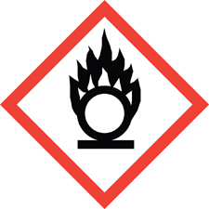 | 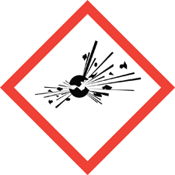 | 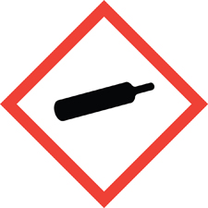 | 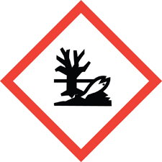
NOTE OTHER SIGNIFICANT SAFETY CONCERNS  For each hazard identified above, describe the preventative and corrective actions needed to mitigate the risk overleaf. |  |  |  |  |  |  |  |  |  |  |  |  |  |  |  |  |  |  | REFERENCES  Include brief citation to data sources used below:

- PERSON CARRYING OUT THE ACTIVITY
Tick as appropriate.

Academic Supervisor Module Lecturer Laboratory Technician Maintenance Personnel Contractor

Postdoctoral Researcher PhD Student Masters Student Undergraduate Student Other (please specify)

BRIEF DESCRIPTION OF THE ACTIVITY AND SIGNIFICANT HAZARDS (CHEMICAL AND/OR PHYSICAL) AND RISK INVOLVED.

Describe the activity (include balanced chemical equations and/or schematic where appropriate):

Significant chemical or physical hazards and risks involved (Tick as appropriate):
Fire Heat Generation Pressurisation in Closed Vessels Gas Release Explosion Spill
Cut Suffocation Poisoning Cumulative Effects Risk to Pregnancy Environmental Hazard
Other (please specify)_______________________

Summary of hazard & risks involved:

- CURRENT PREVENTATIVE & PROTECTIVE MEASURES (Already in place to control hazards identified above):

STANDARDS & PROCEDURES (Name of relevant Local safety statement, standard operating procedures and/or other reference that controls the use of chemicals):

Safety Data Sheets (Are GHS SDS available for each chemical?): Yes No

CONTAINMENT FACILITIES (i.e. engineering controls, fume cupboards, etc.):

Fume cupboard Extraction trunk Blast shield Other (please specify) _____________

PERSONAL PROTECTIVE EQUIPMENT (i.e. protective clothing, gloves, eye protection, etc.):

Laboratory coat/Overalls Safety glasses Goggles Safety shoes Gloves (specify type required ref. Section 8 of the SDS) _____________________

Dust mask (specify type required) Chemical Respirator Other (please specify) _____________________________

TRAINING (Describe training given to staff / students who will use these chemicals and/or conduct this activity):

LIST OTHER PREVENTATIVES AND PROTECTIVE MEASURES CURRENTLY IN PLACE:

- FURTHER CONTROLS REQUIRED (To reduce the risk level to as low a level as possible):
PERSONS RESPONSIBLE: | TARGET COMPLETION DATE: | ACTUAL. COMPLETION DATE:
NB: The activity may not begin until these additional control measures are in place

6. OVERALL RISK RATING
RISK CLASS at this stage of the risk assessment, look at the existing controls and additional control measures to be put in place. Now estimate the REMAINING risk level/class as either LOW, MEDIUM or HIGH.

High -Probability of fatality, serious injury or significant loss, possibility of minor injury to a number of people.
Medium-Unlikely possibility of fatality, serious injury or significant material loss, possibility of minor injury to a small number of people.
Low -Injury or material loss unlikely though conceivable.

Tick as appropriate
Low Medium High
High=STOP this process cannot be allowed to take place. These risks are unacceptable. Substantial improvements in risk controls are necessary, so that the risk is reduced to an acceptable level). The work activity should be halted until risk controls are implemented. If it is not possible to reduce risk the work should remain prohibited.

FIRST AID | 7. SPILLS & OTHER EMERGENCY PROCEDURES
(Location of showers, first aid arrangements, antidotes, Student Medical Centre contact details, etc.): | (Describe emergency procedures in event of spill: including location of clean-up materials, emergency contacts & phone numbers, and the Departmental Emergency Plan):
8. STORAGE | 9. WASTE
(State the correct storage conditions for the various chemical categories being assessed.): | (Specify if any special precautions should be taken when handling wastes and state the method of disposal of the waste chemical, empty uncleaned container, unreacted chemicals, contaminated sharps, PPE):
10. APPROVAL
I have completed this risk assessment and I am fully aware of the hazards involved in the above activity and of the essential safety precautions to be taken. I acknowledge with my signature here that I will comply with the safety precautions that this work requires.

Signature of Assessor Date

I have personally ascertained that the Assessor is aware of the hazards involved in the above activity and the precautions to be taken. I am satisfied that any hazards that were identified are adequately controlled and these controls will be regularly checked. This activity is deemed to be safe and has my approval.

Signature of Supervisor: Date

Chief Technical Officer / Academic Supervisor / Head of Department, Division or Unit

GUIDELINES – PREPARATION OF CHEMICAL RISK ASSESSMENTS

Staff should be familiar with UL’s health & safety policies and procedures before undertaking risk assessments.

Completing the Chemical Agent Risk Assessment Form

To get the relevant safety information, you need the SDS (Safety Data Sheet) for each chemical in the form you will use it. US and EU format SDS sheets exist. Ensure you have the EU Global Harmonised System (GHS) compliant version so the information sections match what is required on the Chemical Agent Risk Assessment form.

The relevant sections on the SDS are:
2. Hazard identification- details the chemical hazard classification.
4. First aid measures
5 Fire fighting measures
6 Accidental release measures
7 Handling & storage.
8 Exposure controls and personal protective equipment.

For mixtures (e.g. polymer resins), it’s the safety data for the MIXTURE, not its components (which are listed in sections 3) that you’re interested in.

How do I treat suspected health hazards?

You need to check Section 2 of the chemical’s SDS, which details the chemical hazard classification including the hazard statements.

How do I determine dustiness or volatility?

 | Solid | Solvent
High | Powders | Evaporates at room temp
Medium | Crystalline solid | Must be heated to evaporate
Low | Pellets | Does not evaporate

If no data available for a solid compound, treat it as non-specific “dust” per COP.
For carbon nanotubes, treat as asbestos.

What if I (or a co-worker) may be pregnant?

The following chemical agents in one or more of the hazard classes and hazard categories with one or more of the following health hazard statements can endanger the health of pregnant employees and the unborn child which can only be determined following a risk assessment of a particular substance or mixture in the workplace:
- germ cell mutagenicity, category 1A,1B or 2 (H340,H341)
- carcinogenicity, category 1A, 1B or 2 (H350, H350i, H351)
- reproductive toxicity, category 1A, 1B or 2 or the additional category for effects on or via lactation (H360, H360D, H360FD, H360Fd, H360Df, H361, H361d, H361fd, H362) and
- specific target organ toxicity after single exposure, category 1 or 2 (H370,H371)
- substances and mixtures referred to in Schedule 1 of the Carcinogens Regulations 2001 http://www.irishstatutebook.ie/eli/2001/si/78/made/en/print amended by the Carcinogens (Amendment) Regulations 2015 http://www.irishstatutebook.ie/eli/2015/si/622/made/en/print.
- substances and mixtures released by a process referred to in Schedule 1 of the Carcinogens Regulations 2001 http://www.irishstatutebook.ie/eli/2001/si/78/made/en/print amended by the Carcinogens (Amendment) Regulations 2015 http://www.irishstatutebook.ie/eli/2015/si/622/made/en/print
- antimitotic (cytotoxic) drugs
- carbon monoxide
- chemical agents of known and dangerous percutaneous absorption
- lead and lead derivatives insofar as these agents are capable of being absorbed by the human organism.

NB: Pregnant (or potentially pregnant) workers should notify their Supervisor so that appropriate safety measures can be put in place to safeguard them.

How do I reduce the risk if I decide it is unacceptable?

The order of preference for improving safety is:
Elimination | Change the process to avoid using chemical or eliminate step
Substitution | Replace hazardous materials with safer alternatives. Can you buy in materials or outsource the job rather than attempting it yourself?
Engineering Controls | e.g. work in fumehood or glovebox
Administrative Controls | e.g. restricted work area access, hot-work permits
Personal Protective Equipment | e.g. chemical-resistant apron, safety boots, chemical respirator. Only use these as a last resort. It is better to control risks than try to shield yourself from them!

Frequently Asked Questions

Q1: When do I need to complete a chemical risk assessment for my process/activity?

If you are conducting a procedure that:
- uses hazardous chemicals
- produces hazardous chemicals, either as an intended product or by-product

If you routinely prepare stock reagents to be used in other procedures, this preparation can be assessed on a separate form. This cuts down on paperwork for you.

Q2: Do I need to complete a chemical risk assessment if I order in a new chemical?

- If the chemicals is classified as hazardous as confirmed in Section 2 of the EU GHS compliant safety data sheet a chemical agent risk assessment is required to be completed.

Q3: When do I have to review my chemical risk assessment?

- At least once a year or
- If there are significant changes to the work or
- If the person doing the work changes, e.g. an FYP student repeats a procedure previously done by a postgraduate (page 2 of assessment form)
- If the work is repeated in a different work area (page 3 of form)
- If you have reason to suspect the assessment is no longer valid or
- If the occupational exposure level (OELV) for any of the materials used is exceeded. OELVs are detailed in https://www.hsa.ie/eng/Publications_and_Forms/Publications/Chemical_and_Hazardous_Substances/Chemical_Agents_COP_2018.pdf

Q4: What should be included in the chemical risk assessment?

The assessment must take account of:
- Starting materials in the form you will use them (e.g. 1M NaOH solution, not NaOH pellets)
- Preparation of starting materials used (e.g. drying of solvents)
- Intermediates formed during the reaction
- End products
- By-products and waste generated.
You must also consider:
- Safe storage of materials
- Safe disposal of waste including the waste chemical and the empty uncleaned container.
- Are the appropriate controls, first aid and emergency procedures in place?

Q5: The risks are minimal; parts of the form don’t apply to my process/activity. Do I need to complete it?

You must complete the form to show you’ve considered the risks and found the process/activity is safe. Do not leave any section blank, mark it N/A (not applicable).

Q6: I don’t understand what the form is asking me for. What should I do?

If you don’t understand the information in the SDS sheets or on the chemical agent risk assessment form. Ask for help.

