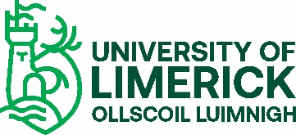

Emeritus Professorships and Lectureships

May 2013

Emeritus Professorships and Lectureships
Introduction
Most universities internationally honour their retired academic staff who, at the date of retirement, hold the title of Lecturer through to Professor by allowing them retain the title following their retirement. The advantage of such a facility is that
- It allows the university to recognise and honour retiring academic staff.
- It maintains a link between the retired member of staff and the university.
Criteria for Title
To be allowed use the title, retiring academic staff must satisfy the following criteria:
- s/he must have been employed by UL for a minimum of five years immediately prior to retirement;
- s/he must on the date of retirement hold the title of Professor, Associate Professor, Senior Lecturer or Lecturer.
Process for determining the award
- Retired Lecturers, Senior Lecturers, Associate Professors and Professors in UL will be allowed use the title of Emeritus Lecturer, Emeritus Senior Lecturer, Emeritus Associate Professor, Emeritus Professor according to their academic status (grade) at the time of retirement.
- No retired members of academic staff will be allowed use the adjunct title.
- The University of Limerick does not grant emeritus titles for Head of Department, Assistant Dean, or Dean. The emeritus title only applies to Lecturer, Senior Lecturer, Associate Professor and Professor.
- The Governing Authority of the University of Limerick may allow the title President Emeritus.
Please note that a retired member of staff allowed the title of Emeritus does not have employee status or any other contractual entitlements. The holder of the title Emeritus must not use the title in any manner which may bring the university into disrepute.

