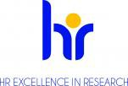
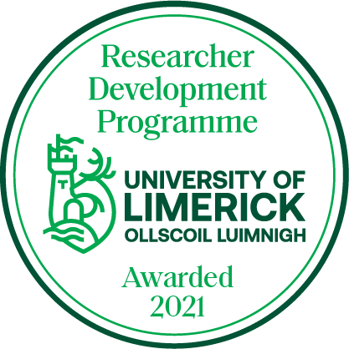

RESEARCHER DEVELOPMENT PROGRAMME
E-PORTFOLIO

Name:
Department/Research Centre:
Name of PI/Manager:
Last Review Date:
Next Review Date:

This document should be completed on an on-going basis as you progress through the Career Development Programme. You can record all of your learning here, not only the training modules that you attend as part of the RDP but also any other work or learning that you do that can build your skills as a researcher. This can include but is not exclusive to:

- Chairing meetings
- Organising or attending conferences
- Presenting papers a symposia
- Award nominations
- Networking events
- Other training
- CPD events

Once you have completed the document, please email it to researchdevelopment@ul.ie

Section 1. For Ongoing Completion Mid-Programme
+

Courses Undertaken
Course Title | Learning Objectives(to be completed in advance of course) | Key Learning(to be completed after course) | Action. What action are you committing to as a result of this training?

Other relevant experiences / feedback / activities
(This could involve meetings with mentors; conference attendance; feedback from PI; etc.)
Activity Undertaken | Learning Objectives(to be completed in advance) | Key Learning(to be completed after)
+

Section 2. For Completion at the End of the Programme.
Key Learnings / Reflection
What are the top five things you learned about developing your career as a result of your experiences during this programme?
1.
2.
3.
4.
5.
Please outline your strategy to continue from here.
This should include both your research strategy and your personal career development strategy.
Research Strategy:
Career Development Strategy:

Section 3. The PI's Perspective
This Section is to be Completed by your PI
What are the top three things this person should focus on in the next 12 months to develop their career? (Please be as detailed as possible in how these could be addressed: contacts / supports available, etc.)
1.
2.
3.

