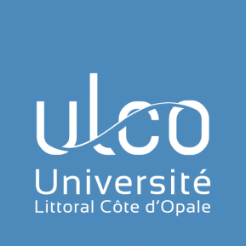

- Institutional Information

Full legal name of the institution | Université du Littoral Côte d’Opale - ULCO
Erasmus Code | F DUNKERQ09
Address | 1, Place de l’Yser – BP 71022 – 59375 Dunkerque cedex 1 – France
Website | www.univ-littoral.fr
President | Prof. Hassane SADOK

2. International Relations Office

We site for incoming exchange students | www.univ-littoral.fr/international/etudier-en-france/pour-etudier/
General email | international@univ-littoral.fr

Vice-president for International Relations | Contact: Prof. Rachid AMARA
 | Email: rachid.amara@univ-littoral.fr

Institutional coordinator | Contact: Mrs Myriam COURCO
 | Email: myriam.lemaire@univ-littoral.fr

Contact for Erasmus+ incoming students
Incoming students –  Boulogne campus | Contact: Mrs Sophie TERRIER
 | Email: incoming.bl@univ-littoral.fr

Contact for outgoing students
Outgoing students | Contact: Mrs Hélène PIHEN
 | Email: outgoing.studies@univ-littoral.fr

3. Calendar

Academic year
First semester | 1st September - Mid January
Second semester | Mid January – End of May

The academic calendar may vary depending on the level of study (Bachelor or Master).
Nomination Deadline

First semester /  Full year | 31st May
Second semester | 31st October

Application Deadline

First semester /  Full year | 30th June
Second semester | 30th November

- Additional Information

Language of Instruction

Our bachelor’s degree programs are all taught in French.
Only a selected number of courses is offered in English at the Master level:
- Master MECS (Master in Engineering of Complex System) : https://mecs.univ-littoral.fr/
- Master Tourism Engineering and Territories (in project for 2022/2023)

A B2 level is recommended but we do not require evidence of this level.
French compulsory classes (3 ECTS/semester), exempted for students whose mother tongue is French. Possibility to attend conversational workshop in the Boulogne-sur-Mer campus for 2 additional ECTS.

Buddy program
International students can sign up for our Buddy Program.
Link to our Buddy Program: https://buddysystem.eu/fr/

Holidays
November 1
November 11
December 25
January 1
May 1
May 8
May : Ascension day (date vary from year to year)
May/June : Pentecost day (date vary from year to year)
July 14

3.4 Campus
ULCO is based on 4 campuses.
The current Erasmus+ agreement is for the Boulogne-sur-Mer campus (Field of Languages).
https://www.univ-littoral.fr/contacts-plans-dacces/

