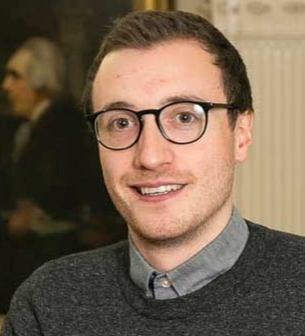

Oisín Hassan is currently Policy Executive for Lifelong Learning and Skills with the Irish Universities Association (IUA), advocating on behalf of eight Irish universities to government and state bodies to ensure Ireland meets its ambitions to offer diverse learning experiences in our ever-changing society and world-of-work. Previously Oisín was the Programme Manager of the National Student Engagement Programme (NStEP), which was co-founded by the Higher Education Authority (HEA), Quality and Qualifications Ireland (QQI), and the Union of Students in Ireland (USI). Through this work Oisín spearheaded a national strategy to ensure students were able to act as partners with staff, that their voices were heard, and that they were able to advocate for and implement change within our higher education institutions to improve the student learning experience.

Oisín was previously the VP for Equality and Diversity (2015/16) and VP for Education (2016/17) in Queen’s University Belfast Students’ Union, before taking up the role of Deputy President and VP Academic Affairs (2017-2019) with the Union of Students in Ireland representing 374,000 students north and south. He is a previous Board member of Quality and Qualifications Ireland (QQI), the National Forum for the Enhancement of Teaching and Learning and is the current Co-Chairperson of the StudentSurvey.ie Steering Group. Oisín has just completed a term as an international board member for the Icelandic Quality Board for Higher Education, and is also a voluntary member of the strategy team for the Museum of Childhood Ireland. He holds an LLB Law with Politics from QUB and recently completed an MSc in Public Policy from Dublin City University.

