EDI Bulletin January 2024

Welcome
Welcome to the January 2024 edition of the Faculty of Arts, Humanities and Social Sciences Equality, Diversity and Inclusion (EDI) Bulletin. The EDI Bulletin is an initiative of the AHSS Athena SWAN EDI Committee. The objective of the Bulletin is to keep the AHSS faculty updated on the implementation of the faculty Athena SWAN Action Plan and related activities and to document and showcase recent EDI initiatives in the faculty.
This edition of the Bulletin contains a variety of contributions from staff and students. It features contributions relating to teacher training in inclusive pedagogies and refugee education; mental health and music therapy by the Irish World Music Café; events and initiatives that foster intercultural awareness; and criminal justice and disability, among other stories.
Previous issues of the bulletin can be accessed on the AHSS website.
Dr Maria Rieder,
AHSS Assistant Dean Equality, Diversity and Inclusion

Table of Contents
- Athena Swan Update
- FAHSS ASEDI committee members
- The Irish World Music Café at the UL City Campus
- New Study Abroad Practicum in Teaching English to Adult Learners from the Ukraine in conjunction with UL Access Campus
- AHSS-LCETB Training for Teachers in Inclusive Pedagogies
- The Sustainable Alliances Against Anti-Muslim Hatred (SALAAM) project
- Dr Alan Cusack Invited to Deliver Guest Address at Landmark International Safeguarding Conference
- World Health Organisation Collaborating C﻿enter (WHO-CC)
- BA Contemporary Dance 2+2 programme with Hainan University, China
- Mindful Music for Family Carers
- Irish World Academy Tower Seminar: ‘Music Therapy for Perinatal Wellbeing’
- Limerick Irish Algerian Friendship group and UL colleagues celebrate diversity and inclusion at Culture Night 2023
- Towards an inclusive education using visual literacies and arts for teaching, learning and assessment
- Successful Launch of Intercultural Virtual Societal Challenge Workshop for Students
- Japanese language and culture event series
- Tell your own story (TYOS) project
- Supporting the introduction of a new Master’s programme at Pwani University, Kenya
- AHSS Equality, Diversity and Inclusion Resources
- Contact details

Athena SWAN Update
Thank you to colleagues who have joined and are continuing to work on the AHSS Athena Swan EDI Committee (see membership on p.2). The committee recommenced their work in November 2023 and are currently evaluating the AHSS Bronze Action Plan and reviewing data in relation to 4 areas (students, academic/research staff, professional managerial support staff, culture, inclusion and belonging) which will feed into our Athena Swan Silver Application due in November 2024.
This process will reveal any additional data needs and an attitudinal student and staff survey will be circulated in early February.
We would very much appreciate if you could keep your eyes out for the survey, this is one of many ways in which you can feed into and have a say in our future action planning around EDI issues in our Faculty, so we would encourage maximum participation. A detailed timeline for the work of the committee until the date of submission in November 2024 can be found here: Timeline and tasks.docx

FAHSS ASEDI committee members
Student Group:
- Oonagh Grace (FO)
- Dr Alan Cusack (Law)
- Dr Breandán MacGabhann (Geog/ Hist)
Academic/Research Staff Group :
- Dr Niamh NicGhabhann (History)
- Dr Cecilia Benaglia (MLAL)
- Dr David Coughlan (EIC)
- Helen Fitzgerald (Law)
- Dr Lindsay Garratt (Sociology)
- Dr Conor Caldwell (IWAMD)
- Dr Michaela Schrage-Früh (MLAL)
- Annie Girardin-Halpin (MLAL)
Professional Managerial Support Staff Group:
- Rina Carr (FO)
- Dr. Andrew Shorten (PPA)
- Jess Beeley (FO)
- Dr Brendan Halpin (Sociology)
- Dr Niamh Lenahan (FO)
- Emma Foley (History)
Culture, Inclusion and Belonging:
- Audrey Galvin (EIC)
- Dr Laura Linares (MLAL)
- Dr Sandra Joyce (FO/IWAMD)
- Dr Nita Mishra (PPA)
- Dr Triona McCaffrey (IWAMD)
- Dr Chris McInerney (PPA)

The Irish World Music Café at the UL City Campus
The Irish World Music Café is a weekly, music-based social gathering aimed at creating a space of welcome to newcomers in Limerick. Its primary goal is to harness the potential of music and singing to support connection and engagement between newcomers and the wider community of Limerick and beyond. Since 2023, It has taken place each Thursday morning at 11am in the UL City Campus. The café is hosted by the Irish World Academy of Music and Dance in association with the migrant NGO Doras and the Participatory Health Research Unit in the School of Medicine, UL. This innovative music café was created in 2015 in the context of the Irish Refugee Protection Programme.
The model was developed by Professor Helen Phelan, Director of the Irish World Academy, in collaboration with musicians, researchers and community-based partners and is currently coordinated by Academy PhD candidate Ewa Zak Dyndal with support from doctoral and postdoctoral colleagues, Sarbik Guha and Dr Fran Garry. Since 2019, Professor Phelan has been working closely with Professor MacFarlane in the Participatory Health Research Unit, in integrating the music café model into migrant health research, teaching and learning initiatives. The migrant NGO Doras is a critical partner in the success of the music café.
Ahmed Hassan, a Community Sponsorship Worker with Doras has highlighted the importance of the café in the context of the recent conflict in Ukraine: “With the arrival of Ukrainians in Limerick and the Mid-West, Doras approached the Irish World Academy of Music and Dance to support an initiative to welcome the newcomers into Limerick through participatory arts. The Irish World Music Café was a valuable method for sharing within the group their own experiences as Ukrainians in Limerick.”
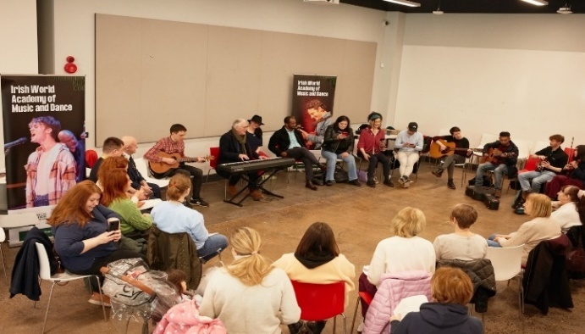
New Study Abroad Practicum in Teaching English to Adult Learners from the Ukraine in conjunction with UL Access Campus
A new community-based teaching practicum has been developed for Study Abroad students at the University of Limerick with students from three universities in the United States participating in the first iteration in Autumn semester 2023.
As part of the initiative, the visiting students received initial training in teaching of English as a foreign language to adult learners from the Ukrainian community currently residing in Ireland under EU Temporary Protection. The training also included a focus on trauma-informed practice.
To hear Study Abroad student Jackson Meadow’s talking about his experience, click on the link here

AHSS-LCETB Training for Teachers in Inclusive Pedagogies
An AHSS-led teacher development day was held at the Radisson Hotel in September 2023 for more than 150 teachers from the Limerick-Clare Education Training Board. The training day focused on upskilling teachers in intercultural and pedagogical skills in order to support the integration of pupils from diverse language and cultural backgrounds into schools and vocational training programmes. It was led by Assistant Dean International, AHSS, Dr Angela Farrell with colleagues Dr Catherine Martin, Dr Jane Seely and Michelle Daly from the TESOL/Linguistics Section (School of Modern Languages and Applied Linguistics).
It is the first in a series of teacher training workshops to be offered within the framework of the new Memorandum of Understanding between UL and the LCETB. Dr Angela Farrell is a member of the regional ESOL and Migrant Learner Steering Group which coordinates further education provision in Limerick and Clare.
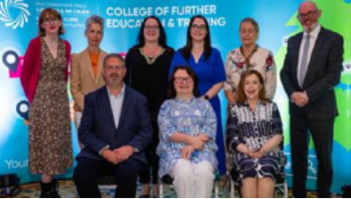

The Sustainable Alliances Against Anti-Muslim Hatred (SALAAM) project
The Sustainable Alliances Against Anti-Muslim Hatred (SALAAM) project, led by Dr James Carr (Dept. of Sociology) and funded by the EU Commission under its Citizens Rights, Equality and Values programme (CERV) continues to make strong progress. The SALAAM team has now expanded and a warm welcome to the project and Faculty is extended to Patrick Fox, Educational Technologist and new Postdoctoral Researcher Dr Tiba Bonyad. Building on the extensive fieldwork undertaken in year one, involving work with 193 people from within Muslim communities and 69 staff from seven different Local Authorities, a range of SALAAM initiatives are starting to take form.
These include the development of an anti-racism training programme that has now been piloted with the participating local authorities; the recruitment of trainers from within Muslim communities; and the creation of tools to support people who experience racism to report racist incidents, and seek further assistance if required. To these can be added the development of local community platforms designed to create/deepen linkages between local authorities and members of the Muslim communities in their area. 2024 holds much promise for SALAAM with even more outputs on the horizon which are both academically and community focused.

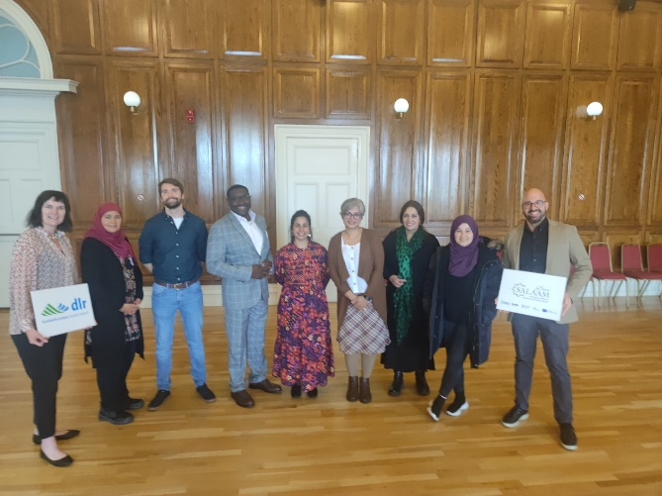
Dr Alan Cusack Invited to Deliver Guest Address at Landmark International Safeguarding Conference
Dr. Alan Cusack (School of Law) was invited to deliver an address at a landmark, international conference, entitled “Criminal Justice, Safeguarding and Adults with Disabilities” which took place online on 22 September 2023. The conference is part of a series of free seminars focused on the theme of safeguarding and adult protection which was organised by Safeguarding Ireland, and the Health Service Executive. Safeguarding teams in Scotland, Ireland, England, Wales and Northern Ireland all attended the conference proceedings.
Dr. Cusack delivered a paper entitled ‘Towards a Community Co-Response Model: An Overview of the Position of Adults with Intellectual Disabilities in Custody in Ireland’. Other keynote speakers at the event included Vivian Geiran (Adjunct Assistant Professor at School of Social Work & Social Policy, Trinity College Dublin & Chairman, Irish Association of Social Workers) and Jan Pickles OBE (Director of a confidential advisory service for child and adult protection and safeguarding).
World﻿ Health Organisation Collaborating Center (WHO-CC)
The Participatory Health Research Unit, Co-Directed by Professor Anne MacFarlane (School of Medicine) and Professor Helen Phelan (Irish World Academy of Music and Dance) is home to the World Health Organisation (WHO) Collaborating Center for participatory health research with refugees and migrants. In 2023, the UL WHO Collaborating Center agreed a new 4 year partnership with the Department of Health to increase the involvement of refugees and migrants in the development of health policy in Ireland.
The event was attended by community partner organisations including Doras, Migrant Health Research Ireland, Ballyhaunis Inclusion Project and Shannon Family Resources Centre, statutory partners including the HSE, Limerick County Council and the Department of Health; and academic colleagues leading research in refugee and migrant health. The WHO Collaborating Centre has a strong commitment to using participatory, arts-based methods to support diversity and inclusion in research and works closely with the Irish World Academy of Music and Dance in this regard.

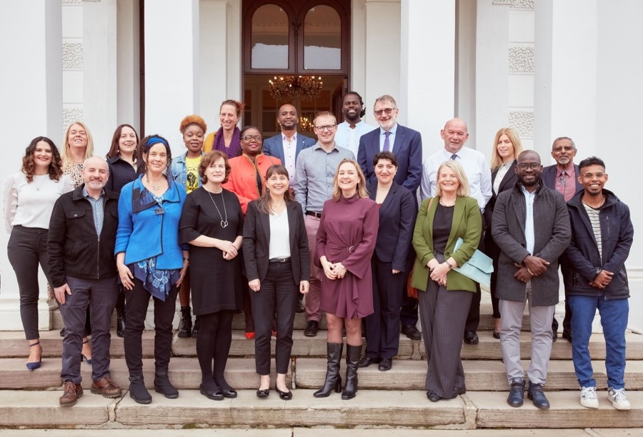

BA Contemporary Dance 2+2 programme with Hainan University, China
The Irish World Academy of Music and Dance’s BA Contemporary Dance (LM133) is creating a pathway for students to attend UL through a 2+2 programme with Hainan University, China. The creation will include a bespoke Semester 5 set of modules with a strong continued focus on their artistic practice, English language and intercultural development, with additional supports to facilitate their social and cultural integration (e.g. international buddy system/ IWAMD intercultural advocate).
From Semester 6 onwards, students will progress on the existing programme where they will continue to develop their artistic practice as well as their general and academic English by taking additional modules as electives. Adding additional English language modules to elective bundles will encourage and develop the student’s general and academic language engagement which in turn will accommodate different skill/competency levels.

Mindful Music for family carers
Mindful Music is an online mindfulness-based telehealth music therapy (MBMT) programme combining guided live and recorded music listening with simple mindfulness practices (awareness of the breath /body scan/guided visualization). This 30-minute programme was created by Dr. Hilary Moss, and fellow researchers Dr Katie Fitzpatrick and Dr Lisa Kelly, as a workplace wellness break to support university staff.
It was then adapted as a psychosocial support for family carers of people with dementia and has also been tested as an employees’ lunchbreak wellbeing with UHL staff. All developments have been been interdisciplinary, notably with HSE Wellbeing and UHL staff, Professor Ita Richardson and the Aging Research Cluster, HRI. In January 2023 Dr. Moss piloted a four week Mindful Music online group for family carers of people living with dementia, with support the Alzheimer’s Society and Family Carers Ireland.
The weekly Carers Mindful Music group, facilitated by Dr. Moss and her MA student Niamh Crowhurst, continues to support family carers through mindfulness, relaxation, emotional and peer support and was so successful, that it continued past the pilot phase of four weeks and has now been running weekly for the past twelve months with no end in sight. Future plans include extending the group to more family carers through collaboration with Family Carers Ireland, funding for a larger research project to see if Mindful Music is commercially viable and a testing of the benefits with healthcare staff at Croom Hospital.
Traditionally, music therapy is delivered face-to-face in a variety of contexts including at home, in the community, residential care and hospitals. The emergence of telehealth music therapy became prominent in 2020 due to the impact of Covid-19, demanding an immediate transition from in person to online delivery formats for many music therapists. As well as supporting Irish family carers this work contributes to international excellent practice for delivering telehealth music therapy. Dr Moss is co-chair of the International Association of Music and Medicine Telehealth Special Interest Group, who have endorsed and actively support this research.

Irish World Academy Tower Seminar: ‘Music Therapy for Perinatal Wellbeing’
On the 11th of October 2023, a hybrid Tower Seminar took place at the Irish World Academy, and was livestreamed online for a wider audience, in collaboration with the Specialist Perinatal Mental Health Team (SPMHT) at the University Maternity Hospital Limerick (UMHL). At this seminar, findings from the first music therapy study in perinatal mental health in Ireland were presented.
This is part of PhD research by Pui Sze Cheung who together with the SPMHT has developed a music therapy programme that has been commended by the Department of Health for its innovation in perinatal mental healthcare delivery. A highlight of this seminar included presentations of lived experience of this UMHL music therapy programme as shared through word and song by Noelle O’Riordan, Mairéad Morales and Elaine Costello. Shining a spotlight on women’s lived experiences of music therapy is key to ensuring that women’s voices are central to developing further research in this area.
This child-friendly event also included presentations from Pui Sze Cheung and Dr Tríona McCaffrey (Irish World Academy), Dr Sylvia-Murphy Tighe (Department of Nursing and Midwifery), Dr Mas Mahady (Consultant Psychiatrist, UMHL) and Maria Gibbons (Advanced Midwife Practitioner, UMHL).

Limerick Irish Algerian Friendship group and UL colleagues celebrate diversity and inclusion at Culture Night 2023
This Culture Night event took place on the 22nd of September and was organised jointly by Limerick Irish Algerian Friendship Group, the UL Ethnic Diversity Forum and the UL PSU.
The photo shows Dr Angela Farrell, Assistant Dean International, AHSS and university teacher Michelle Daly with visiting scholars from partner universities in China who recited a poem in Chinese at the event.
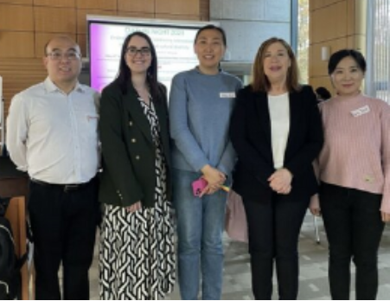

Towards an inclusive education using visual literacies and arts for teaching, learning and assessment
During Autumn semester 2023, the Broadening module Communication Across Cultures implemented a project that uses visual literacies and visual learning to enhance teaching practice and assessment in undergraduate modules. In alignment with UL’s strategic priorities, this project embraces a UDL approach to the adaptation and development of technology-enhanced learning activities to develop visual literacies vis-à-vis intercultural learning, this last one being the main aim of the module.
As part of the project, the lectures followed a pedagogical practice based on the use of materials from the Culture Shocked! exhibition, developed by Dr Florence Le Baron-Earle in collaboration with student artists and the videos commissioned to the Irish comedian Killian Sunderman, who tailored 9 videos about intercultural episodes led by Dr Marta Giralt.
Both visual cultural artefacts (comics and videos) were used as pedagogical materials for the classes as well as examples of what the students needed to develop as part of their assessment. In order to offer guidance to the students and help them with the creation of their visual intercultural artefacts, a guest lecture with the artists was organised.
The students provided very positive feedback about the innovation implemented in the module and offered comments such as “visuals provide a sort of universal language. They transcend linguistic barriers, making them an effective tool for communication in diverse classrooms like ours”.
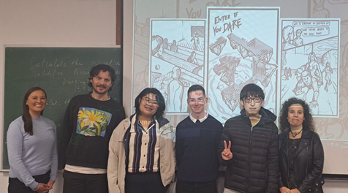

Successful Launch of Intercultural Virtual Societal Challenge Workshop for Students
In Autumn semester 2023, more than sixty AHSS students took part in a new virtual exchange workshop with peers from partner universities in Germany, France, Spain and Slovakia. The workshop involved the students working in inter-institutional on societal challenges in the areas of race, gender and the environment and provided exciting opportunities for intercultural and digital upskilling also. The workshop was developed as part of a K2 Erasmus + project and will be offered as an ‘alternative to Erasmus’ module from September 2024.

Japanese language and culture event series
In Autumn 2023, the Japanese Section at the School of Modern Languages and Applied Linguistics and the University of Limerick Language Centre collaborated on a series of events to bring together students of Japanese and Japanese students of English.
The Japanese Section and the Language Centre have created an inclusive and supportive environment where students could freely exchange their language and cultures. There were eight events throughout the semester. These events were organised to promote diversity and good relations between all students within the campus. They also served to foster engagement within and across institutions and to cultivate and strengthen a sense of identity and belonging among students. Photos of these events can be viewed on Instagram (@uljapanese and @ul.languagecentre).
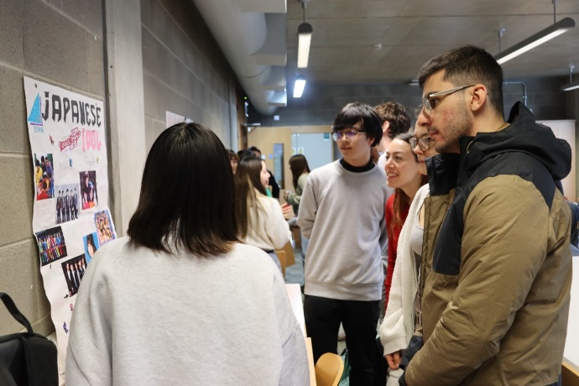
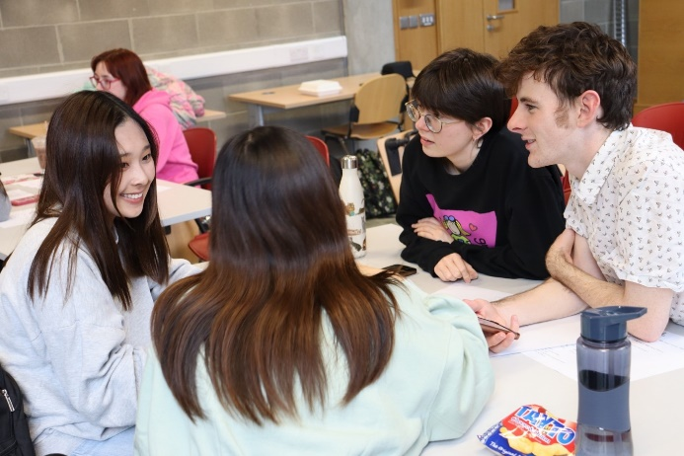

Tell your own story (TYOS) project
The Tell your own story project was proud to run a third iteration of their ‘Creating Media for Empathy’ Training Course. Both UL international students and participants from outside UL joined in the course and completed training in Irish media, self-empowerment, transculturality, a Narrative 4 story exchange, and creative workshops in podcasting, videography and writing for media. The participants are currently gathering and editing material for publication in different local media organisations.
The TYOS ‘Creating Media for Empathy’ course will run again in September 2024 and is open to everybody with an interest in media creation and diversity and inclusion. The project seeks to break down stereotypes and barriers by highlighting what we all share across cultures and identities
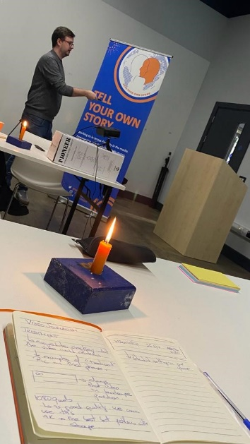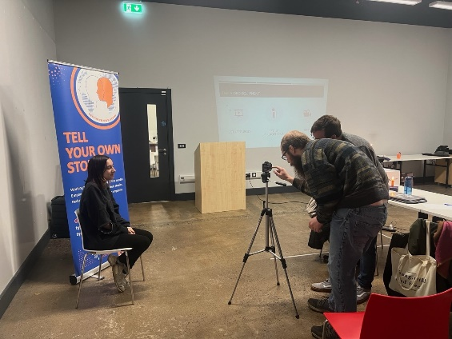

Supporting the introduction of a new Master’s programme at Pwani University, Kenya
Dr Yvonne Cleary is collaborating with colleagues at the University of Applied Sciences, Karlsruhe, Germany, and at Pwani University, Kenya, to run the first year of a new Master’s programme in Communication and Media, following a successful pilot last year. This is the first programme of its kind in Africa, and it is funded by the DAAD (Deutscher Akademischer Austauschdienst – the German Academic Exchange Service). Dr Cleary has been involved in the project since it began in January 2022 and she helped to develop the curricula for the pilot and the full Master’s programme.
The curriculum includes writing, information design, communication, video production, business, and technology. It offers exceptional employment opportunities for graduates in a range of local and national companies in Kenya. An important feature of the programme development has been close cooperation with local companies.
She will travel to Kenya in February this year, supported by International Credit Mobility funding. The main objectives of the trip are to meet the other teachers involved in the programme, teach on-site at Pwani University, and meet the current cohort of students in person. Teaching up to now has been online. During her stay, Dr. Cleary will facilitate workshops to continue curriculum development. She will also participate in an event to launch the Master’s in Communication and Media for the next academic year and to meet prospective students.
Because of the close collaboration between the three universities, and through the support of the DAAD funding, the programme will become sustainable and will be run independently by Pwani University from September 2025.
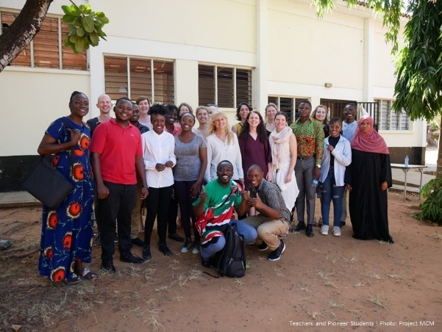

AHSS Equality, Diversity and Inclusion Resources
Online Equality, Diversity and Inclusion training :
- EDI in Higher Education training
- Let’s talk about race programme
- Unconscious bias training
- Bystander intervention training, a sexual violence awareness programme developed by UCC
Information on inclusive teaching practices using Universal Design for Learning (UDL) can be accessed here.
AHSS Equality, Diversity and Inclusion information resources:
- AHSS Equality, Diversity and Inclusion website
- Previous editions of the AHSS EDI Bulletin can be viewed here.
Graduate Certificate/Diploma in Equality, Diversity and Inclusion:
For further details on the programmes please consult the course page here.
Dont forget to also check out our monthly EDI email update sent to all AHSS Staff

Contact us
For general queries related to AHSS EDI activities please contact AHSSADEDI@ul.ie
To keep update on all AHSS EDI Activity, why not follow our EDI Social media channels
LinkedIn:
Equality, Diversity and Inclusion, Faculty of Arts, Humanities and Social Sciences, University of Limerick
Twitter:
Equality, Diversity and Inclusion, AHSS
@EDI_AHSS

