Information Technology Division Newsletter 2023
Contents
Information Technology Division Newsletter 2023 1
Welcome to the latest newsletter by University of Limerick’s Information Technology Division (ITD) 2
UL Enable strategy sets out digital journey for University 3
Digital User Access Project goes live 3
Transforming the student learning experience with Brightspace 4
Workload Allocation Model 4
Making the grade 4
Research Information System update 5
Future-ready: Driving the digital transformation of teaching spaces 5
ITD Engage: Elevating the student IT experience 6
UL launches new Digital Governance Steering Committee 8
Strengthening the University’s cybersecurity posture 8
Improving device setup 9
Marcomms Web Team implements TOPdesk 9

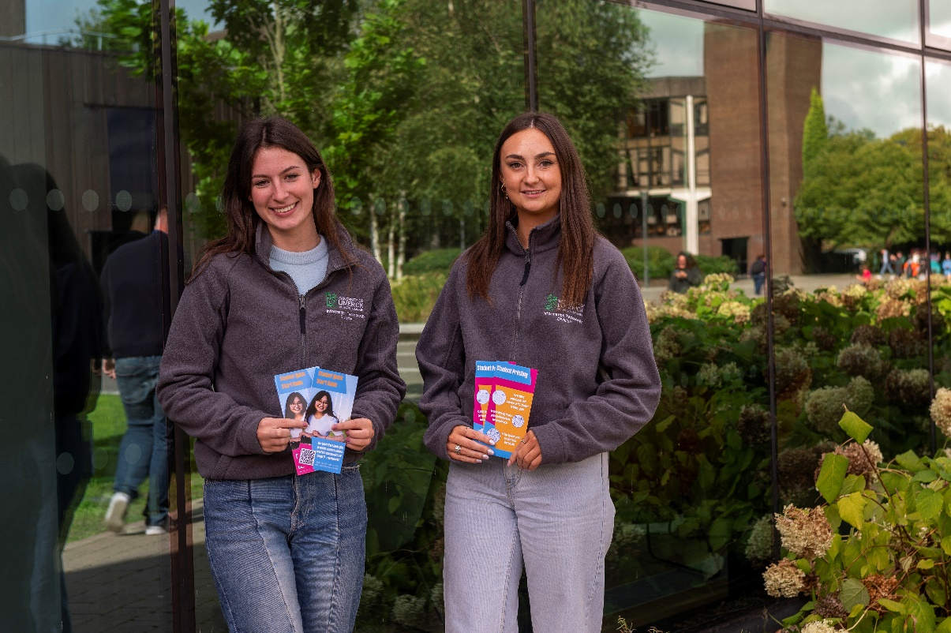
Figure 1 KBS Marketing students Eloise Coryell and Kori Morrison, who completed their COOP placement with the Information Technology Division, pictured promoting student IT services during Orientation Week

Welcome to the latest newsletter by University of Limerick’s Information Technology Division (ITD)
Thank you for taking the time to peruse the latest edition of the ITD newsletter. From launching UL Enable, the University’s ambitious five-year IT strategy, to enabling the rollout of the new VLE Brightspace, it has been an incredibly busy 12 months for the division.
I hope that this newsletter will give you a flavour of some of the projects ITD staff have been engaged in and provide insight into upcoming transformation projects such as UL’s new Research Information System which has been formally approved by the Digital Governance Steering Committee (DGSC).
In addition to supporting day-to-day IT services, ITD have delivered over 60 digital enablement projects and implemented 775 technical changes in 2023 to continually improve our operational capabilities and provide excellent service to all stakeholders. Finally, I would like to thank all ITD staff, our UL colleagues and students across the campus for your ongoing collegiality and support during the year. Wishing you all a happy Christmas and safe New Year.

UL Enable strategy sets out digital journey for University
ITD are pleased to present University of Limerick’s IT Strategy, UL Enable, which sets out a five-year vision for Information Technology in UL. This ambitious strategy focuses on key areas including cybersecurity, enhancing our collective technical capabilities, streamlining processes, promoting good governance and leveraging innovative technologies. UL Enable will also empower UL to achieve its goals and help create a sustainable future for the University. This roadmap will also allow us to continue to deliver excellent IT services to the entire UL community and support the University’s continued growth and success.

Figure 2 Noel O’Brien, Padraig Hyland, Edel Gissane, Treasa Cunneen, Maria Linnane, Marguerite McEnery, Sharon Aherne, Jean Chaplin, Dominic Burns, Brendan Dore and Liam O’Reilly Photo: Siobhan Gleeson Hayes

Digital User Access Project goes live
In another step towards transforming UL’s digital environment, 2023 saw the successful rollout of the Digital User Access Project which has revolutionised how we manage access to key digital systems, such as Email and SharePoint, in UL.
This project was delivered through collaboration between ITD and HR. In alignment with UL Enable IT Strategy, the Digital User Access Project has also achieved its core objective of strengthening UL’s governance and cyber security posture by ensuring that access to key digital systems is linked to a person’s term of employment. To date, the Digital User Access Project has delivered the following:
- Automation and linking of all UL staff digital accounts with Core HR ensuring that all employees have timely access to digital resources.
- Reduction in manual tasks and improved communication.
- 1,300 postgraduate research students received enhanced UL digital accounts, providing extended access to digital resources for one year after completion of studies.
- Partner Records are now managed on the Partner Access Management System (PAMS) eliminating all associated manual processes for line managers, HR and ITD.
- 96% reduction in requests logged to the ITD Service Desk to create or modify digital accounts.

Transforming the student learning experience with Brightspace
The Brightspace VLE project has benefitted from the enhanced digital capabilities of the IT team, made possible by the investments from Stage 1 of the UL Enable IT Strategy.
ITD staff from Educational Technology, Project Management, Enterprise Architecture, Service Delivery and Business Intelligence and Reporting Systems collaborated to deliver a high-quality system to enable the transformation of teaching and learning for the University.
Enhanced functionality for this important university wide system was delivered to provide streamlined and secure access to the system as well as module creation and enrolment from the Student Information System.
Access to additional platforms to enhance digital education, such as Turnitin, Panopto and Leganto, and to report on teaching and learning interactions and activities for academics and the University Executive were also delivered. There has been significant activity on the Brightspace VLE this semester, where we see in excess of 12,000 logins daily.
Students spend their time interacting with content in their modules, completing assignments and interacting with other learners using the communication tools. Additionally, students keep in touch with their learning using the Pulse mobile app that provides quick access to calendars, content and notifications on the go.
Further work on the Brightspace VLE is planned until the project ends in April 2024. Academics will have the opportunity to digitally enhance their teaching and learning by participating in pilots on accessibility and peer assessment. Additionally, the project team will seek feedback from students and academics in the spring semester that will assist in our continuous improvement approach to our teaching and learning systems.

Workload Allocation Model
ITD have been supporting the specification of the system to underpin UL’s new Workload Allocation Model (WAM) through our IT Business Engagement Partners who have been working in partnership with the Office of the Provost. The purpose of WAM is to establish an evidence-based approach for UL to support transparency and equity in work allocation to academic staff members.

Making the grade
The Academic Services Team within ITD have a key role in the Tactical Stabilisation Programme with the focus now on the move to a Grade Point Average (GPA) model for the 2024/5 intake of students. Currently, the team are committed to the project on a continual basis in the roles of IT Project Lead, IT Business Analyst and Senior SITS Technical Analysts.
The team is heavily involved in most aspects of the project including but not limited to:
- Working closely with external vendors; Clarion, Tribal and STU3 to deliver robust technical changes.
- Creation and validation of progression rules.
- Set up of data for User Acceptance Testing.
- Development of a brand-new suite of automations that have been adapted to the new GPA model.
- Redevelopment of communication emails to streamline the overall process and create efficiencies within Academic Registry Operations.
- Transition scenario planning for any students that need to transition from the old QCA model to the new GPA model post go-live.
- Analysis of integrated systems to determine the level of impact the new model may have and create a plan for any redevelopments that are required.
- Supporting the Oracle Discoverer Replacement Project to replace ageing reporting technology with modern Business Intelligence dashboards and reports.

Research Information System update
The implementation of a new Research Information System, Elsevier Pure, to support UL’s Research Advancement and UL Enable, replacing the current ULRIS Vidatum system has been formally approved by the Digital Governance Steering Committee (DGSC). The new system will provide UL researchers with access to a tool that is globally adopted by more than 400 institutes. This capability will enable UL researchers to collaborate more effectively, maximise funding opportunities and showcase UL research more broadly.

Future-ready: Driving the digital transformation of teaching spaces
A collaborative initiative between the Department of Electronic and Computer Engineering (E&CE) and the Information Technology Division (ITD) has led to the significant transformation of the B2-041 lab in the Main Building into a dynamic and inclusive educational space. This renovation marks a significant shift from traditional educational environments, offering a more flexible and engaging learning experience that caters to the diverse needs of students.
The redesigned B2-041 lab moves away from the conventional setup of rows of desks and desktop computers. It now supports over 70 students, organised into groups of five in various pods. This new arrangement not only fosters active learning but also enhances accessibility, ensuring that the space meets a wide range of student needs.
Each pod is equipped with a large computer screen, which can be controlled by lecturers for instructional purposes or used by students for collaborative projects, using their own devices. To achieve this modern teaching environment, ITD worked closely with colleagues from Science and Engineering, selecting Mersive Solstice as the key technology to revolutionise the lab into a cutting-edge interactive space. Additionally, ITD played a crucial role in overseeing the AV installation, boosting Wi-Fi capabilities, and managing the network infrastructure of the room.
John M Kelly, Chief Technology Officer in the Department of Electronic and Computer Engineering, commented on the project’s impact: “We have created a space that not only enhances the student learning experience but also addresses the diverse needs of all students, making it a more inviting and accessible environment for class engagement and participation.”
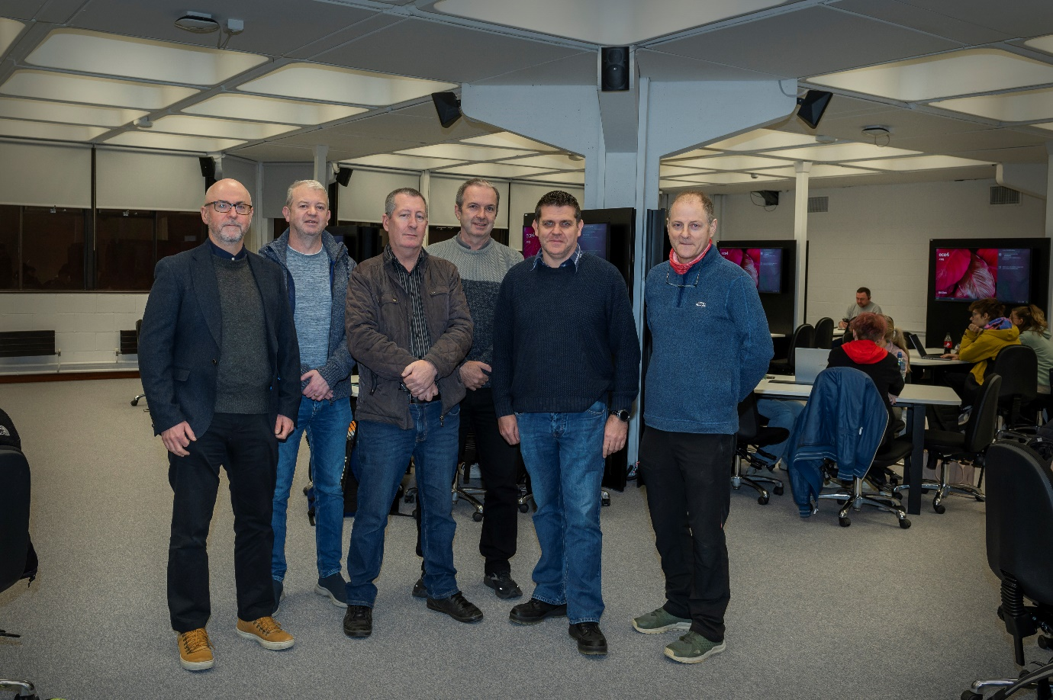
Figure 3 L-R: Colin Fitzpatrick, Head of Department of Electronic & Computer Engineering (ECE), John Morris Senior Technical Officer ECE, Alan Hayes Information Technology Division, John Fitzgerald Commnet, John Kelly Chief Technology Officer ECE and Fran McCarthy Senior Technical Officer ECE. Photo: Siobhan Gleeson Hayes

ITD Engage: Elevating the student IT experience
From taking to the stage at the Orientation tent to running brand awareness campaigns, it has been a busy semester for ITD promoting the vast range of IT supports available to new and existing students.
Throughout Orientation Week, staff from the ITD Service Delivery team facilitated thirteen individual talks for new students, provided multiple daily tours of IT services in the library and provided additional information at a pop-up desk in EG-010.
We were delighted to collaborate with our colleagues in Academic Registry, UL Global and GPS to deliver an engaging week of events. ITD also collaborated with staff from the First Seven Weeks programme and library peer advisors to ensure there was consistent messaging around digital services for students and promote our Student Quick Start Guide to IT. Further engagement events also took place in the library in October via a pop-up desk, providing advice on student print services.
In October we ran a highly successful campaign called ‘Get to Know ITD.’ Information about digital services such as our Student Quick Start Guide, TOPdesk, Office365, OneDrive and print services were communicated to students who were then encouraged to test their knowledge and enter a prize draw to win a Dell laptop. The campaign proved to be a major success for the division, with particularly strong engagement among first-year students. The summer season marked a notably busy period for the department as we engaged in a brand refresh of our social media channels and updated our complete video library on YouTube. Our video guides have proven to be highly successful with over 2,000 views on our Multi-Factor Authentication tutorial alone!
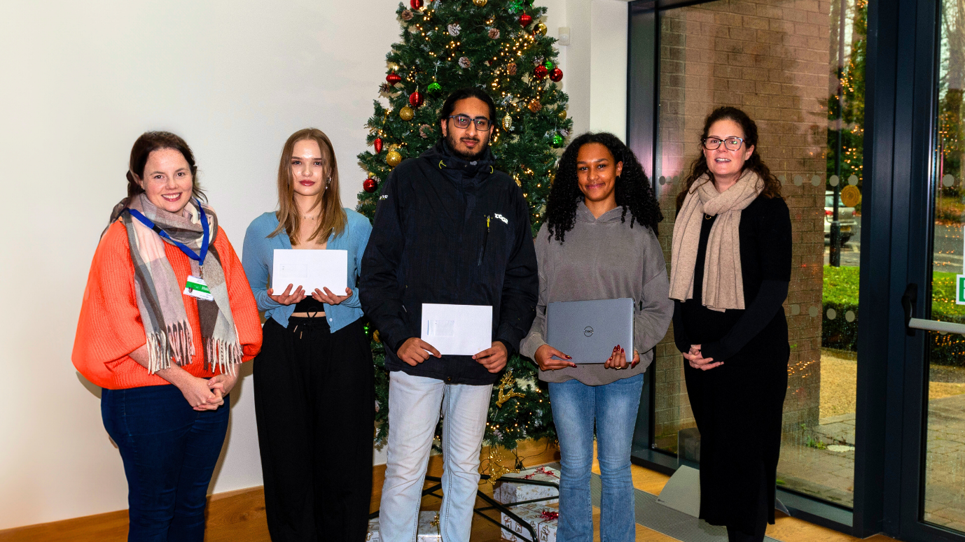
Figure 4 Niamh Dillon, ITD, with Get to Know ITD competition winners Amelia Polak, Mihir Suvarna, Niema Issa and Maria Linnane, ITD

Figure 5 Back row: Eamonn Fitzgerald, Richard Bourke, Eugene Murnane. Middle row: Tom Carey, Jean Chaplin, Elaine Kennedy, Anna Marie Gildea, Mary C O’Donogue, Edel Quinn, Edel Gissane, Eamonn T Fitzgerald, Majella O’Halloran, Brendan Bolger, Brendan Dore Deputy Director ITD. Front row: Liam O’Reilly, Director ITD, Mamie Hayes, Patricia Hickey, Sharon Aherne, Linda Maloney. Missing from photo: Brian Sexton, Niall Collins, Dorothy Kealy, Gabriel Peters, Joseph Murphy, Susanne O’Mahony

UL launches new Digital Governance Steering Committee
In recognition of the important role of technology in shaping the educational landscape, a Digital Governance Steering Committee (DGSC) has been formed at UL to support the strategic prioritisation of the University’s investment in its IT and digital infrastructure.
Already, the establishment of the DGSC has played a key role in implementing the UL Enable IT Strategy. Over the last 12 months, the DGSC has worked with the President and Executive Committee to implement a governance process for the approval, planning, and management of digital investment for the campus.
Additionally, the DGSC supports the Executive Committee to ensure all digital activities are aligned with the University’s overall objectives in teaching, learning, and research. The DGSC, which is a subcommittee of the Executive Committee, advises on the management of digital platforms, reviews IT and digital project initiatives and reports on progress to the Executive Committee. It also provides ongoing recommendations for critical issues and risks related to cyber security and ensures current and future projects are aligned with UL’s strategic goals.
To help with the prioritisation of digital and IT infrastructure projects in UL, a new process has also been developed to categorise initiatives under specific criteria such as mandatory projects, priority development, improvement projects and maintenance.
The Digital Governance Steering Committee consists of representatives from the University including the:
- Chief Financial and Performance Officer (Chair)
- Director ITD (Deputy Chair)
- Provost and Deputy President
- Chief Commerical Officer
- Vice President of Research
- Director HR
- 2 x Executive Deans (nominated by the President)
- Deputy Director ITD
- Corporate Secretary
- Associate VP Academic Services
- Other stakeholders as requested by the Chair for a specific period or project

Strengthening the University’s cybersecurity posture
Throughout 2023, there have been a number of high-profile cyber-attacks in the Higher Education sector in Ireland and abroad. Due to the rapidly changing cyber threat landscape, ITD has continued to strengthen UL’s cybersecurity posture through phishing simulations, education campaigns, and a number of other technical projects.
Now, more than ever, it is vital that all members of the campus community are proactive in trying to mitigate potential cybersecurity incidents given the continued rise in cyber-attacks focused at third-level institutions. Education campaigns play a crucial role in increasing awareness of good cybersecurity practices. During the year, a number of phishing simulations were carried out to raise awareness amongst staff. As part of Cybersecurity Awareness Month in October, ITD ran an engaging social media campaign featuring bite-sized cyber-safe tips and infographics targeted at staff and students. Information campaigns ran on user vigilance around phishing, password security and how to identify online scams.
A suite of new ITD-branded pull-up banners were placed at key locations across campus to amplify the cyber-safe messaging. Continuous improvement is key to any organisation’s response to the growing threat of a cyber incident.
ITD regularly reviews and tests existing procedures and controls in certain areas such as Disaster Recovery and Incident Response to ensure their effectiveness and alignment with both national and international standards.

Improving device setup
One of the key areas ITD has focused on this year is improving our services around UL-owned desktops and laptops. Our work on device setup has meant easier and faster setup of new staff devices, remote setup options for staff working off campus and most importantly, increased security for UL’s network infrastructure. These upgrades, which were rolled out for both Apple (iOS) and Windows operating systems, have given greater flexibility to staff while also ensuring that sensitive UL data can only be accessed on a secure device. More information on Modern Device Management is available on ULConnect.

Marcomms Web Team implements TOPdesk
The successful onboarding of the Web Team from the Marketing, Communications & Public Affairs Division onto UL’s call management system TOPdesk marked another milestone in ITD’s strategic digital transformation efforts. This collaborative project between ITD and Marcomms reflects our commitment to improving partnerships and efficiencies across different areas of the University and improving the experience for our UL community. More information is available on ULConnect.

